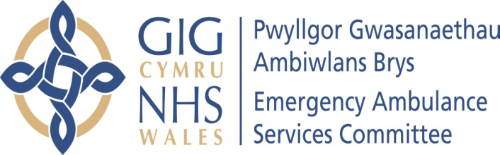 | AGENDA ITEM 2.1  14 May 2019

Emergency Ambulance Services Committee Report
EASC CHAIR’S REPORT

Lead: Chris Turner
Author: Chris Turner
Contact Details for further information: Chris.Turner2@wales.nhs.uk 01443 744946

Purpose of the Emergency Ambulance Services Committee Report
The purpose of this report is for the Committee to receive an update on key matters related to the work of the Chair.

Governance
Link to the Commissioning Agreement | The Committee’s overarching role is to ensure its Commissioning Strategy for Emergency Ambulance Services utilising the five step patient pathway outlined within the National Collaborative Commissioning Quality and Delivery Agreement and the related outcomes for each care standard aligned with the Institute of Healthcare Improvement's (IHI) ‘Triple Aim’ are being progressed.  This report focuses on all the above objectives, but specifically on providing strong governance and assurance.
Supporting evidence | The development of this report has where appropriate been informed by updates provided through established governance processes.  A number of the issues highlighted within the report are covered in more detail within the main agenda of the Committee meeting.
Engagement – Who has been involved in this work?
The Emergency Ambulance Services Commissioning Team has contributed to the development of information contained within this report.

Emergency Ambulance Services Committee Resolution to:
APPROVE |  | ENDORSE |  |  | DISCUSS | √ | NOTE | √
Recommendation |  | The Emergency Ambulance Services Committee is asked to:  - DISCUSS and NOTE the report
Summarise the Impact of the EASC Report
Equality and diversity |  |  | There are no equality and diversity implications contained within this report.
Legal implications |  |  | There are no legal implications contained within this report.
Population Health |  |  | No impact.
Quality, Safety & Patient Experience |  |  | Ensuring the Committee and its Sub Groups make fully informed decisions is dependent on the quality and accuracy of the information presented and considered by those making decisions. Informed decisions are more likely to impact favourably on the quality, safety and experience of patients and staff.
Resources |  |  | No impact.
Risks and Assurance |  |  | Ensuring the Committee is fully sighted on key areas of its business is essential to Board Assurance processes and related risks.
Health and Care Standards |  |  | The 22 Health & Care Standards for NHS Wales are mapped into the 7 Quality Themes;  - Staying Healthy; Safe Care; Effective Care  - Dignified Care; Timely Care; Individual Care; Staff & Resources  Within an overarching Governance Framework.  Welsh Government Health & Care Standards Framework 2015  This report focuses mainly on Governance & Accountability but also spans some of the 7 quality themes.
Workforce |  |  | No impact.
Freedom of information status |  |  | Open

CHAIR’S REPORT

1. SITUATION / PURPOSE OF REPORT

The purpose of this report is for the Committee to receive an update on key matters related to the work of the Chair.

2. BACKGROUND / INTRODUCTION

- Since the last Committee meeting Members will have received my objectives agreed with the Minister for Health and Social Services namely:

- Oversee amber review actions and system implementation.
- Support for WAST IMTP and plan for 2019-20 (to 2021-22).
- Undertake demand and capacity assessment of WAST for system discussion and actions
- Ensure collaborative governance in place and key collective decisions made.
- Review and agree further EASC actions to underpin winter planning 2019-20.
- Facilitate more of WAST options beyond 999 response as enablers for WAST role in community services and alternatives to hospital.
- Align EASC with broader work on unscheduled care actions.

- I have also had a first meeting with the CASC regarding his objectives. We are due to finalise these shortly.

3. ASSESSMENT / GOVERNANCE AND RISK ISSUES

- Members will wish to note that I served on the selection panel for the Chair of WAST and I am pleased to report that Martin Woodford has been appointed as substantive Chair.

- The all Wales Chairs meeting was postponed from 29 April to 9 May. An oral update will be presented at the meeting.

4. RECOMMENDATION

The Emergency Ambulance Services Committee is asked to:

- DISCUSS and NOTE the report.

Freedom of information status | Open

