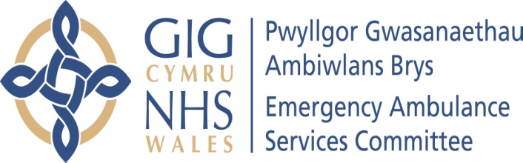 | AGENDA ITEM 2.1  12 November 2019

Emergency Ambulance Services Committee Report
EASC CHAIR’S REPORT

Lead: Chris Turner Chair of the Emergency Ambulance Services Committee (EASC)
Author: Chris Turner
Contact Details for further information: Chris.Turner2@wales.nhs.uk 01443 744946

Purpose of the Emergency Ambulance Services Committee Report
The purpose of this report is for the Committee to receive an update on key matters related to the work of the Chair.

Governance
Link to the Commissioning Agreement | The Committee’s overarching role is to ensure its Commissioning Strategy for Emergency Ambulance Services utilising the five step patient pathway outlined within the National Collaborative Commissioning Quality and Delivery Agreement and the related outcomes for each care standard aligned with the Institute of Healthcare Improvement's (IHI) ‘Quadruple Aim’ are being progressed.  This report focuses on all the above objectives, but specifically on providing strong governance and assurance.
Supporting evidence | The development of this report has where appropriate been informed by updates provided through established governance processes.  A number of the issues highlighted within the report are covered in more detail within the main agenda of the Committee meeting.
Engagement – Who has been involved in this work?
The Emergency Ambulance Services Commissioning Team has contributed to the development of information contained within this report.

Emergency Ambulance Services Committee Resolution to:
APPROVE |  | ENDORSE |  |  | DISCUSS | √ | NOTE | √
Recommendation |  | The Emergency Ambulance Services Committee is asked to:  - DISCUSS and NOTE the report
Summarise the Impact of the EASC Report
Equality and diversity |  |  | There are no equality and diversity implications contained within this report.
Legal implications |  |  | There are no legal implications contained within this report.
Population Health |  |  | No impact.
Quality, Safety & Patient Experience |  |  | Ensuring the Committee and its Sub Groups make fully informed decisions is dependent on the quality and accuracy of the information presented and considered by those making decisions. Informed decisions are more likely to impact favourably on the quality, safety and experience of patients and staff.
Resources |  |  | No impact.
Risks and Assurance |  |  | Ensuring the Committee is fully sighted on key areas of its business is essential to Board Assurance processes and related risks.
Health and Care Standards |  |  | The 22 Health & Care Standards for NHS Wales are mapped into the 7 Quality Themes;  - Staying Healthy; Safe Care; Effective Care  - Dignified Care; Timely Care; Individual Care; Staff & Resources  Within an overarching Governance Framework.  Welsh Government Health & Care Standards Framework 2015  This report focuses mainly on Governance & Accountability but also spans some of the 7 quality themes.
Workforce |  |  | No impact.
Freedom of information status |  |  | Open

CHAIR’S REPORT

1. SITUATION / PURPOSE OF REPORT

The purpose of this report is for the Committee to receive an update on key matters related to the work of the Chair.

2. BACKGROUND / INTRODUCTION

Since the last Committee meeting Members should note:

I have continued to attend the Chair’s Peer Group meetings and the Ministerial meetings which took place 23 September and 29 October. Amongst the topics discussed have been around Major Trauma, winter delivery and public appointments. The Welsh Ambulance Services NHS Trust (WAST) report on Emergency Services map was also welcomed by Chairs and the Minister but with a call for the potential outcomes and evaluation of these developments to be given greater prominence.

The programme of visits by the Chief Ambulance Services Commissioner (CASC) and myself to all Health Boards is underway with the first visit on 31 October being made to Cardiff and Vale University Health Board. We are most grateful for the opportunity to address the Board and it was good to receive positive and helpful feedback.

On 1 November I attended a very interesting and enlightening presentation by WAST colleagues on the Optima predictive tool which has significant potential.

3. ASSESSMENT / GOVERNANCE AND RISK ISSUES

I have received, and have accepted, an invitation to stay on as Interim Chair for the Committee for a further year and look forward to continuing to work constructively with the Committee, the CASC and the team.

At this point can I repeat my commitment to Members that I am open to feedback, whether they are general comments or concerns, about any aspect of the Committee’s work.
.
4. RECOMMENDATION

The Emergency Ambulance Services Committee is asked to:

- DISCUSS and NOTE the report.

Freedom of information status | Open

