1000 Beds or Equivalent Community Service Closure Report
Background
On the 15th May 2023, the NHS Leadership team commissioned a programme of work to provide an additional 1000 beds or equivalent community services for winter 2023 to ease system pressure and reduce anticipated delayed discharges. The programme was commenced as a joint endeavour between Health and Adult Social Care (ASC), with Welsh Local Government Association (WLGA) support. Additionally there was engagement with Care Forum Wales, Social Care Wales (SCW) and Health Education in Wales (HEIW). The below governance structure provided regular reporting to Welsh Government (WG) via Care Action Committee (CAC).
Figure 1- Governance Structure
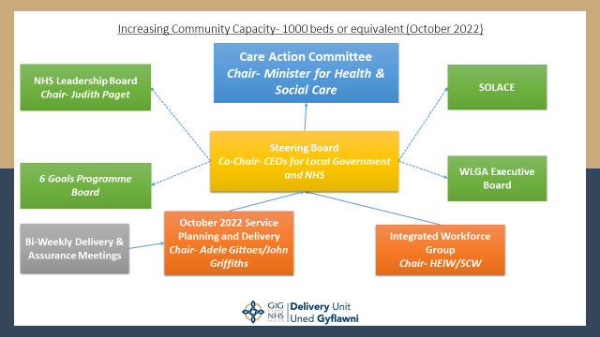

The Governance structure in place re-enforced the Joint Endeavour ethos and sought to ensure no one partner was perceived as leading this work. It was recognised that the success of this programme and the longer term Strategic/Transformational change required is dependent on joint design, ownership and accountability between Health and Local Government.
Discovery
A task team was established with representation from health and social care including amongst others, the Delivery Unit (DU) Transformation Team, Adult Directors of Social Services Cymru (ADSSC), HEIW and SCW.
Initial activity focussed on data collection, and risks at a locality level within each Region. Initial meetings were established with executive leads from HB and ASC to discuss the risks, opportunities and their proposed plans. Data presented to the regions by the task team at the initial meetings included the National Hospital Bed Occupancy, Delayed Discharges, Day of Care Audits, Rightsizing programme, DEWIS, Social Care Checkpoint Dataset and bespoke questionnaires.
The themes and demonstrated learning from these initial meetings included:
- There was limited recognition of the nationally held data presented.
- A greater understanding of each organisations data and processes was required at a regional level to ensure focus in the correct place to maximise outcomes – knowing their numbers. There was a huge amount of data available and this needs to be reviewed as “whole system” level by the Regions;
- Partnerships and relationships appeared stronger in some regions when observing the discussions and reviewing plans submitted;
- There were already some excellent examples of models of care across health and social care which seek to reduce harm;
- An acknowledgment that delayed discharges were also due to Hospital processes and the need to share the work being undertaken to address these inefficiencies;
- Regulatory issues and registration issues of staff can created barriers and National discussions with regulators in relation to risk balance would be welcomed;
- D2RA pathways were not embedded and further work was required (being undertaken via Goals 5 & 6) to embed D2RA and support local implementation;
- There was no consistent optimising hospital care principles in Wales i.e. SAFER, Red to Green and full acknowledgement that an All Wales Framework would be beneficial, which in turn would be aligned to daily reporting and escalation;
- That the core constraint was social care workforce and that until a sustainable workforce could be recruited and retained the system would not be able to meet the needs of its people in terms of getting to the right place, first time.

A key outcome of this initial discovery was the estimated demand & capacity gap in domiciliary and reablement care, estimated to be approximately 25,000 hours per week across Wales. This was the first nationally recognised estimate based on questionnaire responses from ASC. However, this was a snapshot of data in the absence of standard, regulated data capture.

It was acknowledged that this work programme would not address some of the identified themes as they sit within the medium to long term transformational programmes. The priority was to support the regions with the growth of community capacity to improve outcomes for our population by using resources to maximum effect and minimise harm.
Design
Following the joint endeavour purpose the structure of the programme needed to reflect this and therefore the bi-weekly, meetings were held with both Health and Social Care partners across each of the regions. This joint representation was seen to be crucial in the joint ownership of the design and delivery. Although there were initial reservations with the focus on delayed discharges rather than prevention, it was acknowledged that the immediate system risk and potential harm through delayed discharges was the short-term priority, which would be supported by parallel work on prevention and hospital avoidance.
By assessing the current themes of the data, available two main capacity growth areas were identified:
- Physical Bedded Capacity (Hospital and Care Home Beds)
- Community Capacity (E.g. Domiciliary and Reablement Care)
There was also an acknowledgement of efficiencies, which could further maximise capacity without the need to grow resource allocation. Therefore, the third category would focus on efficiency release such as reductions in hospital length of stay.
The final element of design was the production of a reporting template, which outlined:
- Scheme Narrative
- Type of capacity
- Organisational Lead
- New or Repurposed capacity
- Final Projected Scheme Bed or equivalency.
- Trajectory of delivery
- Funding Source if required
- Risk RAG rating
- Variances
This template was seen to be crucial to the audit trails, assurance meetings, identifying opportunities/good practice and potential impacts.
Delivery
October 2022 – March 23
Schemes were identified and implemented by the regions, with trajectories set alongside a RAG risk rating. Further to these schemes, national datasets were being improved to track overall performance of the health and social care system such as a new version of Social Care Checkpoint, 21-day length of stay and the Pathway of Care Delays.
Figure 2- Original Additional Capacity Trajectory
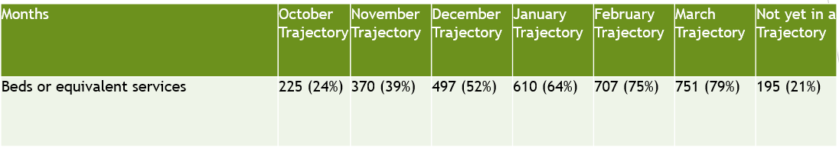
Figure 3- Actual Additional Capacity Delivery
Figure 3 demonstrates the changes made with each bi-weekly reporting cycle. The bi weekly meetings provided scrutiny of plans and the opportunity to share good practice between regions. Regional colleagues have reported they found the sharing of good practice and the creation a shared equation of bed calculation to be helpful.
A final figure of 678 beds delivered, although short of the 1000 bed target represented a significant achievement given that there was no additional resource given to regions but a greater focus on regional working to deliver this additional capacity.
Figure 4- Final Breakdowns of Delivery by Organisation and Risk RAG
Organisation | Total | %
UHB | 180 | 20.55%
LA | 456 | 52.05%
Joint | 240 | 27.40%
Total | 876 | 100.00%
RAG | Total | %
Amber | 198 | 22.60%
Green | 678 | 77.40%
Total | 876 | 100.00%
Green Only | Total | %
UHB | 138 | 20.35%
LA | 385 | 56.78%
Joint | 155 | 22.86%
Total | 678 | 100.00%

Figures 3 & 4 demonstrate the joint endeavour mechanism was effective at delivering capacity across organisations for both Physical beds and Community Capacity. There was also an endeavour improve efficiencies which could not always be effectively captured and sustained.
Examples of Best Practice
- Overseas Recruitment
An overseas recruitment drive in the N. Wales region has demonstrated some positive results. This scheme has delivered approximately 750 hours of additional domiciliary care into the social care system and the LA area, which now has one of lowest numbers of delayed discharges since the pandemic. The relevant Local Authority did not undertake the recruitment, but supported the independent care provider. The recruitment via overseas mechanisms has been explored in other areas but is not widespread and presents opportunities for further roll out.
- Micro-Enterprises.
The concept of micro-enterprises has grown during the process with a number of different methods being used to grow capacity within this area. Some LAs have used organisations such as Community Catalysts whilst some have developed internal delivery mechanisms. Both models have had success with the most successful being in Denbighshire with a total 26 personnel supporting 140 citizens. Microenterprises have been particularly useful at returning staff back into the social care workforce and supporting individuals with complex social issues, which on occasion providers, struggled to consistently cover.
- Reablement Agency
A scheme that was an early success was the use of an English workforce agency to provide additional staff to support reablement care in the Bridgend area. The programme was initially planned to deliver 300 hours per week, but it has now surpassed this initial expectation and delivers 640 hours. These hours had a stabilising effect on the regions capacity and was seen to be instrumental in providing cover for sickness and vacancies. It also supported the transitioning of people from the reablement caseload into longer-term domiciliary care enabling further capacity for the reablement pathway with rightsizing.
- Step Down to Recovery Beds
With attempts to grow the immediate bed capacity within the care home sector, there were two distinct models across the regions, Step Down to Recover (SD2R) and Bridging. The SD2R models were the most effective at rightsizing packages and maximising throughput, with up to 80% of patients returning to their own home with no ongoing care. Two schemes that stood out were the Ty Pili Pala in West Wales and Gorseinon Care Home in West Glamorgan. These schemes were based on expanding on existing SD2R capacity, with therapies provision already attached. Other regions struggled to develop SD2R due to therapy constraints. In mitigation the bridging capacity model, while providing additional capacity was reported to be a greater challenge for both the initial placement and moving people back to home.
SD2R National Minimum Service Guidelines were developed by the Task Team and Goal 6 colleagues to support the RPBs and operational teams to best design SD2R beds.
2023/2024 Impact
Whilst the Building Community Capacity programme was focused on winter 2022/23 all Regions were requested, where possible to explore opportunities to increase capacity on a recurring basis. As a result, circa 500 beds or equivalent services are recurring into 2023/24 largely funded from RIF funding. These schemes are mixture of 2022/23 schemes which will continue and those schemes which were established as part of the BCC programme but do not commence until Mar/Apr 2023 and will be in place throughout 2023/24.
The table below provides a high level summary of this recurring capacity per Region. It should however be noted that whilst this capacity is/will be commissioned as with all capacity it is dependent on private sector market stability and workforce.
Region | Physical Beds | Community Capacity | Total
Gwent | 20 | 32 | 52
N.Wales | 3 | 99 | 102
CTM | 34 | 75 | 109
CAV | 55 | 10 | 65
West Wales | 29 | 42 | 42
West Glam | 30 | 80 | 110
Powys | 9 | 7 | 16
 | 180 | 345 | 496

Workforce
The Integrated Workforce Group, which operated in parallel to the Bi-weekly meetings, arranged meetings with regional workforce leaders. The key messages and challenges were:
- Recruiting additional workforce
- Retaining current workforce
- Pay, Terms and Conditions and lack of parity - seen as primary barriers
- Recruitment difficulties - operating in a competitive market (within and outside of health and care) and especially across the foundation economy
- Registration and re-registration of social care workers was perceived to be a barrier to both recruitment and retention, and not consistent with HCSW requirements
- Support for a once for Wales Trusted Assessor model
- Review medicines administration policies
- Access to resources and good practice models
- National solutions may not work for all (e.g. Powys and issues of rurality)
- Wellbeing of existing workforce remains a high priority
Another outcome of the workforce meetings, was an improvement in the awareness of the availability of training and recruitment drives already provided for, these include:
- We Care Wales– national job portal to advertise jobs; additional recruitment campaigns including TV advert for domiciliary care underway and social work to follow later this year
- Careersville promoting the wide range of occupations across social care and health
- Regional Connectors –in each region to support and facilitate attraction into social care jobs
- Introduction to social care – free 3-day course supporting individuals considering a career in the sector with targeted pilots for young people; refugees etc in development. Resources to support temporary redeployment of staff to support social care available from info@socialcare.wales
- Guidance Employing people from Ukraine and refugees in social care: resource for providers | GOV.WALES
- Working in social care in Wales: guidance for foreign nationals – Explains how to apply to work in social care in Wales if you aren’t a UK citizen.
- Train work live supporting health professional recruitment
- Values based recruitment training for employers in social care
- Revised registration rules for Social Care Worker professional registration
- International recruitment and employer support for nurses into health boards, and potential expansion for social care role subject to demand
- Fair Work Forum for Social Care focussing on pay, terms and conditions
- Continued focus on the impact of cost of living particularly around travel costs where additional funding was provided to local authorities to support domiciliary care
- National Wellbeing offers to support retention and support of the current workforce Wellbeing Tools for Care Workers in Coronavirus | Social Care Wales
- Vocational learning available at L2,3,4 & 5 including formal qualifications and apprenticeships
- Care Home Education Facilitators
- Care Aims (health) and Outcomes training and developing the skills of our workforce in social care | Social Care Wales programmes
- All Wales Guidelines for delegation - these national guidelines have been developed to assist in the management and practice of all acts of appropriate delegation.
- Verification of Death training is available via learning@wales available to health and social care staff. https://learning.nhs.wales/course/view.php?id=48
- Rehabilitation Awareness Training – Y ty dysgu HEIW - Online resource for rehab training with links to further modules and qualifications available. Also Agored Cymru Level 3 Diploma in Rehabilitation Support (Wales) C00/4517/1 (created specifically for role) and Agored Cymru Level 4 Diploma for Therapy Assistant Practitioners C00/3964/6
- Joint induction programme for HCSW and Social Care Support Workers

Impact
When assessing the impact on the system, it was difficult to attribute one programme to delivering an improvement across Health and Social Care. However, Figure 5 demonstrate the improvement in delayed discharges during this this work. It should be noted that it is not possible to predict the data trends should the 1000 bed or equivalent services programme had not been commissioned.
- Delayed Discharges
The original regional distribution of expected beds was based on the delayed discharges in May; the measure has acted as the consistent measure during the programme. There was a peak of delayed discharges in late November that has gradually reduced to date.
Figure 5- Delayed Discharges May 2022-February 2023.

- 21 Day LOS
At the start of the programme, there was limited consistency in the reporting of length of stay (LOS), which focussed on patients already discharged. It was recognised it would be beneficial to capture patients LOS who were yet undischarged as it likely these would contribute to the delayed discharge cohorts. During the programme, Goal 5 and DCHW developed a consistent method.
Figure 6 & 7 display the similar trend of improvement in performance to that of the delayed discharges shown in Figure 5.
Figure 6- Monthly Count of 21 Day
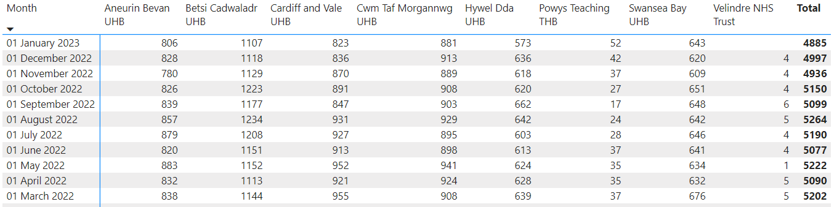
Figure 7- % Patients greater than 21 Day within the current bed base.
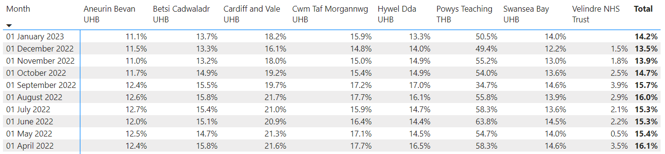
- Pathways of Care Delays- POCD
The previous delayed discharge reports were undertaken via the Delayed Transfers of Care (DTOC) census reporting which was stood down at the start of the pandemic. As part of the work undertaken by Goal 6, there was a project to refresh and restart reporting which provides validated data for total discharge delays and reason codes for the delay. By refreshing the dataset, it also allowed the opportunity to apply a consistent definition of a delay across Wales, which allows effective comparison/benchmarking between regions. Due to the improvements made with the launch of the Pathways of Care Delay reporting it is not possible to compare delayed discharges via DTOC pre pandemic to those outlined in Figure 8. When assessing impact from November, the overall number of delays have risen but the days delayed has stayed relatively static which suggests that the longest lengths of stay patients were being discharged at a faster rate. This also corresponds with the improvements in performance shown in the 21+ cohorts that are the longest LOS patients.
By being able to identify reasons for delay, it enabled regions to best target their resources and for national bodies to provide supporting infrastructure. An evidence of this process was the identification of significant assessment delays preventing patients from moving on to the next stage of their discharge. To begin to address these assessment delays, Trusted Assessor guidance was launched during the programme to enable a more efficient assessment based on the principle of only undertaking proportionate assessments.
Figure 8- Pathways of Care Delays November 2022- February 2023.
- Social Care Checkpoint
Based on learning of the bespoke questionnaires undertaken at the start of the process, the Social Care Checkpoint data was revamped to capture a more comprehensive data set for the Social Care system demands and crucially remains the source of data for both in-hospital and community based demand.
The embedded document was the most recent report from February 2023. On review, it has been suggested:
- Contacts and referrals remain high which suggest the system demand remains
- Assessment completions remains at consistent high levels but waiting for assessments were static
- Low numbers waiting for residential placement so potential stem of pressure for alternative placements
- Unplanned residential placements – Numbers of people in alternative residential care for 6 months plus are now reducing so care packages being identified to support people to return to their own homes
- Numbers of people waiting for domiciliary care reduced since November 2022
- Numbers of people in receipt of domiciliary care since Nov 2022 has increased
- Numbers of people waiting for domiciliary care hours has reduced since Nov 2022, currently 14284 hours (whole social care system not just hospital based)
- Reablement waits reducing which improves opportunity for people and the rightsizing of any ongoing care.

It is envisaged these currently separate reporting mechanisms will become joint as they the datasets and definition mature and the 1000 bed programme has shown the need for a joint endeavour to support by health and social care metrics.

Conclusion
As stated above this programme was commissioned to reduce risk and harm across the system whilst more Strategic/Transformation change was being designed and delivered. The Further Faster Programme will be the main component moving forward in terms of articulating the Strategy/Vision for Integrated Care within Wales and addressing the more complex challenges such as private sector stability, workforce recruitment and retention and delivering community services which are truly integrated at the point of delivery.
Alongside Further Faster, existing National Programmes such as the 6 Goals for Urgent and Emergency Care Programme, the Strategic programme for Primary Care and the Regional Integrated Fund must continue to deliver the changes required to deliver sustainable care to our population.
Recommendations
Members are asked to:
- Note the impact of the BCC programme for 2022/23 and the recurring impact for 2023/24;
- Confirm that Further Faster will now be the core mechanism to lead the Integrated Care Strategy/Vision and delivery;
- That the Governance structure established for the BCC work will be stood down from 1st April 2023 and replaced by the Further Faster Governance structure. As such the Steering Board will be stood down from 1st April 2023 and the bi-weekly Regional meetings (these are not fit for purpose for Further Faster and will be replaced accordingly as agreed as part of the Further Faster programme).

