AGENDA ITEM
2.1

EMERGENCY AMBULANCE SERVICES COMMITTEE

APPROACH TO EMERGENCY AMBULANCE CAPACITY IN 2022/23

Date of meeting | (18/01/2022)

FOI Status | Open/Public

If closed please indicate reason | Not Applicable - Public Report

Prepared by | Ross Whitehead – Deputy Chief Ambulance Services Commissioner
Presented by | Stephen Harrhy – Chief Ambulance Services Commissioner
Approving Executive Sponsor | Chief Ambulance Services Commissioner

Report purpose | FOR DISCUSSION / REVIEW

Engagement (internal/external) undertaken to date (including receipt/consideration at Committee/group)
Committee/Group/Individuals | Date | Outcome
Choose an item. | (xx/xx/2020) | Choose an item.

ACRONYMS
EMS | Emergency Medical Services

- SITUATION/BACKGROUND

  - Delivery of effective and responsive emergency ambulance services has been and continues to be challenging.

  - Changes in demand, lost capacity through handover, sickness and other areas, has resulted in poor responses for patients, failure to achieve response targets and harm for some patients.

  - The Welsh Ambulance Service (WAST) has proposed that it could recruit and train additional staff during 2022/23, which would aid a reduction in patient harm, system risk and support the move towards their strategic ambition.

  - This paper aims to seek the views of the committee on the approach to increasing operational capacity within the emergency ambulance service during the financial year 2022/23, in order to improve the responsiveness of emergency ambulances for the population.

Background

  - Following the publication of the jointly commissioned Demand and Capacity Review (2019) the committee has provided substantial investment to the WAST to grow its front line operational resource.

  - This funding enabled the recruitment of an additional 136 full time equivalents in the financial year 2020/21 and a further 127 full time equivalents during the current financial year.

  - These additional staff are expected to be in post by the end of March 2022 and available operationally during May 2022.

  - This growth in full time equivalents has closed the “relief gap” i.e. the gap between roster lines and staff employed to fill those lines.

  - For a number of reasons, particularly increases in sickness and abstractions from the rosters, the increased full time equivalent position has not yet resulted in more consistent shift fills.

  - Whilst it is likely that this additional capacity has prevented a worse position, the ambulance service has seen growth in the number of patient safety incidents and episodes of harm to patients as well as needing to enter higher levels of their clinical safety plan more frequently and for longer durations.

  - Each step within the clinical safety plan increases the number of patients who are told they cannot receive an ambulance due to the pressures within the system.

  - To reduce risk, the ambulance service is currently receiving support from circa 250 military personnel until the end of March 2022, this position is not sustainable beyond this point.

  - The investment in additional staff was part of a wider package of modernisation agreed between the committee and WAST. Work is ongoing on the delivery of the wider improvements required, particularly around revising the rosters and reducing post-production lost hours.

  - Lost hours to ambulance handover delays are significantly above the levels used as the December 2018 baseline for the Demand and Capacity Review and, as previously discussed by the committee, current handover levels cannot be fully mitigated by any short term additional capacity.

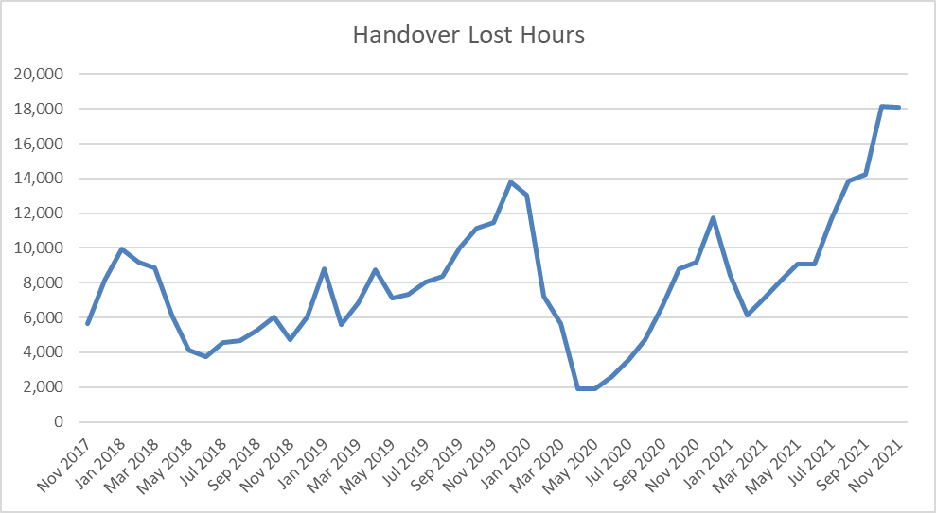

  - Lost capacity is a significant driver of poor performance, with both achievement of the Red target and the Amber response, particularly the tail worsening over a sustained period.

  - The committee has held two previous “focus on” sessions on developing a vision for the future ambulance service. These sessions have focused on “inverting the triangle” i.e. dealing with more incidents through remote clinical assessment and resolution at scene without onward conveyance to health board services.

  - Delivering this inversion will require additional up-front investment in the emergency ambulance service.

- SPECIFIC MATTERS FOR CONSIDERATION BY THIS MEETING (ASSESSMENT)

  - The Welsh Ambulance Service has provided a transition case to the Chief Ambulance Services Commissioner at the end of December, which outlines their preferred option for additional growth next year, as part of the building block towards a transformation of the service.

  - This case has been considered and agreed by the WAST Board in closed session and is available to members on request.

  - The EASC team are currently reviewing the case on behalf of the committee and are developing feedback around the following areas:
- Deliverability
- Operational Impact
- Affordability
- Efficiency
- Wider system links

  - It has not been possible to fully appraise this case in the timescale between its submission and this meeting of the joint committee. However, it is clear from an operational delivery and patient safety perspective that the ambulance service will require additional capacity next year.

  - The case outlines the potential to recruit up to an additional 294 full time equivalents during 2022/23.

  - This additional capacity would bolster operational resources and mitigate the impact of lost capacity through handover delays and workforce practices, whilst improvement plans to these are being implemented.

  - The transition case includes proposals to release paramedics to undertake advance paramedic practitioner training, with the aim of delivering benefits to the system in 2023/24, as well as introducing a high acuity response service that could boost red performance alongside improving clinical outcomes. The timing in terms of delivering these elements of the plan would need to be considered alongside the need to increase capacity.

  - This expanded operational capacity would predominantly come from recruiting and training additional Emergency Medical Technicians and so is unlikely to draw significantly on candidates that health boards would also be seeking.

- KEY RISKS/MATTERS FOR ESCALATION TO THE COMMITTEE

  - The cost associated with full delivery of the WAST preferred option includes £10m revenue during 2022/23 with an ongoing revenue tail of £16m plus an additional £16m capital requirement.

  - There are multiple risks associated with delivering the preferred model, particularly from a recruitment perspective, that would result in a significant underspend against this requirement if they materialised.

  - Previous investment in the service has been on a cost-incurred basis, with ongoing revenue provided following evidence of delivery. However, the scale of the financial ask for the WAST preferred option is much larger than previous years, so an alternative funding model may be required if this was to be supported.

  - Ambulance response times continue to deteriorate. A failure to increase ambulance capacity through investment or material reductions in lost capacity will accelerate this deterioration.

  - There is currently no identified funding source from the committee or centrally to fund any uplifts in ambulance capacity on a recurrent basis.

  - The committee does not have responsibility for capital funding for emergency ambulance services, but effective delivery of any additional capacity will require capital funding.

  - The Committee may wish to consider whether a more limited investment in 2022/23 or a phased investment over a longer period might be appropriate or possible given current financial uncertainties.

- IMPACT ASSESSMENT

Quality/Safety/Patient Experience implications | There are no specific quality and safety implications related to the activity outined in this report.
Related Health and Care standard(s) | ALL are relevant to this report
Equality impact assessment completed | Not required
Legal implications / impact | There are no specific legal implications related to the activity outlined in this report.
Resource (Capital/Revenue £/Workforce) implications /  Impact | Yes (Include further detail below)
Link to Commissioning Intentions | The Committee’s overarching role is to ensure its Commissioning Strategy for Emergency Ambulance Services utilising the five step patient pathway outlined within the National Collaborative Commissioning Quality and Delivery Agreement and the related outcomes for each care standard aligned with the Institute of Healthcare Improvement's (IHI) ‘Quadruple Aim’ are being progressed.
Link to Main WBFG Act Objective | Provide high quality care as locally as possible wherever it is safe and sustainable

- RECOMMENDATION

  - The Emergency Ambulance Services Committee is asked to:
- Support in principle the need to recruit additional frontline Ambulance staff in 2022/23
- Request that the CASC and his team undertake a full assessment of the transitional plan recently received from WAST and provide clear recommendations to the committee via the EASC Management Group
- Include reference to the transition plan in the draft EASC IMTP subject to clarification on funding and delivery of previously agreed efficiency targets and requirements

