AGENDA ITEM
3.3

EMERGENCY AMBULANCE SERVICES COMMITTEE (EASC)

welsh ambulance services nhs trust (WAST)
provider update

Date of meeting | 18 Jan 2022

FOI Status | Open/Public

If closed please indicate reason | Choose an item.

Prepared by | Rachel Marsh, Director of Strategy, Planning and Performance (WAST)
Presented by | Jason Killens, Chief Executive WAST
Approving Executive Sponsor | Chief Executive

Report purpose | FOR DISCUSSION / REVIEW

Engagement (internal/external) undertaken to date (including receipt/consideration at Committee/group)
Committee/Group/Individuals | Date | Outcome
(Insert Name) | (DD/MM/YYYY) | Choose an item.

ACRONYMS
ABUHB  CTMUHB  D&C  EMS  NCCU  NEPTS  SAI  WAST | Aneurin Bevan University Health Board  Cwm Taf Morgannwg University Health Board  Demand and Capacity  Emergency medical services  National Collaborative Commissioning Unit  Non-emergency patient transport services  Serious Adverse Incident  Welsh Ambulance Services NHS Trust
- SITUATION/BACKGROUND

  - The purpose of this report is to provide EASC with an update on key issues affecting quality and performance for EMS and NEPTS and to provide an update on commissioning and planning for EMS and NEPTS.

- SPECIFIC MATTERS FOR CONSIDERATION BY THIS MEETING (ASSESSMENT)

CoVID-19

2.1 WAST continues to track CoVID-19 and related metrics through its weekly CoVID-19 Intelligence Pack. There is a clear third wave (positive tests). WAST is currently at maximum escalation, however, the reasons for this are complex, and not just CoVID-19 demand, and include high abstractions (linked directly to CoVID-19, but also workforce fatigue) and high system pressure, in particular, handover lost hours.

2.2 WAST now undertakes seasonal forecasting and modelling as a matter of routine. WAST collaborates with the NCCU on this work via its Forecasting & Modelling Group, with the modelling results for winter being shared with senior stakeholders. The modelling indicated a very difficult winter period, with the results being used to help seek military aid. WAST has decided not to undertake further modelling using Omicron forecasts, but instead focus on quarter 1 2022/23 i.e. after military aid, which will cease on 31 Mar-22, and also on the potential impact of the Transition Plan (see 2.43).

2.3 As previously reported, in addition to being at maximum escalation WAST has again stood up its pandemic structures (Pandemic Plan) and introduced an organisation wide Performance Improvement Plan (PIP), which sets out the actions being taken to mitigate the risks highlighted in the modelling, including increasing capacity where possible (re-engaging with the military and fire & rescue services) and deployment when required of the Clinical Safety Plan. The PIP is regularly reported on to the CASC.

EASC is asked to NOTE that: as a result of CoVID-19 and the cumulative impact on CoVID-19 on WAST and the wider health care system, WAST is currently at maximum escalation; WAST is receiving military aid until 31 Mar-22; WAST is performance managing delivery against an organisational wide PIP (which is also regularly reported to the CASC); and that WAST is now focusing its forecasting and modelling on quarter 1 2022/23 and on the potential impact of the Transition Plan.

Quality, Safety & Patient Experience

Patient Response Times in the Community

2.4 One of the key indicators which measures the quality of the service provided is the timeliness of the response by WAST to patients waiting in the community. The graphs below show the current response times performance for Red calls and for Amber calls. Both graphs show that response times have continued to worsen throughout 2021. Inevitably these worsening times have had an impact on patient safety.

2.5 The Red 8-minute target was not achieved in Dec-21 (and is expected to be similar in Jan-22). The percentage of emergency responses to Red incidents within 8 minutes was 51% (target 65%) with 95% of Red calls receiving a response within 23 minutes. Red 9 minute performance was 58% and Red 10 minute performance 63%.

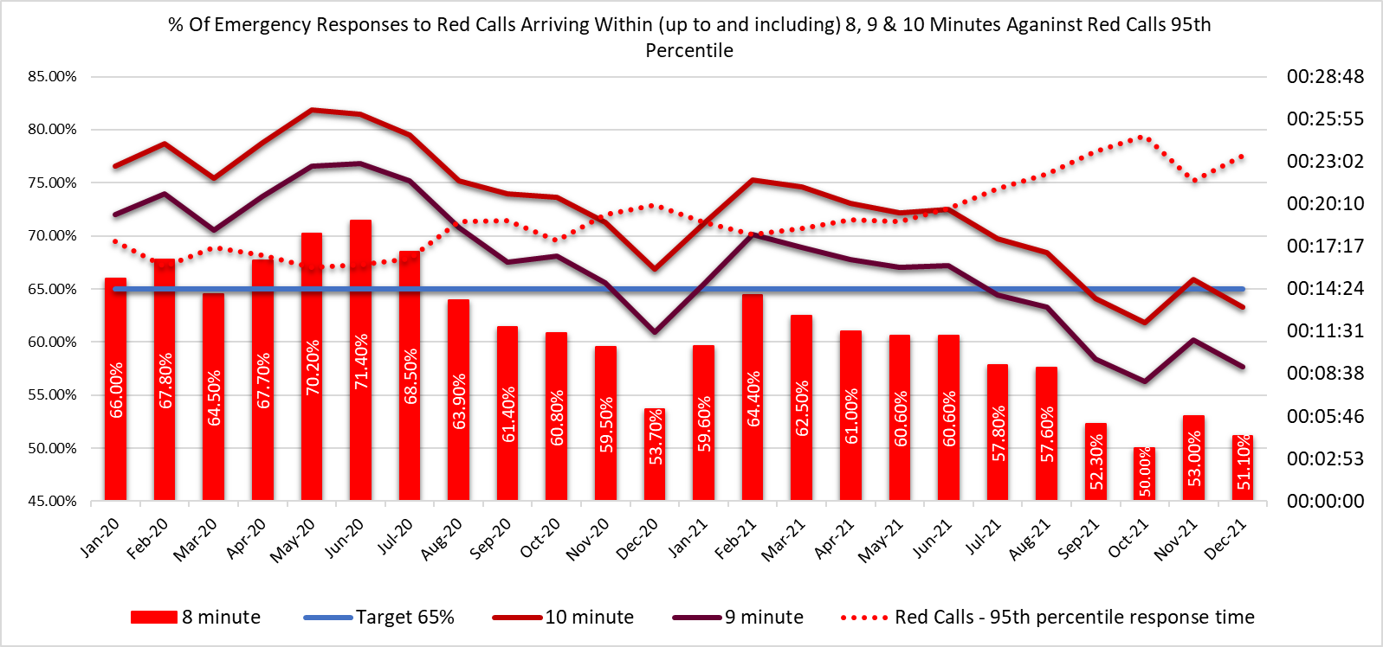

2.6 At previously requested by EASC missed Red incidents by time of day is demonstrated in the following infographic by day and hour (Dec-21).
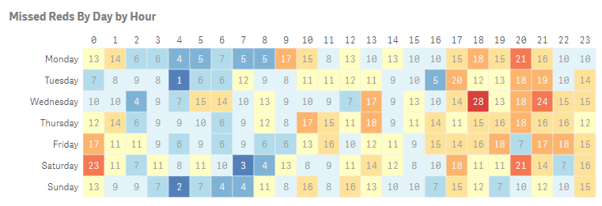

2.7 WAST reviews missed Red incidents as a matter of routine and is aware of the increase in missed Reds in the evening and early hours. WAST has undertaken modelling which has identified four demand hotspots. Under more normal conditions WAST would target Rapid Response Vehicles (RRVs) at these times; however, due to CoVID-19 and the level of abstractions WAST is currently operating a tactical approach to ambulance production with a focus on Emergency Ambulances, which can convey patients and have a higher utilisation.

2.8 The Amber median percentile in Dec-21 was one hour 19 minutes and the Amber 95th percentile was seven hours 4 minutes. The Amber 1 performance parameters used in the EMS Demand & Capacity Review were 35 minutes (Dec-21 position) and 18 minutes (Dec-24 position) respectively.

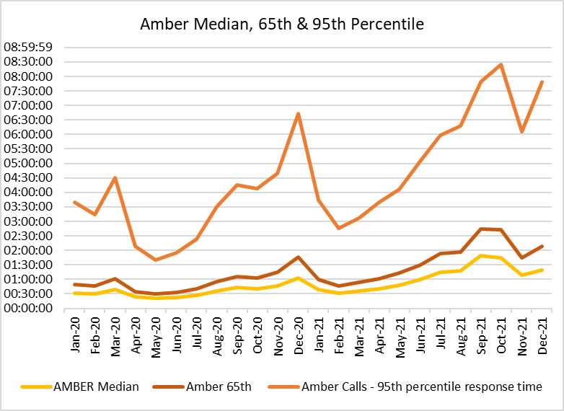
2.9 These very long Amber median times mean that the patient waiting times in the “Amber tail” are a particular concern from a patient safety perspective (it is where the bulk of serious adverse incidents occur). As part of its quality, safety and patient experience arrangements, WAST continues to monitor the longest patient responses. The table below shows the number of patients who had to wait 12 hours or over. The table shows that very long waits were almost eliminated during the first wave, but subsequently returned as system pressures increased. There were 625 long waits in Dec-21, the second highest reported.

2.10 These long response times impact on patient safety and outcomes. WAST has been supplying weekly information on quality, safety and patient experience to the CASC and monthly information through the CASC Assurance & Delivery meeting. This information includes more detailed analysis, patient stories (positive and negative) and patient feedback from surveys.

2.11 WAST supplies health boards with a monthly report on one hour and over patient waits.

2.12 In extreme cases, long response times can lead to National Reportable Incidents (NRIs). In the last 3 months, 79 patient safety incidents have been passed to health boards as part of the joint investigation framework (Appendix B).
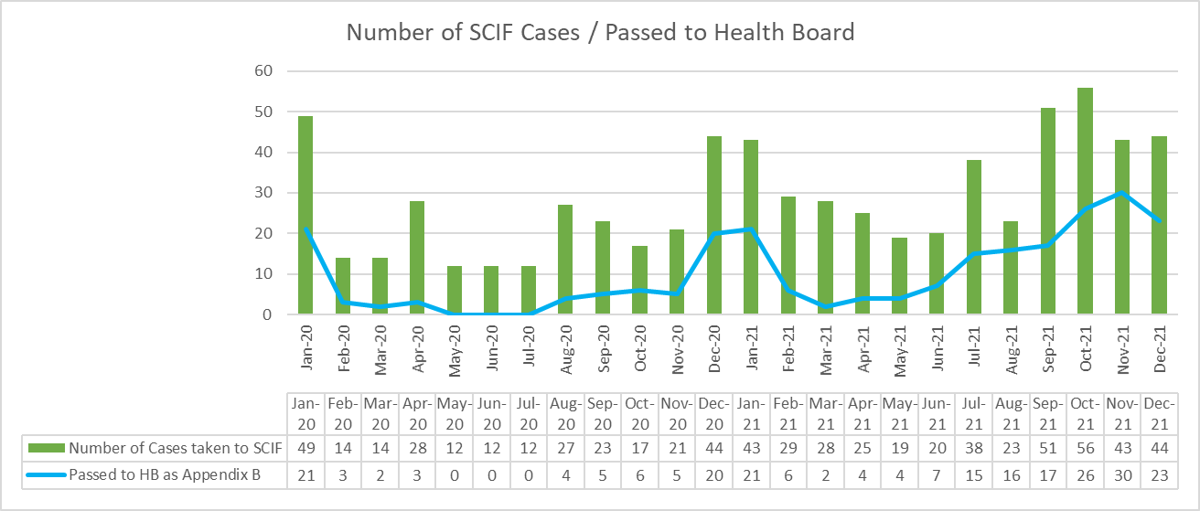

2.13 Whilst there are many factors affecting response times, which are described later in this report, one of the factors outside WAST’s control is the number of ambulances which wait longer than 15 minutes to transfer patients into secondary care at Emergency Departments (EDs). The graph below shows the number of ambulance hours that are lost outside EDs which, if released earlier, would have reduced patient waits in the community. As with the other graphs, during the first wave of the pandemic, the number of lost hours decreased very significantly, but they are now higher than those seen in the worst of winter.
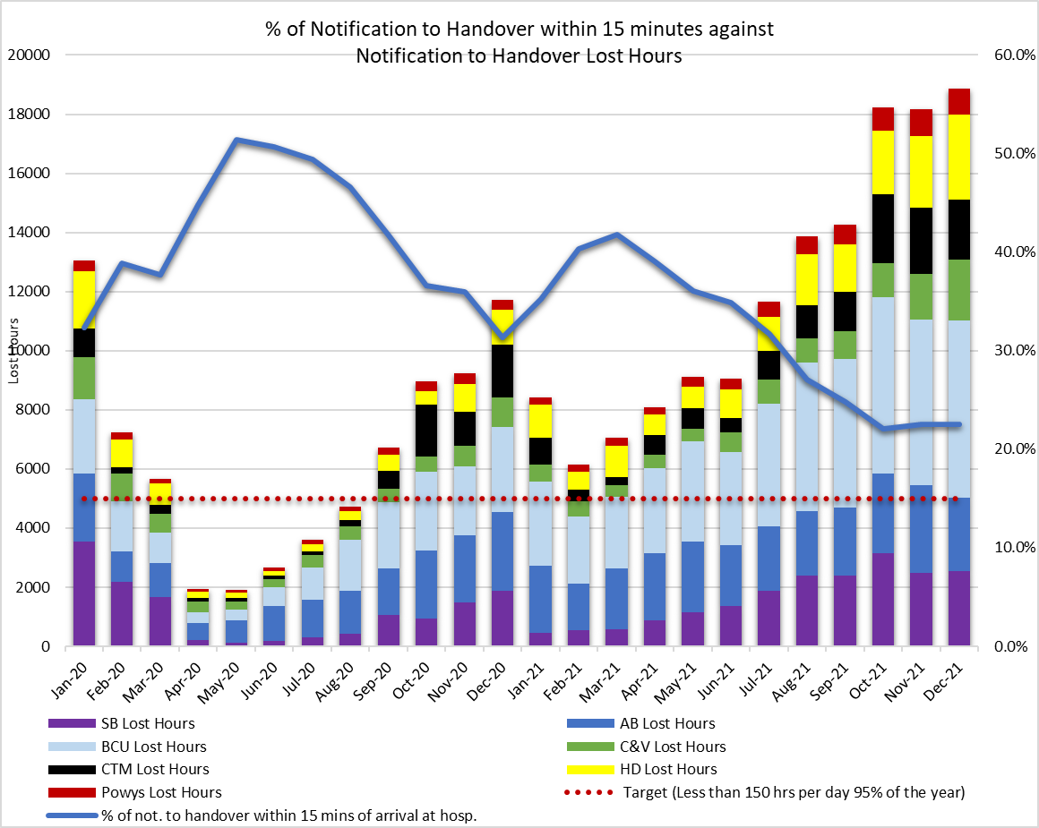

2.14 18,860 hours were lost to handover in Dec-21 (or 22% of WAST’s actual conveying resource), compared to 11,708 in Dec-20 and 13,820 in Dec-19. The 2021/22 EASC EMS commissioning intentions include: “NHS Wales is a significant outlier in the UK and Internationally for lost productivity due to extended notification to handover times. By the end of 2021/22 NHS Wales will have reduced 1 hour waits to less than 5% of total arrivals and ensured that total lost hours at Welsh Hospitals do not exceed 150 hours per day on 95% of the year”. The draft 2022/23 intentions include the development of improvement trajectories per site; however, there is a general system recognition that there is unlikely to be a significant reduction in handover lost hours in the short term; consequently, WAST is currently undertaking further EMS Demand & Capacity modelling on a radical “shift left”, which would be the next phase in the strategic response by WAST beyond the Transition Plan (see 2.43).

2.15 In the last three months WAST has reported 20 NRIs to the Delivery Unit and continues to have regular dialogue with EASC through the NCCU.

2.16 The WAST CEO has previously written (27 Jul-21) to the Director General detailing the clinical risk that WAST is carrying and the patient harm that is occurring in communities across Wales. As part of its preparations for winter, WAST has reviewed and updated its Demand Management Plan, now Clinical Safety Plan (CSP). A health board escalation policy is currently in development nationally that connects with the WAST CSP and that there is a clear system wide approach to shared risk and patient safety. WAST has supported this work by providing health boards with access to its modelling software.

Health & Safety

2.17 There have been 1,173 reported staff positive CoVID-19 since the start of the pandemic (Mar-20 to Dec-21). 158 positive cases were reported in December-21. All cases continue to be investigated and reviewed and, where applicable, reported to the Health and Safety Executive (HSE) in line with the Reporting of Injuries, Diseases and Dangerous Occurrences Regulations (RIDDOR) 2013. 38 RIDDORS have been submitted to the HSE for potential exposure to CoVID-19 to date. The HSE have informed WAST that we only need to report incidents where there is a high degree of certainty that the infection was acquired as part of the work undertaken by WAST staff.

2.18 The internal investigation into the serious road traffic collision in Apr-21 at Dolgellau is coming to its conclusion with the investigation report to finalised in January 22/23.

2.19 The “Pump Prime” phase of the Working Safely Programme continues with a full complement of staff in post in January 22. The Working Safely Programme Plan has been agreed by the Working Safely Programme Board and the Executive Team.

Clinical Outcomes

2.20 This report includes an update for the clinical indicator measures July-21 to Sept-21. It has been agreed that for Q3, given the transition from Digital Pen to ePCR clinical records that October and November data will be published. This will enable the Clinical Audit and Effectiveness Department to assure the quality of the data in the new system. The data for October and November is being processed and is due for publication in later January 2022.

2.21 Currently, WAST reports on seven clinical indicators. Five of these are care bundles for specific conditions; a care bundle requires each and every specific criterion of care to be met. Six of the clinical indicators have a commissioning intention of 95%, the exception being the return of spontaneous circulation (ROSC) indicator.

2.22 Of the six, three achieved the 95% in the period July-21 to Sept-21 (quarter two), two others were above 85%. The ST segment elevation myocardial infarction (STEMI) indicator was previously an area of concern with a temporary low of 62.3% in Feb-21, this has now improved. The Clinical Audit and Effectiveness Department (CA&ED) undertook a deep dive of the STEMI compliance, and an improvement plan was agreed and is being progressed. These percentages refer to the application of a whole bundle of care. For each of the individual STEMI care bundle elements, apart from Sept -21 the percentage compliance was consistently above 85%.

2.23 The percentage of patients with attempted resuscitation following cardiac arrest, documented as having a ROSC at hospital door was 6.8% in Mar-21. For quarter two, the rates were July -16.2%, Aug - 8.1%, Sept - 12.4%. Rates of ROSC are complex and determined by a number of factors which contribute to the speed of response and the application of early defibrillation and chest compressions. These factors can include location of the incident, resource availability, public access defibrillation, willingness of bystanders to engage in resuscitation. As part of its plans, WAST has developed the concept of Cymru High Acuity Response Units (CHARU) (see section: Forecasting & Modelling: Strategic Demand & Capacity Reviews). This concept is in place in several areas across the UK and has been very successful in increasing ROSC rates. These units supplement the response to critical incidents and are crewed by a mix of Senior Paramedics and selected paramedics, maximising the provision of enhanced clinical care and ensure the consistent delivery of core critical care requirements across the whole of Wales. The CA&ED are conducting a review of the ROSC rates to determine where future improvements can be made. This will report through the Clinical Intelligence Assurance Group (CIAG) to the Clinical Quality Governance Group.

2.24 A new chronic obstructive pulmonary disease (COPD) clinical indicator has been developed to support the Band 6 Paramedic project. The onward referral aspect of this indicator is work in progress and forms part of the national COPD pathway development. The CA&ED have undertaken a benchmarking exercise to test the COPD Clinical Indicator which has been presented to the Clinical Intelligence Assurance Group. The testing highlighted the requirement for significant manual scrutiny of all COPD Patient Clinical Records and the need to refine the criteria to automatically capture more of the data. Feedback from the Group will finalise the required criteria, Health Informatics can then develop the reporting dashboard.

2.25 Discussions have commenced with EASC for the transition from Digipen to ePCR data when reporting AQIs. Seven areas for future clinical indicators have been suggested and will be processed through the appropriate governance route before a more detailed plan can be developed.

2.26 The longer term ambition for WAST is to link its patient and CAD data with health board patient data so that WAST can report on agreed time-based aspects of clinical indicators and track the eventual patient outcome once conveyed into a hospital. The ePCR project will be critical to delivering this ambition. The ePCR is live in North Wales with the roll-out for the rest of WAST continuing through January and February 2022 according to the agreed plan.

EASC is asked to NOTE that: the Red 65% target was not achieved in Dec-21 (and has not been since Jul-20); Amber waiting times remain very long; these delayed responses are impacting on patient safety; in the last three months 79 patient safety incidents were reported to health boards (under the Appendix B arrangements) and 20 NRIs were reported to Welsh Government by WAST; and of the six clinical indicators with a 95% compliance target, for the period Sep-Dec-21 two achieved the target, one was above 90%, two were above 80% and one was above 75%.

2.27 WAST is EASC commissioned for two patient flows (journeys) within the unscheduled and scheduled care systems: the 999 Emergency Medical Services (EMS) and the Non-Emergency Patient Transport Service (NEPTS). These patient flows and their safety are now looked at in turn.

EMS Performance

Response Times

2.28 As outlined earlier in the report, response times for both Red and Amber incidents remain too long.

2.29 There are a range of factors that affect response times:

- Demand: comparing demand is difficult because of the pandemic, but WAST has previously identified that Red demand has increased significantly over the last few years as a result of a change in the application of the Medical Prioritisation Dispatch System (MPDS) for breathing difficulty calls (an improved approach to patient safety). This is a major contributing factor in relation to Red performance. In collaboration with the NCCU WAST reopened the EMS Demand & Capacity Review to update the strategic modelling with this change (see 2.13). Whilst there is a long term trend of increasing Red demand it was lower in Nov-21 and Dec-21 compared to Oct-21.

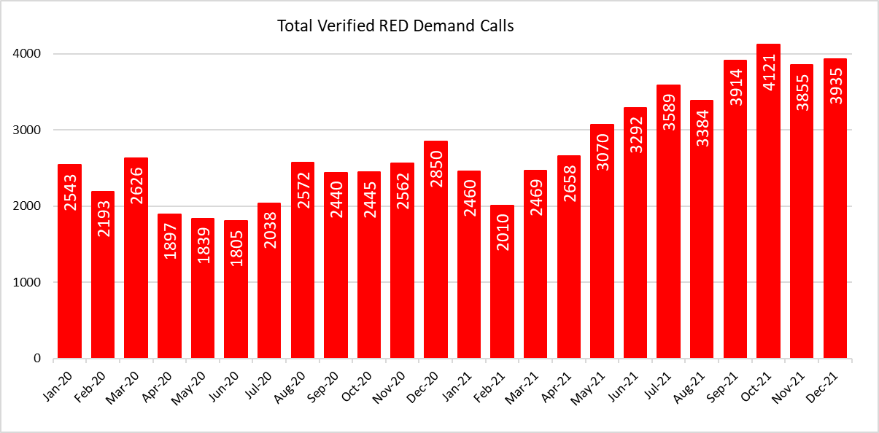

- Overall demand has also seen a long term increasing trend, and like Red demand, one that has been increasing faster than that forecast in the 2019 EMS Demand & Capacity Review, however, overall demand has declined in the last two months and was 11% lower in Dec-21 compared to Dec-19. This reduction in demand correlates with similar reductions in previous CoVID-19 waves.

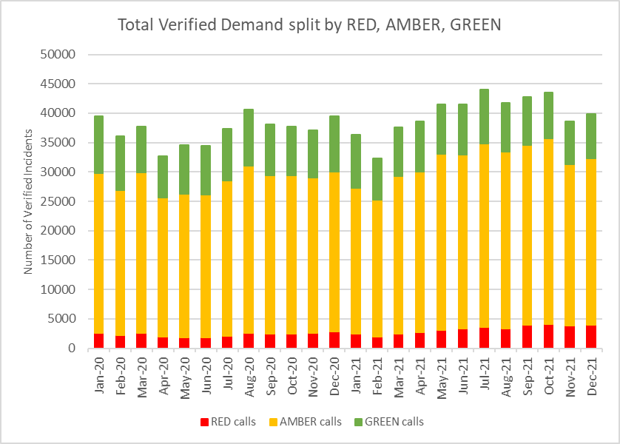

- The number of Response hours produced: total actual ambulance hours (all resource types) dropped to 102,647 in Sep-21, but with the start of PIP and support for the fire & rescue services, the military and St John, WAST delivered 119,509 hours and 116,484 hours in Nov-21 and Dec-21 respectively with emergency ambulance (EA) unit hours production at 96% in Dec-21, unscheduled care service (UCS) production at 110% and Rapid Response Vehicles (RRVs) at 74%; RRV production is lower due to a tactical focus on conveying resource. Whilst conveying resource production is holding up with the support from external partners the situation in quarter 1 2022/23 is now a major concern, as this support will largely stop. Also, whilst the good UHP performance is clearly welcome, the scale of the lost hours to handover is so great, WAST simply cannot offset these types of losses within existing resources.

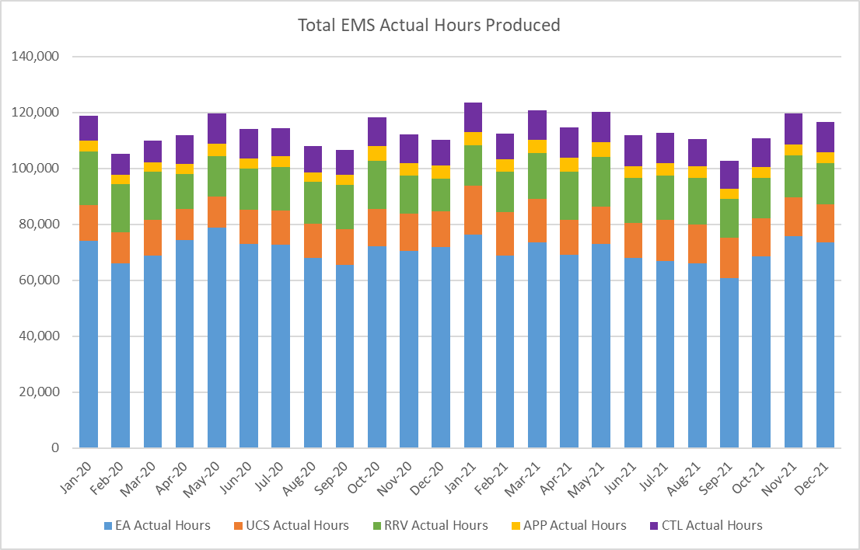

- Roster abstractions, in particular, sickness absence: the Operations Response sickness absence rate in Dec-21 was 15.11%. There is significant variation within this overall percentage. The biggest cause of sickness (in Nov-21) is anxiety/stress/depression/other psychiatric illnesses, accounting for 22%, followed by chest and respiratory problems, accounting for 18%. WAST is concerned about the burnout and mental fatigue in its workforce. WAST has extensive and comparatively good arrangements for managing absence and well-being including access to psychological support and a long CoVID-19 programme. For Dec-21 total abstractions off Response rosters were 45.4% (benchmark 30%) and 37.15% for its clinical contact centres (CCC), which is impacting on call performance. Prior to CoVID-19 WAST had started to achieve the 30% benchmark for Response abstractions. Given the on-going impact of CoVID-19 WAST wants to revisit this benchmark. WAST, via its Omicron Tactical Action Plan, has also put in place a range of infection, prevention and control actions to protect its workforce and reduce the spread of the variant.
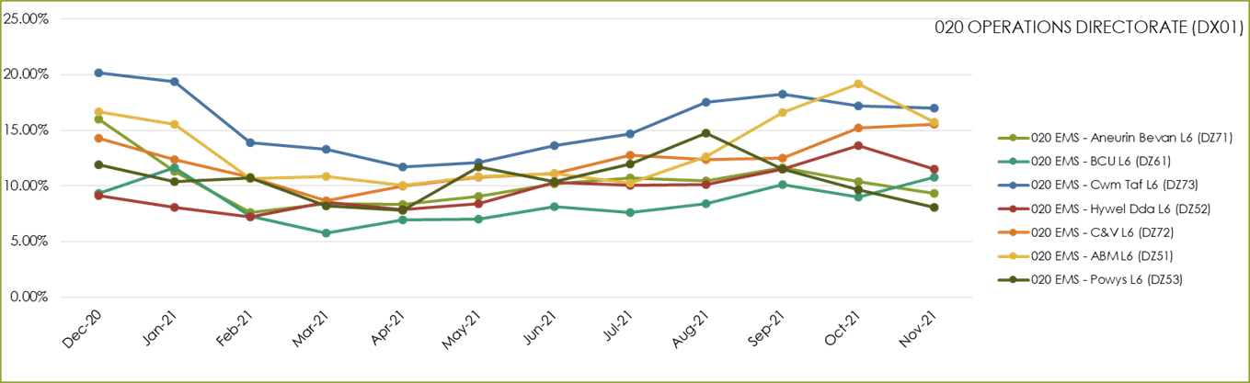

- The number of hours lost each month due to hospital handover delays. See paragraph 2.13 above.

- Multiple variables: in dialogue with the CASC WAST has identified up to 23 “suspected” variables that impact on performance, with four: demand, utilisation, handover and time as scene considered key. This analysis has led to the innovative development of a pilot measure of ambulance unit hours utilisation (UHU), which the CASC has started to share more widely with stakeholders since Sep-21 and is reported internally within WAST.

- Post production lost hours (PPLHs): 13,099 hours were lost post production in Dec-21. PPLHs include a range of reasons e.g. vehicle defect, trauma stand down, police interview, etc. which cannot be viewed as areas for potential efficiencies. The EMS Demand & Capacity Review identified that WAST benchmarked comparatively well on PPLHs with the exception of return to base meal breaks (in the Dec-21 figures they account for 51% of PPLHs). Cmmittee members will note the dark blue data in the graph which forms a significant proportion of the total, which relates to lost hours due to increased HALO duties, which are required and utilized at times of high pressure within EDs. WAST has undertaken some recent benchmarking with three other ambulance services, two of which WAST benchmarks favourably with whilst the third is significantly better. WAST is looking to make contact with this third ambulance service. WAST re-started (08 Sep-21) negotiations with TU partners on a collaborative solution for return to base meal breaks (and other workforce practices); this is expected to take 3 – 4 months. If this proves unsuccessful further consideration will need to be given as to next steps, as it is acknowledged that this is an area where improvement is required. WAST has piloted a voluntary approach to improving meal breaks, but this has not proved particularly successful.

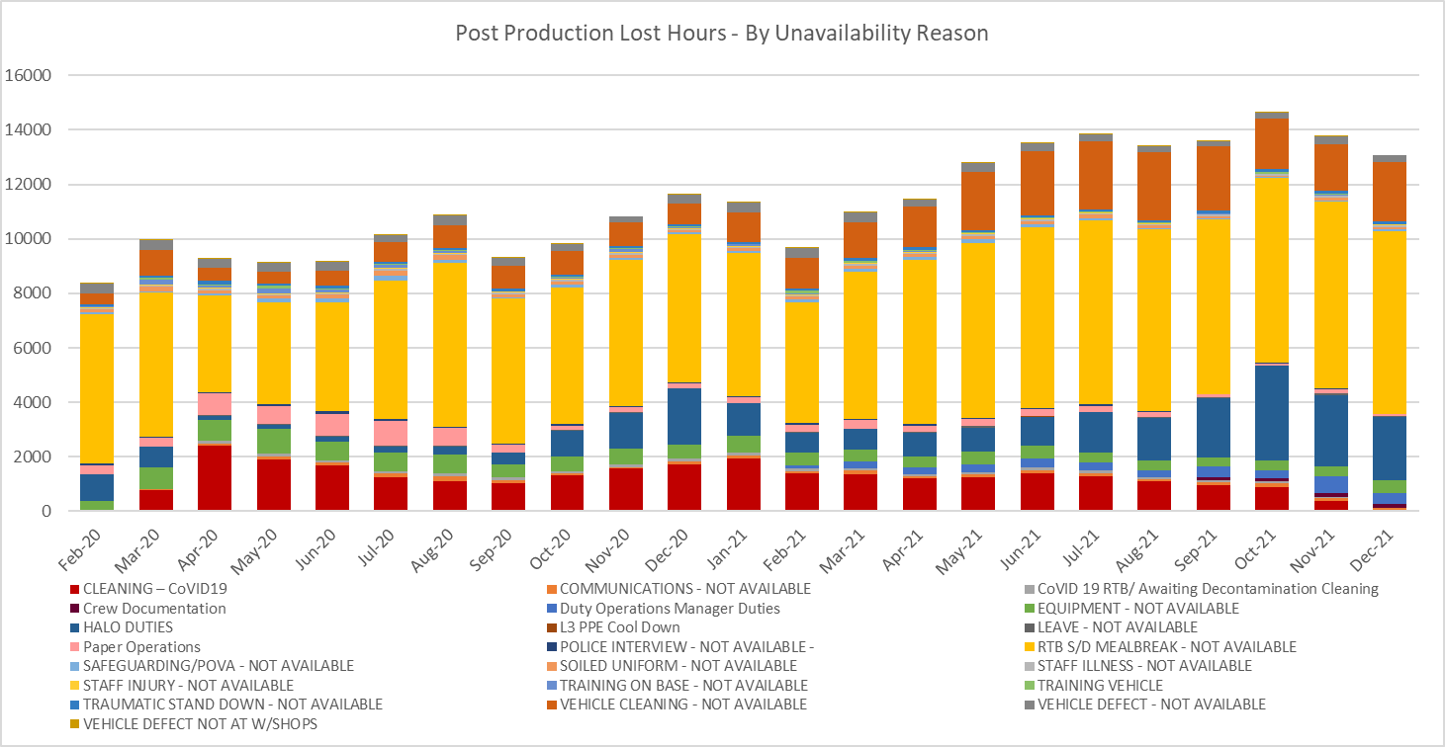

2.30 WAST is also engaged in a number of programmes across the unscheduled care system which are designed to shift demand left including: the core 111 service was launched in BCUHB on the 22 Jun-21. The roll out of the core 111 service in C&VUHB is currently planned to be completed by the end of March 2022. Work is ongoing with Health Boards to continue the launch of the 111 First model through Q4 21/22 and Q1 22/23. WAST has received support from EASC to expand the Clinical Support Desk (CSD) which will see an increase in mental health professionals and 36 FTE Paramedics. These increases will support hear & treat, but also patient safety netting and other related activities. The CASC has requested an evaluation of the impact of these additional CSD FTEs. Their recruitment is on-target. The CSD and NHSDW (Hear & Treat) achieved a combined rate of 11.0% in Dec-21. The EMS Demand & Capacity Review identified a benchmark of 10.2% (modelled to be achieved by Dec-21).
2.31 ​If mitigating actions agreed / funded are not sufficient to manage patient demand WAST (which currently they are not) WAST will enact its CSP previously known as the Demand Management Plan. The CSP aligns with the Association of Ambulance Chief Executives (AACE) approved UK Clinical Safety Plan Framework requiring members to realign their existing plans to provide national consistency in the definition and reporting levels. WAST has seen increased use of the higher levels of the CSP (level 4) which means “can’t send” to Amber 2 and Green incidents; for the 30 days to 02 Jan-22 WAST was at level 4 for periods of time in 19 of the 30 days. WAST has also moved to Level 2 moderate triage for Protocol 36 (CoVID-19).
EASC is asked to NOTE that: WAST continues not to achieve the Red 8 minute 65% target; that is likely to continue through the winter period; that there are a range of factors coalescing to affect Red (and Amber) performance – very high demand (for Red), high abstractions and high system pressure (all linked to CoVID-19); WAST has boosted ambulance production through support from external partners, but whilst it can almost offset the abstraction losses it cannot offset the levels of handover; WAST is drilling into the PPLH data to more accurately quantify the potential efficiency around return to base meal breaks and is re-engaging with trade union partners on negotiations to introduce new working practices that reduce PPLHs; WAST is further expanding CSD capacity to shift demand left; and that the CSP provides the backstop for managing patient demand should actions/funding prove insufficient which they are not at this time with the result that there are more occasions when the Trust is operating at level 4 in the CSP (the highest level).

NEPTS

2.32 The NEPTS ambulance quality indicators have now resumed reporting. Key points about NEPTS are as follows:-
- CoVID-19 saw a significant drop-in patient transport activity at the start of the pandemic. Levels have increased, and are at or in excess of pre-pandemic levels for all journey types apart from outpatient journeys; however, the overall level of activity has still not recovered to pre-CoVID-19 levels due to the reduction in outpatient activity;

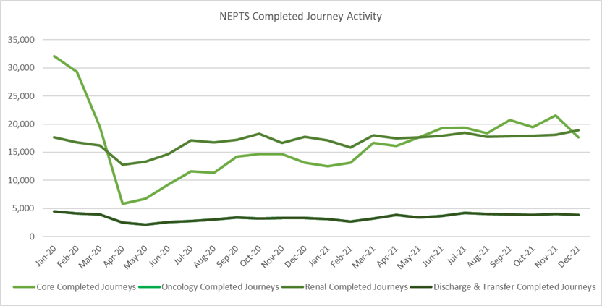

- CoVID-19 abstractions and social distancing has been challenging, but NEPTS has seen a continued improvement in key areas of service delivery particularly discharge and transfer journeys;
- Enhanced services performance has improved with some tailing off in recent months;
- Social distancing means that the number of patients than can be transported per journey has reduced, which has a significant impact on NEPTS capacity;
- In the first wave there was a significant reduction in outpatient transport activity, which meant that the impact of CoVID-19 on NEPTS capacity could be offset by the reduced demand; however, core demand is now on a clear upward trend;
- NEPTS capacity is also adversely affected by other CoVID-19 factors: journeys taking longer due to PPE, staff sickness and need to provide alternative duties to high-risk staff, staff training and testing, infection prevention and control arrangements and so on; and
- NEPTS continues to liaise closely with the commissioning process and the final transfer of works (CTMUHB) has recently been completed.

2.33 79% of core journeys arrived within 30 minutes (+/-) of their appointment time in Dec-21; 76% of enhanced renal journeys arrived within 30 minutes prior to their appointment time; and 53% of enhanced oncology journeys arrived within 30 minutes prior to their appointment time. Oncology has been identified as an area of focus from the NEPTS Demand & Capacity Review and will require changes in the way WAST works with the voluntary and community sector (VCS) to improve performance.

2.34 There is a Welsh Government ambition to see outreach appointments reduce by 50% “in time” (Health & Social Care in Wales – CoVID-19: Looking Forward); however, the short term scenario is that as the health care system emerges out of the pandemic response in 2022/23 this may see pent up demand for NEPTS as the system is switched back on and tries to catch up on certain services. This is a significant risk to the system as social distancing/PPE has reduced Ambulance Care capacity. WAST modelled this scenario and reported the results and impacts to the CASC. WAST subsequently received in year investment to boost NEPTS capacity, in particular, the recruitment of drivers and procurement of external providers. This additional capacity is in place and applies until 31 Mar-22. Further consideration is being given by the NCCU and WAST as to what happens post the 31 Mar-22.

2.35 Finally, the NEPTS Demand & Capacity Review is complete and WAST has now established an Ambulance Care Transformation Programme Board, which includes recommendations from the Review and other key transformation work. Both health boards and the NCCU are represented on the Board. The programme is a significant body of work including pan-Wales roster reviews (ambulance transport and NET call centre), options for improving oncology performance times, testing approaches for efficiency improvements linked to outpatient outbound ready times, CAD updated/replacement and so on. WAST is making good progress on the programme; however, the original plan to re-roster NEPTS transport in 2022/23 is expected to change because of the complexity of re-rostering against a demand pattern that is unstable. WAST has discussed this with the NCCU and the current plan is to undertake further work on agreeing a set of roster keys, with implementation now expected early in 2023/24.

EASC is asked to NOTE that: NEPTS capacity is being boosted through investment to mitigate the risk of reduced capacity caused by CoVID-19 and to aid system flow; performance has been maintained, but with oncology being an on-going area of concern; further consideration needs to be given to what happens when the in-year investment stops on 31 Mar-22; the Ambulance Care Transformation Programme has been established and is making good progress; and the revised plan is now to undertake more detailed pre-work on NEPTS re-rostering in 2022/23 with the potential go live being in 2023/24.

Commissioning, Planning and Service Change

Forecasting & Modelling: Strategic Demand & Capacity Reviews

2.36 The EMS Operational Transformation Programme (arising from the EMS Demand & Capacity Review) is WAST’s main strategic response to patient safety and experience concerns for the EMS five step ambulance care pathway. In addition to the EMS Demand and Capacity Review recommendations three other IMTP actions – CHARUs, Rural Model Pilot (in Powys) and Leading Service Change Together (modernisation of working practices) have been brought under the umbrella of the programme.

2.37 EASC had delegated oversight of the delivery of the programme to EASC Management Group. Dec-21’s EASC Management Group was cancelled, but WAST supplied an update on the programme to the NCCU. WAST is making good progress on the recruitment and training aspect of this programme. The original 20-22 recruitment and training target i.e. closing the relief gap, was 1,691 FTEs. This target has been amended up in 21/22, to reflect the EASC supported decision to boost Clinical Support Desk (CSD) capacity (36 FTE Paramedics and 6 Mental Health Professionals). WAST’s year-end forecast is 1,725 FTEs versus the original total of 1,691 FTEs (to be confirmed). WAST is also boosting its 999 CCC call handling capacity; however, the current rate of attrition is working against delivering this uplift by Feb-22 as planned. Remedial action, in particular, increased support from Workforce & OD to aid the recruitment process has been put in place.

2.38 Other key aspects of the programme include re-rostering RRVs/EAs and UCAs pan-Wales. The rostering project was paused to consider further modelling information linked to changing Red demand, lost hours in the system and feedback from stakeholders, but has now restarted with the CHARUs (unfunded at this time) built into the roster keys. WAST is currently undertaking further modelling around rurality in collaboration with the Deputy Ambulance Services Commissioner (DASC) and continues to work with TU partners on workforce practices via the Leading Service Change Together approach.

2.39 In Aug-21 the CASC agreed to re-open the EMS Demand & Capacity Review to look at the period 2022-25. Initial modelling on the CHARU concept has been completed (and built into the re-rostering project) with a Transition Plan business case developed for 2022/23, designed to put CHARU, APP and EA capacity into the system, to help offset the impact of handover lost hours. The Transition Plan also represents the next steps towards a more radical and transformed service model for Wales to be implemented over the coming 2-3 years. WAST is expecting the modelling for this to be available in late Jan-22 with the DASC included in this process.

Commissioning Intentions

2.40 The Dec-21 EASC Management Group did not meet, but the NCCU and WAST collaborated on a joint report on WAST’s progress on the 2021/22 intentions. WAST is considered to have made good progress.

2.41 WAST has also been in dialogue with the NCCU on the draft 2022/23 EMS and NEPTS commissioning intentions and is broadly supportive of these, in particular, a continued focus on being clinically led, shift left, workforce stabilisation and workforce availability.

Integrated Medium Term Plan (IMTP)

2.42 The WAST IMTP is delivered through a portfolio of transformation programmes supported by enabling programmes, projects and workstreams, which align to both WAST strategic ambitions and commissioning intentions. Despite the continued operational pressure and the need to pause some work on the IMTP there has been continued progress across our major programmes of work.

2.43 EMS Operational Transformation Programme:-

- Recruitment and training is on track to close the relief gap early in 2022/23;

- The roster review project has been re-commenced;

- Leading Service Change Together project has progressed on discussions with Trade Union partners about potential efficiencies across PPLHs, shift over-runs and overtime allocation;

2.44 Looking forward to 2022/23, a major element of the Trust’s IMTP will be the proposals set out in our Transition Plan, submitted to the CASC in late December. The Trust is committed to doing all that it can to reduce clinical risk, improve patient care and outcomes, and to playing an increasing role in a transformed urgent and emergency care system, ensuring that patients get the right service, in the right place, every time. This case proposes additional investment to increase front line capacity across the Emergency Medical Service (EMS), including advanced practice paramedics (APPs). This new investment, building on previous investment, together with the delivery of a series of changes and efficiency improvements commenced over the last 2 years, will provide a range of significant benefits:

- an increased capacity and resilience in our core service to meet the needs of the population of Wales in a safe and timely way, improving outcomes for patients and reducing clinical risk and harm;
- an improvement in the working lives of our frontline staff, alleviating the causes of stress and sickness and further improving our ability to provide the required capacity;
- a transition away from the traditional model of ambulance services, towards a transformed state in which patients are increasingly treated at or near home, avoiding unnecessary conveyance to an Emergency Department (ED), improving patient outcomes, and relieving pressure within the urgent and emergency care system;
- a realignment of resources, ensuring that their value is maximised in the most effective and efficient way to meet patient needs.

2.45 Ambulance Care:-

- Taking forward the NEPTS Demand and Capacity Review a PID has been developed for a Roster Review project and a case developed for additional 12 FTEs in planning and day control;

- Following the completion of health board transfers of work, the next stage of the Plurality Model project is to develop a Procurement Strategy, for which work has already commenced;

- There has been a six-month extension to the Commissioning Agreement for the Grange Hospital and NCCU is facilitating a senior group to review the future service development;

- The refreshed PNA (Patient Needs Assessment) launched on 01 December 2021 and an alternative options search tool has been added to the NEPTS website; and

- The operational improvement plan is making steady progress in its four key domains.

2.46 Strategic ambition programmes:-

- The transformation programmes for EMS and Ambulance Care are supported by two further core service transformation programmes: Gateway to Care focusing on 111 and the implementation of the CCC Clinical Review; and Clinical Transformation with a focus on the clinical transformation required to shift left in the five step model. The enabling programmes and workstreams are focusing on our people, estates, fleet and digital enhancements required to support IMTP delivery and commissioning intentions as well as the strong partnerships required to support system wide improvement across Wales;

- 36.72 FTE have been recruited to the CSD (target 36 FTEs);

- Both the ECNS and CSD Roster Review projects are on track;

- EPCR Programme remains on track to deliver across Wales;

- Consultant Paramedic agreed start date 17 Jan-22 which will have a key role in taking forward the clinical transformation agenda;

- WAST held a clinical Process Mapping Workshop in Dec-21 for initial thinking and shaping the "Inverting the Triangle" concept and shift left options, with the DCASC involved in the workshop. There has also been continued engagement with the WG and health boards in relation to Same Day Emergency Care proposal

- There have been ongoing discussions with Aneurin Bevan UHB to explore the option to expand the COPD pathway to breathlessness; and the development of a SOP and flowchart with SBUHB;

- Non-Injury Falls Pathway: Digital Solution agreed and updated via TerraPACE app, but will require testing in Q4 prior to implementation;

- Other enabling programmes: WAST continues to make good progress supporting staff and delivery of the IMTP. Estate SOP continues to support the different short term contingency plans and long term strategic ambitions. Delivery of the vehicle replacement scheme as per the approved business justification case is in progress. Following agreement on its environment strategy WAST is now developing its approach to ensure decarbonisation features across all of its plans for the future.

2.47 Value Based Healthcare

- WAST has been fully engaged with NCCU in development of Commissioning for Value and internally will align the development of its own value based approach to demonstrate value for investment, whilst widening the remit to include quality improvement, staff and patient outcomes and experience and sustainability as measures of value. Whilst specific work on this has paused during the latest wave of COVID-19 and winter pressures, the approach has been embedded into the emerging EMS Transition Plan.

Health Board Changes

2.48 WAST continues to support Regional developments including vascular centralisation in South Wales due to go live in Mar-22 with readiness assessments taking place in Jan-22, Thrombectomy commissioning (North and South), as well as an emerging case to develop Thrombectomy in Cardiff, and working with Powys THB to understand the future clinical model and commissioning arrangements linked to the stroke reconfiguration plans across Hereford & Worcester. WAST is also working with health boards and the NCCU to develop these services and will seek to join up the model and methodology to inform the commissioning intention to develop an All Wales Transfer and Discharge model and commissioning framework.

2.49 Emerging priorities include the reconfiguration of acute medicine in SBUHB. WAST is engaged with SBUHB to understand the impact, scale and pace of change. WAST is also engaged on recovery plans for cataract surgery in South East Wales which could have an impact across Ambulance Care.

2.50 WAST continues to support the work for Thoracic Surgery Centre in SBUHB and awaiting further confirmation of the next steps from the health board dependent on WG approval of SOC to proceed to next stage. Concerns regarding a potential increase in NEPTS activity have been raised and NEPTS thoracic activity will reviewed across UHW Ward C5 Cardio Thoracic and Morriston Cyril Evans Ward.

2.51 WAST’s Integrated Strategic Planning Group has been re-established and will have oversight of health board operational and strategic service changes to comprehend and coordinate implications on WAST and for WAST to support these plans. A summary of the strategic health board service change initiatives that WAST is engaged with can be seen in the following map:

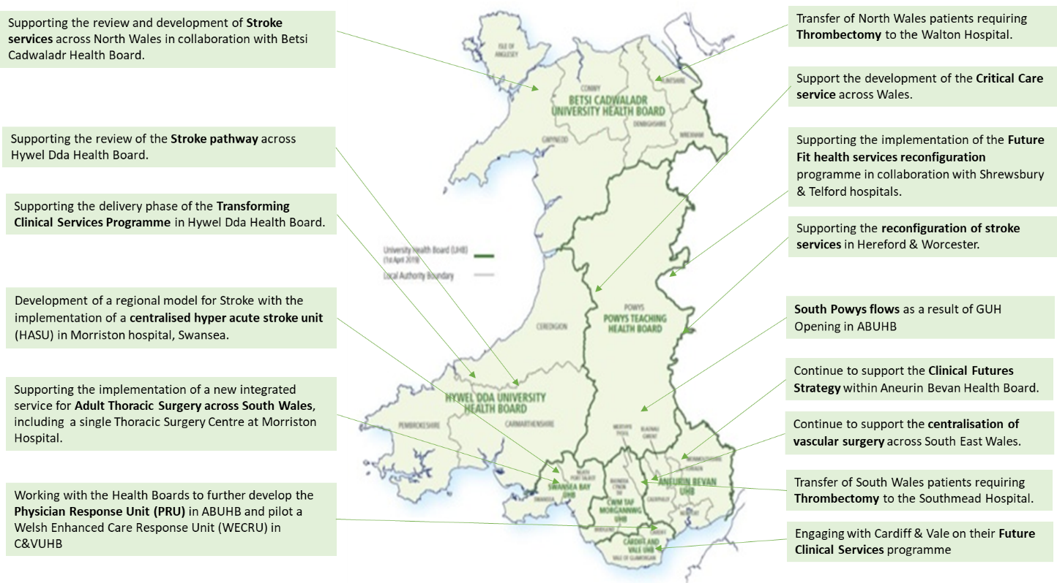

EASC is asked to note that: WAST is making good progress on its 21/22 commissioning intentions; the re-rostering project has recommenced; negotiations with TU partners on modernising working practices are continuing into Jan-22 to ensure proposed changes are tested and impact modelled; a transition plan for 2022/23 has been developed and presented to the CASC with further modelling to be undertaken to understand the impact of “Inverting the Triangle” in 2023-25; detailed discussions are continuing to finalise the 2022/23 commissioning intentions linked to the IMTP process; and WAST continues to make good progress on a range of transformation programmes and actions designed to improve patient safety for EMS and Ambulance Care and support the wider health care system, despite continued pressure requiring some IMTP actions to be paused.

Conclusions and Forward Look

2.52 Current performance levels and patient safety are very challenging.

2.53 WAST is focused at an organisational level on this challenge and is being supported through the commissioning process. WAST is at maximum escalation, is pro-actively managing patient demand (and safety) through enacting its CSP (demand management arrangements) and shift left actions, continues to employ its Pandemic Plan structures, is boosting capacity through a range of investments, has boosted capacity through the support of key partners (fire & rescue services, military and St John) and is boosting capacity through the delivery of efficiencies. All of this work is brought together into WAST’s PIP, which is formally reported on every two weeks to the CEO with the CASC reporting to the Minister each month.

2.53 Whilst WAST must have a focus on immediate operational pressures and its tactical response (Oct-21 to Mar-22), it is also critical that WAST continues look further ahead. The Transition Plan sets out proposals for next year which take the service forward, mitigating risks through increased capacity and transforming the service through expansion of Advanced Practice and other shift left activities, designed to enable patients to get the right service in the right place every time.

- KEY RISKS/MATTERS FOR ESCALATION TO THE COMMITTEE

Members of the EAS Committee are asked to note that:

3.1 CoVID-19 and the impact of CoVID-19 is having a severe impact on WAST, in particular, high roster abstractions, high handover lost hours and social distancing on NEPTS transport;
3.2 WAST is at maximum escalation and expects to remain so for the foreseeable future and continues to operate its Pandemic Plan structures;
3.3 Quality, safety and patient experience monitoring arrangements have continued (and been enhanced) through the pandemic. WAST remains very concerned at the patient safety risks associated with response times that are too long;
3.4 There were 625 12 hour and over patient waits in Dec-21 (the second highest recorded), 79 patient safety incidents were referred to health boards under the Appendix B arrangements) over the last three months and 20 WAST NRIs were reported to Welsh Government;
3.5 The Red 8 minute 65% target has not been hit since Jul-20 (almost 65% of Red incidents were responded to in 10 minutes in Dec-21);
3.6 With support from external partners WAST has been able to main EA and UCS capacity, but in Dec-21 WAST lost 18,860 to handover delays (or 22% of WAST’s actual conveying resource), a level that WAST cannot offset without radical measures to boost production and shift left;
3.7 WAST has produced a Transition Plan for 2022/23 to increase capacity, continue to make improvements in efficiency and to further increase numbers of APPs. It is expecting strategic modelling on hear & treat and see & treat to be completed in Jan-22 (shift left) i.e. the radical measures;
3.8 WAST continues to seek efficiencies, in particular, the pan-Wales EMS Response roster review and modernising working practices;
3.9 The ePCR programme has gone live and is now being rolled out pan-Wales;
3.10 NEPTS has received £2.0m investment to boost capacity to support system flow which it has deployed;
3.11 An Ambulance Care Transformation Programme Board has been established to take forward the findings of the NEPTS strategic Demand & Capacity Review and wider NEPTS and transfer and discharge projects;
3.12 WAST is making good progress on its IMTP ambitions (including the EASC 21/22 commissioning intentions);
3.13 There has been a six-month extension to the Commissioning Agreement for the Grange Hospital and NCCU is facilitating a senior group to review the future service development;
3.14 WAST continues to engage with health boards on a range of service re-configurations that affect ambulance provision; and
3.15 There is a tactical focus on Q1 2022/23 i.e. what happens when some of the current actions to boost both EMS and NEPTS capacity cease and system pressures whilst reduced from mid-winter, remain high.

- IMPACT ASSESSMENT

Quality/Safety/Patient Experience implications | Yes (Please see detail below)
Quality/Safety/Patient Experience implications | Identified within the report
Related Health and Care standard(s) | Timely Care
Related Health and Care standard(s) | And all health and care standards
Equality impact assessment completed | Not required
Legal implications / impact | There are no specific legal implications related to the activity outlined in this report.
Legal implications / impact | Included within the body of the report
Resource (Capital/Revenue £/Workforce) implications /  Impact | Yes (Include further detail below)
 | Included within the body of the report
Link to Main Strategic Objective | The Committee’s overarching role is to ensure its Commissioning Strategy for Emergency Ambulance Services utilising the five step patient pathway outlined within the National Collaborative Commissioning Quality and Delivery Agreement and the related outcomes for each care standard aligned with the Institute of Healthcare Improvement's (IHI) ‘Quadruple Aim’ are being progressed.  This report focuses on all the above objectives, but specifically on providing strong governance and assurance and safe and effective patient care
Link to Main WBFG Act Objective | Service delivery will be innovative, reflect the principles of prudent health care and promote better value for users

- RECOMMENDATION

5.1 The EASC Committee is asked to:
- DISCUSS and NOTE the WAST provider report.

