AGENDA ITEM
2.1

EMERGENCY AMBULANCE SERVICES COMMITTEE

PERFORMANCE REPORT

Date of meeting | 17/01/2023

FOI Status | Open/Public

If closed please indicate reason | Not Applicable - Public Report

Prepared by | Susan Evans, Business Intelligence Developer
Presented by | Ross Whitehead, Deputy Chief Ambulance Services Commissioner
Approving Executive Sponsor | Chief Ambulance Services Commissioner

Report purpose | Discussion and Review

Engagement (internal/external) undertaken to date (including receipt/consideration at Committee/group)
Committee/Group/Individuals | Date | Outcome

ACRONYMS
CASC  DAG  EMRTS  IQPD  NEPTS  WAST  WG | Chief Ambulance Services Commissioner  Delivery Assurance Group  Emergency Medical Retrieval and Transfer Service  Integrated Quality, Planning and Delivery Meeting  Non-Emergency Patient Transport Service  Welsh Ambulance Services NHS Trust  Welsh Government

- SITUATION/BACKGROUND

  - The purpose of the report is to provide an update on current emergency ambulance performance for EASC Members and to provide an overview of the range of actions and processes that have or are being implemented to support performance improvement.

  - This report presents information in line with the most recent publication of the Ambulance Service Indicators attached at Appendix 1.

  - In response to feedback from Members, additional management information will be available during the meeting. This information is un-validated and subject to change prior to publication, therefore use of this information outside of the meeting should be treated with caution.

- SPECIFIC MATTERS FOR CONSIDERATION BY THIS MEETING (ASSESSMENT)

  - This report will set out activity and performance across Calls, Incidents, Response and Output.

  - Chart 1 shows call volume versus the 95th percentile answer time. The 95th percentile answer time remains extended.

Chart 1 – 999 Calls vs 95th Percentile answer times

  - Not all calls received by the 999 Clinical Contact Centres (CCCs) will generate an incident. The Chart 2 shows the relationship between call volumes and incident generation.

  - There is an ongoing gap between the number of calls answered and the number of incidents generated, this is often seen at times of escalation related to individuals calling back due to a delayed response.

Chart 2 – Calls v Incident volumes

  - Members have recognised the importance of remote clinical support for patients and increasing the numbers of patients receiving an outcome of hear and treat.

  - The Chart 3 demonstrates the volume of incidents resolved by hear and treat. Investment in both staff and technology within the clinical support desk is starting to support improvements in this level as well as providing more granular data on the outcomes for patients.

  - This chart contains information for 999 calls resolved by the emergency ambulance services clinical support desk as well as incidents passed to 111 for resolution.

Chart 3- Hear and Treat Volumes.

  - Chart 4 demonstrates the categories of incidents receiving at least one ambulance response. Whilst there is a clear reduction in the number of incidents receiving a response overall, it should be noted that much of this reduction is driven by escalation actions.

  - Members should also note the increase in Red incident volume. By their nature, red incidents often require multiple responses at scene and so have a disproportionate effect on resource availability for other incidents.

Chart 4 – Categories of incidents receiving a response

  - Chart 5 demonstrates the total level of emergency medical services (EMS) hours produced.

  - Cymru High Acuity Resource Unit (CHARU) is a new type of resource that is replacing rapid response vehicles (RRVs), focused on improving clinical outcomes for the sickest patients.

Chart 5 – Total Emergency Medical Services (EMS) Actual Hours Produced

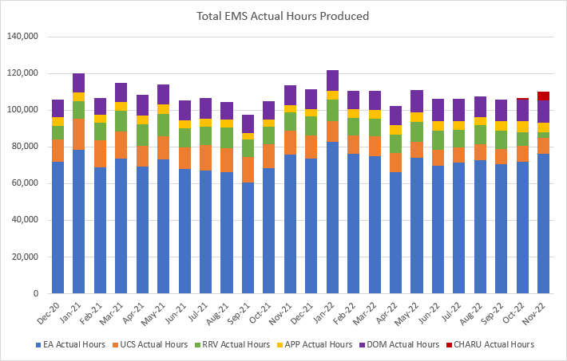

  - Chart 6 demonstrates the levels of post-production lost hours.

Chart 6 – Post-Production Lost Hours
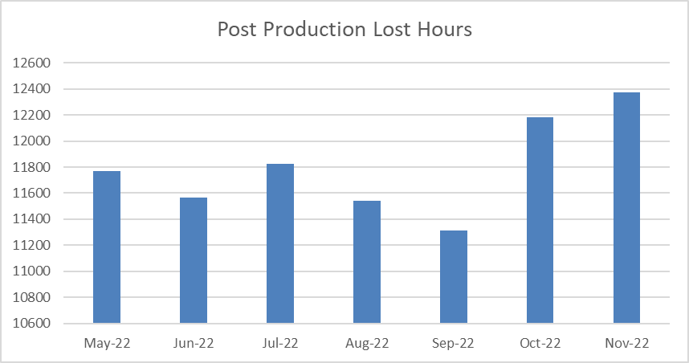

  - Chart 7 demonstrates Red performance alongside the range of response times that have been achieved. The lack of delivery of the target has been well documented, however members should note the increasing response times that underpin this.

Chart 7 – Red Response and Performance

  - Chart 8 shows the response times for Amber patients. Whilst there is no time target for Amber patients, it is accepted that these patients still require a timely response. The current response times for this category are significantly above the level that would be considered appropriate.

  - The key to delivery of appropriate response within Amber is the availability of ambulance resource. Work remains ongoing to develop a utilisation metric to support this.

Chart 8 – Amber responsiveness

  - Optimising conveyance is a key aim of the Six Goals for Urgent and Emergency Care Programme. Whilst Chart 9 shows an overall reduction in both conveyance volume and percentage, this impact must be considered in light of the information provided earlier in this report which showed the reduction in attendance in response to escalation decisions.

Chart 9 – Conveyance volumes

  - Chart 10 demonstrates the level of lost hours to handover outside emergency departments (ED) in Wales.

Chart 10 – Handover Lost Hours

- KEY RISKS/MATTERS FOR ESCALATION TO THE COMMITTEE

Handover Delays
  - As can be seen from Chart 10 above, handover delays at hospital sites in Wales continue to pose a real and significant challenge to the delivery of timely, safe and effective emergency ambulance provision for the population.

  - Members will be aware of the Ministerial Summit held on 28 November 2022 on Handover Delays that took place and a number of EASC members were in attendance. The aim of the Summit was to discuss ongoing concerns around the ambulance handover delays causing harm to patients. Each health board provided an update on their handover improvement plans and commitments.

  - The Minister closed the meeting by asking attendees to continue to work with the Chief Ambulance Services Commissioner (CASC) and the EASC team to update handover improvement plans and to make immediate improvements to reduce the risk to patients in the community.

EASC Action Plan

  - The actions within the EASC Action Plan (at Appendix 2) continue to be monitored via CASC Quality and Delivery meetings with WAST, as well as the fortnightly tripartite handover improvement plan / integrated commissioning action plan meetings and Welsh Government IQPD meetings.

- IMPACT ASSESSMENT

Quality/Safety/Patient Experience implications | Yes (Please see detail below)
Quality/Safety/Patient Experience implications | The impact of handover delays is affecting patient experience including quality and safety aspects and is leading to unsatisfactory service for the people of Wales (or within specific health board areas) with increased likelihood of harm, disability and death.
Related Health and Care standard(s) | ALL are relevant to this report
Equality impact assessment completed | Not required
Legal implications / impact | There are no specific legal implications related to the activity outlined in this report.
Resource (Capital/Revenue £/Workforce) implications /  Impact | There is no direct impact on resources as a result of the activity outlined in this report.
Link to Commissioning Intentions | The Committee’s overarching role is to ensure its Commissioning Strategy for Emergency Ambulance Services utilising the five step patient pathway outlined within the National Collaborative Commissioning Quality and Delivery Agreement and the related outcomes for each care standard aligned with the Institute of Healthcare Improvement's (IHI) ‘Quadruple Aim’ are being progressed.
Link to Main WBFG Act Objective | Commitment to corporate social responsibility and improving health & social equity, work with our staff, partners and communities to build strong local relationships and solid foundations of the past

- RECOMMENDATION

  - The Emergency Ambulance Services Committee is asked to:

- NOTE the content of the report.
- NOTE the Ambulance Services Indicators
- DISCUSS additional actions that could be taken to improve performance delivery of commissioned services
- NOTE the handover improvement Ministerial summit discussion and the specific requirements of organisations.
MANAGEMENT INFORMATION FOR DISCUSSION – THIS INFORMATION SHOULD NOT BE USED OUTSIDE OF THE MEETING AND IS SUBJECT TO CHANGE
