AGENDA ITEM
2.5.1

EMERGENCY AMBULANCE SERVICES COMMITTEE

welsh ambulance services nhs trust (WAST)
provider update (REV)

Date of meeting | 17 January 2023

FOI Status | Open/Public

If closed please indicate reason | Choose an item.

Prepared by | Rachel Marsh, Executive Director of Strategy, Planning and Performance (WAST)
Presented by | Jason Killens, Chief Executive WAST
Approving Executive Sponsor | Chief Executive

Report purpose | FOR DISCUSSION / REVIEW

Engagement (internal/external) undertaken to date (including receipt/consideration at Committee/group)
Committee/Group/Individuals | Date | Outcome
- | - | Choose an item.

ACRONYMS
CSP  CHARU  EMS  NEPTS  NRI  REAP  WAST | Clinical Safety Plan  Cymru High Acuity Response Unit  Emergency medical services  Non-emergency patient transport services  National Reportable Incident  Resource Escalation Action Plan  Welsh Ambulance Services NHS Trust
- SITUATION/BACKGROUND

  - The purpose of this report is to provide EASC with an update on key issues affecting quality and performance for Emergency Medical Services (EMS) and Ambulance Care (including Non-emergency Patient Transport Services NEPTS) and to provide an update on commissioning and planning for EMS and Ambulance Care (including NEPTS).

- SPECIFIC MATTERS FOR CONSIDERATION BY THIS MEETING (ASSESSMENT)

CoVID-19 and Current Operational Pressures

  - WAST continues to track CoVID-19 and related metrics through its weekly Forecasting & Modelling Intelligence Pack. Wales is currently experiencing positive tests equating to 4% of the population.

  - WAST is currently (09 January 2023) at escalation level 3 i.e. second highest, having been at Resource Escalation Action Plan (REAP) 4 over the festive period. WAST has updated the REAP in advance of winter including revised triggers (higher) for handover lost hours. WAST finds the REAP a very useful management tool and would recommend the approach to health boards. In addition, WAST continues to have to move to higher levels of its Clinical Safety Plan (CSP). For the 30 days to 30 November 2022, WAST spent seven days at CSP level 4a (the second highest level), resulting in resulting in clinical screening of Amber 1 calls and WAST being unable to respond to calls in the Amber 2 and Green categories. 11 days were spent at CSP level 3b, with Amber 2 calls being clinically screened and WAST being unable to respond to Green and health care professionals (HCP) calls. WAST revised its CSP for winter 2022/23 with the changes now live. Key changes include: an ability to undertake remote clinical screening, estimated time of arrivals (ETA) for HCPs and revised triggers and approval for escalation.

  - WAST has stood down its pandemic structures but has stood up a Senior Business Continuity Planning Team as well as specific command structures when required e.g. 21 December 2022 strike day. The Trust has been operating a Trust wide rolling tactical seasonal Performance Improvement Plan, however, this has now largely been delivered with 16 remaining actions that have been passed into other accountability mechanisms.

EASC is asked to NOTE that: WAST is currently at escalation level 3 (maximum 4), was at escalation level 4 over the festive season, has had a number of business critical/continuity incidents during December and has had to operate its Clinical Safety Plan up to level 4b (the highest level).

Quality, Safety & Patient Experience

Patient Response Times in the Community

2.4 One of the key indicators which measures the quality of the service provided is the timeliness of the response by WAST to patients waiting in the community. The graphs below show the current response time performance for Red calls and for Amber One calls. Both graphs show that response times remain significantly off target or off benchmark. Inevitably these times have had an impact on patient safety.

2.5

2.6 The Amber 1 median in December 2022 was three hour and 30 minutes and the Amber One 95th percentile was fourteen hours 29 minutes. Amber 1 incidents include chest pains, strokes, unconscious patients etc.

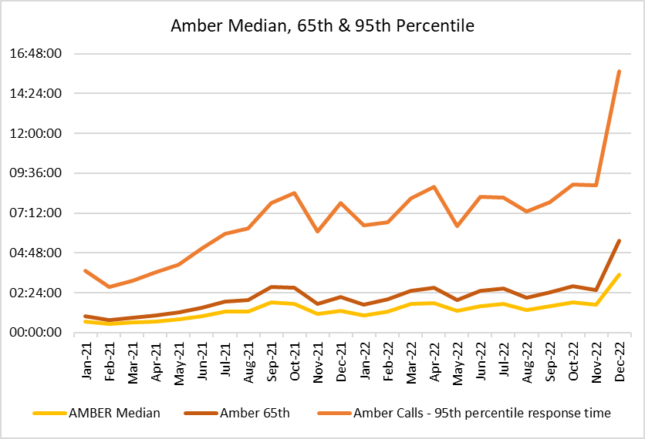

2.7 These very long response times in the “Amber tail” are a particular concern from a patient safety perspective; it is where the bulk of National Reportable Incidents (NRIs) occur.

2.8 As part of its quality, safety and patient experience arrangements, WAST continues to monitor the longest patient responses. The table below shows the number of patients who had to wait 12 hours or over. There were 797 long waits in Nov-22.
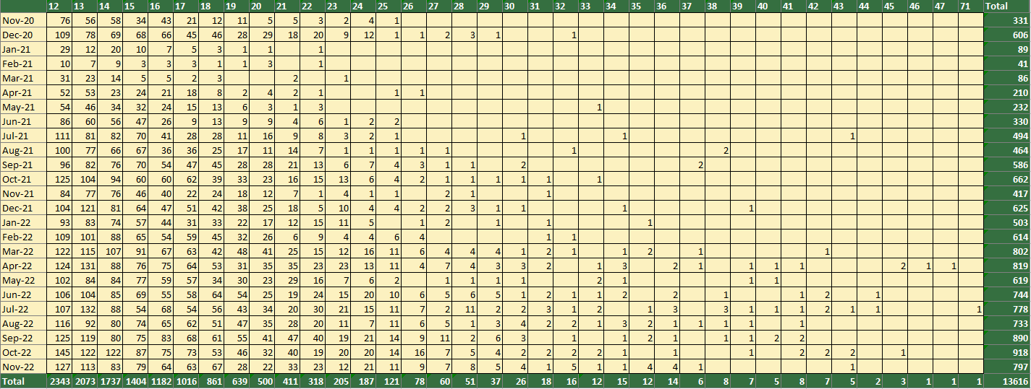

2.9 As well as looking at the data on response times, care is taken in internal and external fora to listen to how this impacts on patients through patient stories and feedback from surveys.

  - In the last 3 months, 40 patient safety incidents have been passed to health boards as part of the joint investigation framework (previously Appendix B). 10 NRIs were reported directly by WAST to the Delivery Unit in the period Oct-Dec-22.
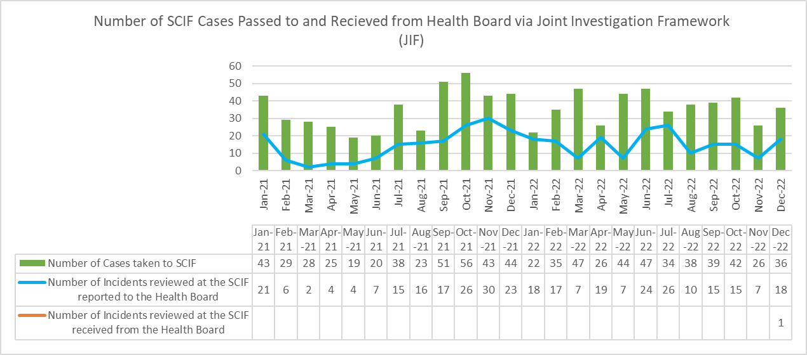

  - WAST has escalated and continues to articulate its concerns about patient outcomes and experience to commissioners and to Welsh Government, with the Trust Board now receiving a specific paper on patient harm at every meeting, detailing harm, predicted harm and what mitigations the Trust can take and wider system mitigations.

Health & Safety
  - Increased rates of incidents and concerns reported in relation to excessive diesel fumes outside A&E departments continued during Q3 2022/23. Atmospheric monitoring was previously undertaken during Q3-Q4 2021/22 and found to be within Workplace Exposure Limits and further surveys are to be undertaken during early Q4 2022/23.

  - Concerns have been formally raised with all Health Boards asking for continued support in the reduction of fume exposure. Workshops have been established pan-Wales and continue working in collaboration with Health Boards to seek pragmatic solutions which has resulted in the fitting of additional shorelines in some areas. Good practice advice to reduce fume exposure has been communicated across WAST to be adopted by staff during hospital delays.

Clinical Outcomes
  - The last publication of the full suite of clinical indicators was January 2022 (Oct-21 and Nov-21 data); there was then an agreed temporary cessation of clinical indicator reporting as WAST transitioned from the Digital Pen to the electronic Patient Clinical Record (ePCR). The transition was completed at the end of March 2022.

  - New ePCR data is now available for Stroke, Fractured Neck of Femur, Hypoglycaemia, ST elevation myocardial infarction (STEMI) and Return of Spontaneous Circulation at Hospital. Deep dive audits have been completed for these clinical indicators and are available online. Improvement work as a result of the deep dive audits is underway to improve compliance (lower compliance was an identified risk based on experiences of English ambulance trusts who have moved to ePCR systems). Improvements include supporting users and also updates to the user interface are planned for delivery in Q4.

  - 2022/23 Compliance to the published care bundles are as follows:

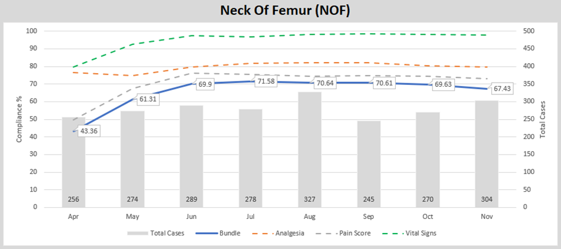
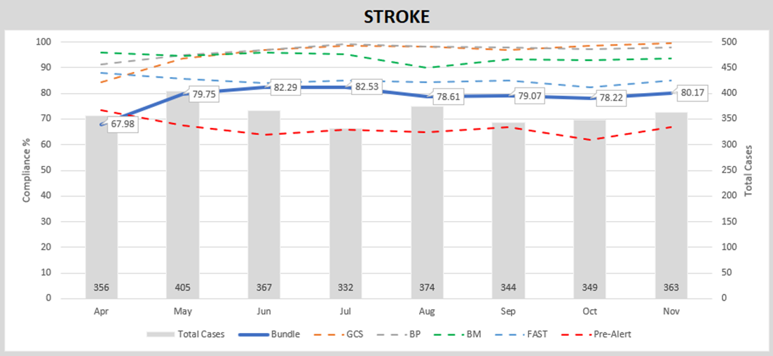
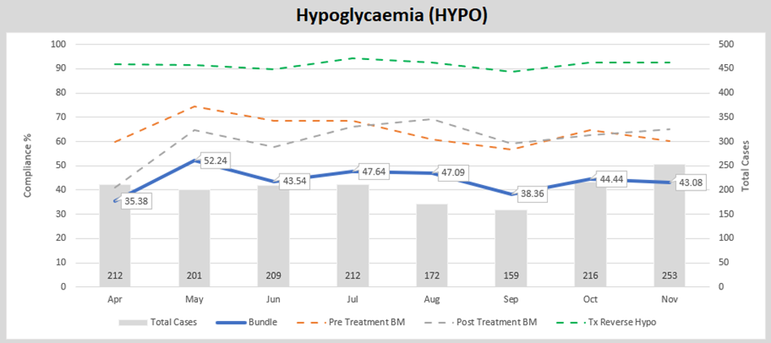
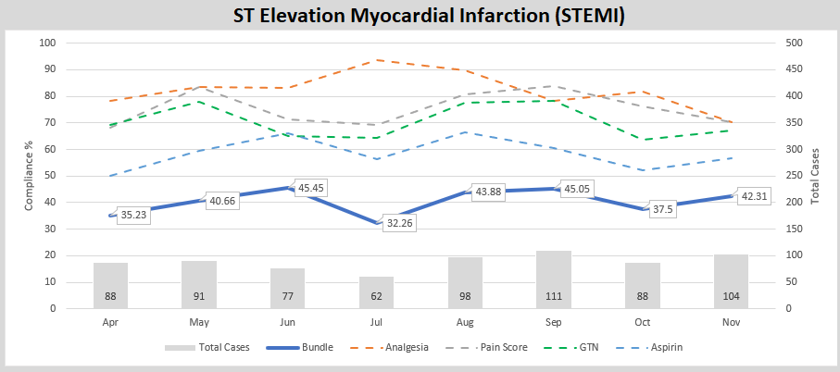
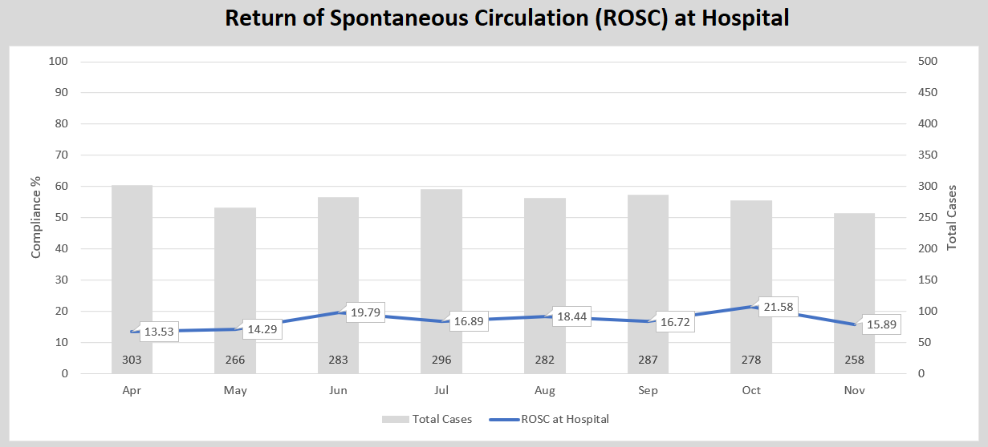
  - As a result of the predicted fall in clinical indicator compliance whilst the new system for creating clinical records becomes embedded, a risk has been raised with an associated action plan internally.

  - The longer-term ambition for WAST is to link its patient and computer aided dispatch (CAD) data with health board patient data so that WAST can report on agreed time-based aspects of clinical indicators and track the eventual patient outcome across their whole pathway. The ePCR project is critical to delivering this ambition.

EASC is asked to NOTE that: Red and Amber response times have worsened significantly in Dec-22 from an already poor position; these delayed responses are impacting on patient safety; in the last three months 40 patient safety incidents were reported to health boards (under the Joint Investigation Framework) where the primary cause is considered to be handover lost hours; clinical indicators have started to be published again after the move to the ePCR.
EMS Performance

Response Times
  - As outlined earlier in the report, response times for both Red and Amber incidents remain too long.

  - There are a range of factors that affect response times:

- Demand:
Red demand has increased from 6% (2019 Demand & Capacity Review) to 10% (2021 update) and 15% (now). Some of the reasons for this are known, for example, a change in the application of the Medical Prioritisation Dispatch System (MPDS) for breathing difficulties (May-19) and the alignment to the English Ambulance Response Programme code set (Oct-22). Comparing demand is difficult because of the pandemic. The spike in Dec-22 is mainly driven by breathing difficulties, however, WAST is undertaking a clinical review of the increase with the results due to be reported by mid Jan-23. It should be noted that WAST is not currently fully funded for the Cymru High Acuity Response Units (CHARUs) with a modelled requirement for 154 FTEs v 71 FTEs funded).

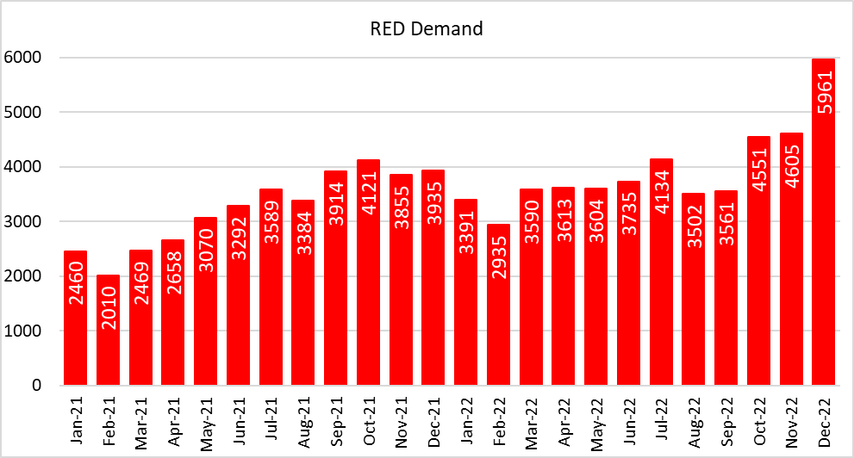

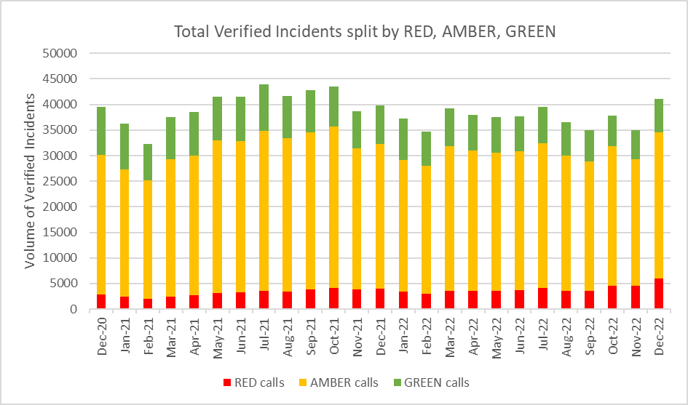

- Capacity produced:

The total actual ambulance hours produced was 112,225 hours in December 2022 with emergency ambulance (EA) unit hours production at 91% in Dec-22 (benchmark 95%), unscheduled care service (UCS) production at 69% and Cymru High Acuity Response Unit (CHARU) at 79% (this is 79% against the funded roster lines). It is important to note that the UHP is for funded roster lines and therefore includes the +100 FTEs coming on stream in Q4, which will boost UHP, particularly for the UCS.

Capacity produced is a product of the number of staff in post less the hours lost through abstractions. An additional £3m has been made available to WAST in 2022/23 to recruit an additional 100 frontline staff. Whilst this is welcome, there will remain an overall gap of 64 WTE against the number of staff required to fill WAST’s new Response rosters). WAST has plans in place to deliver on this additional 100 WTE by the end of February 2023, slightly later than the target date of 23 January 2023as a result of higher staff attrition.

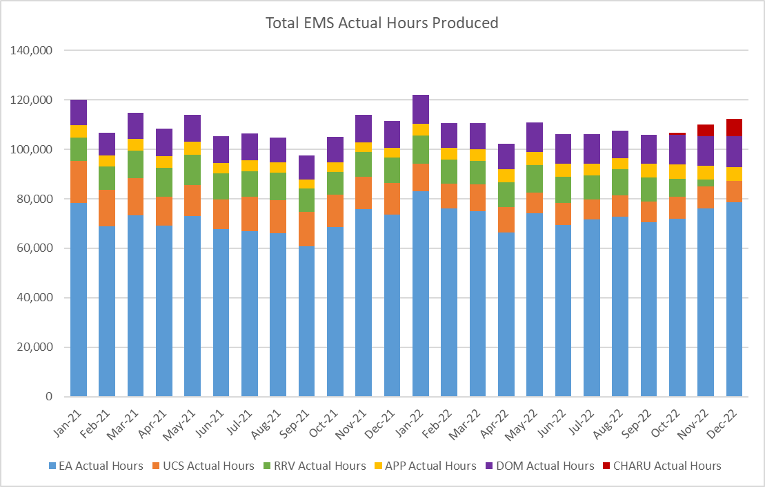
There was a 39.45% abstraction rate in Nov-22. This includes a sickness absence abstraction rate of 9.45%, a decrease compared to Oct-22; and a 7.31% training induction abstraction, which is higher than usual linked to the recruitment of the +100 FTEs, which should start to drop out of the abstraction numbers towards the year end. WAST has introduced a Managing Attendance Plan with seven work-streams and improvement trajectories. The Plan is being reported to Executive Management Team every two weeks. There was initially a clear reduction trend, which reversed in Jun-22 linked to CoVID-19, but has subsequently started reducing again. It remains difficult to manage absence effectively in the light of the remaining CoVID-19 allowances.
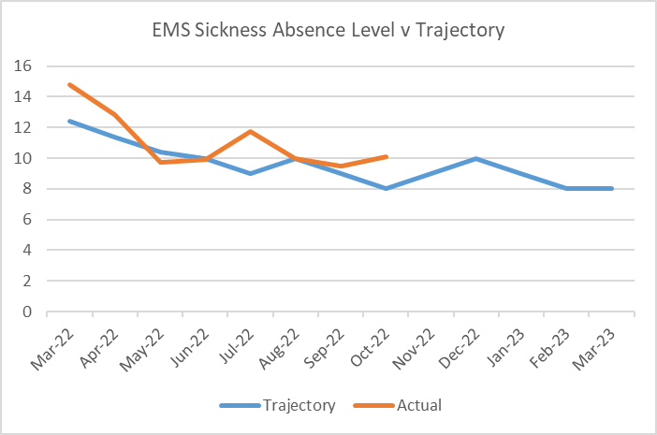

- Capacity Lost
One of the factors affecting response times outside WASTs control is the number of ambulances which wait longer than 15 minutes to transfer patients into secondary care at Emergency Departments (EDs). The graph below shows the number of ambulance hours that are lost outside EDs which, if released earlier, would have reduced patient waits in the community. 32,050 hours were lost to handover in December 2022, which equates to 37% of WASTs conveying capacity. There is a separate report from WAST on the EASC agenda regarding the implications of these levels of handover lost hours on WASTs ability to discharge its responsibilities under the Civil Contingencies Act.
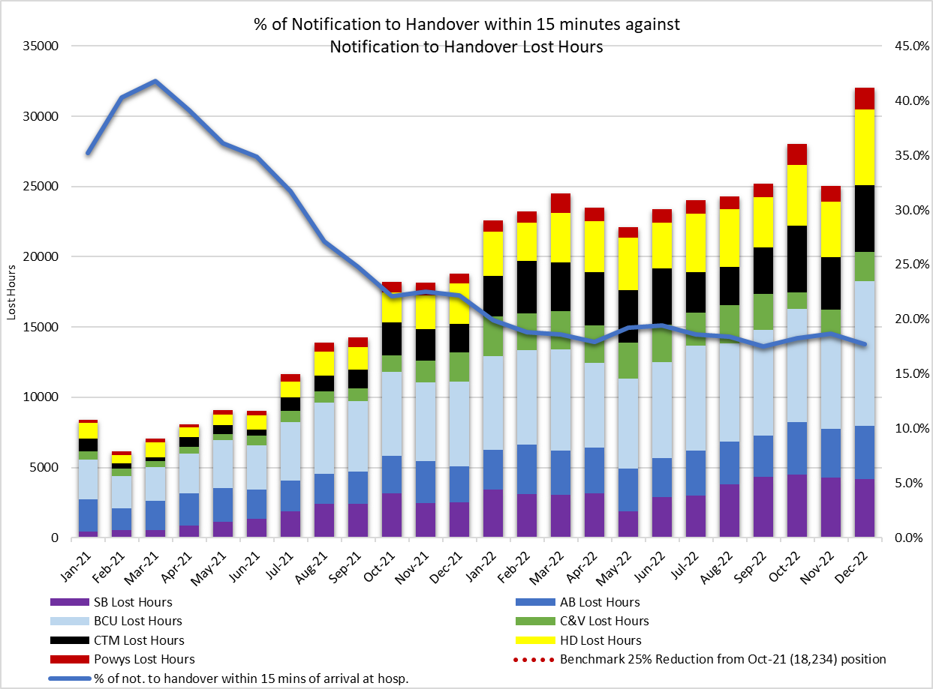
There is a Ministerial requirement of a 25% reduction in minutes per handover with a four hour back stop, with a related focus on immediate release, handover reduction plans for each ED sites and the implementation of same day emergency care (SDEC) units. Performance against these targets is monitored by the EASC Team and improvement plans are included in the EASC action plan. Whilst the increased focus is welcomed, as the data above shows, the plans are not yet delivering the reductions required.

The impact of handover is clearly demonstrated in the following graph:-

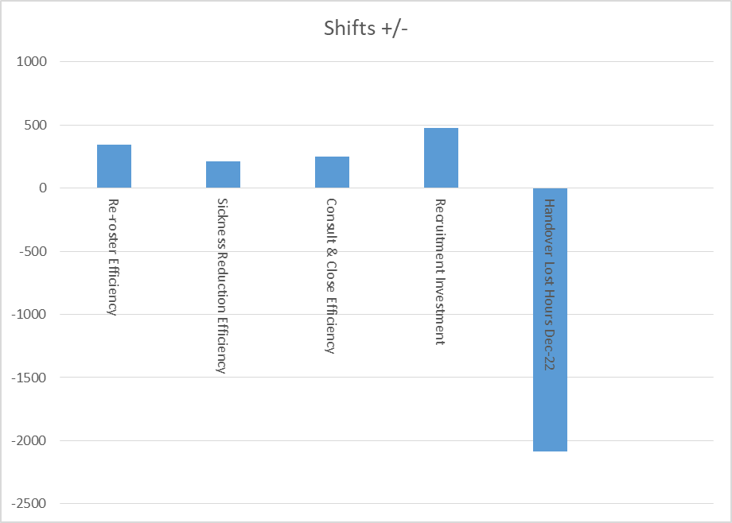

This graph shows the 12 hour EMS ambulance shifts put back into the system by re-rostering, sickness reduction, consult and close increasing from 10% to 15% and increasing the Response workforce by +100 FTEs versus the lost shifts from handover in December 2022.

Immediate Release Acceptance
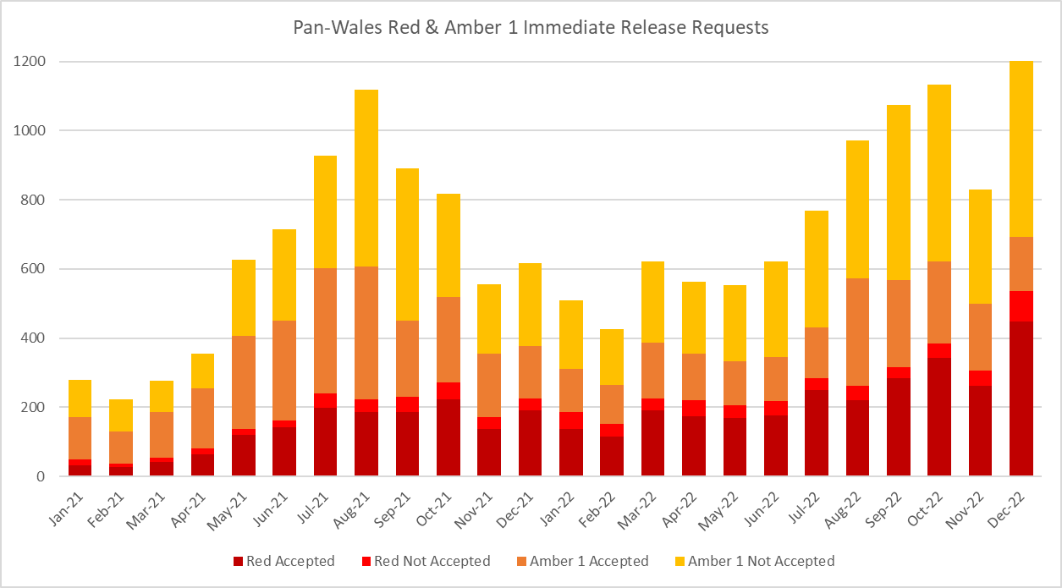

Data on immediate release acceptance/non-acceptance is now being monitored weekly by the Chief Executive of NHS Wales, with improvements being seen in the last couple of weeks. There were 1,234 request made to Health Board emergency departments (Eds) for immediate release of Red or Amber 1 calls in December 2022. Of these, 449 were accepted and released in the Red category, 88 were not accepted. In conjunction to this, 156 ambulances were released to respond to Amber 1 calls, but 541 were not. There is a separate report on the agenda regarding proposed changes to the Immediate Release Protocol. WAST is concerned about its ability to meet its category one responsibilities under the Civil Contingencies Act, given the level of system pressures and emergency ambulances at hospital sites. There is a separate report on the agenda requesting health board civil contingency officers engage with WAST on assurance around plans to the release of ambulances in the event of a mass casualty incident. WAST also needs to consider formally and provide a response to EASC (as commissioners) on the recommendations from the Manchester Arena inquiry. There are a potential 149 recommendations that are relevant to WAST.

The loss of hours post-production (PPLH) is also an area of focus. In Dec-22, 9,379 hours were lost post-production. PPLHs include a range of reasons e.g. vehicle defect, trauma stand down, police interview, etc. which cannot be viewed as areas for potential efficiencies.
Dialogue with Trade Union partners on modernising working practices, particularly around meal breaks and shift overruns, is currently on hold due to industrial action.
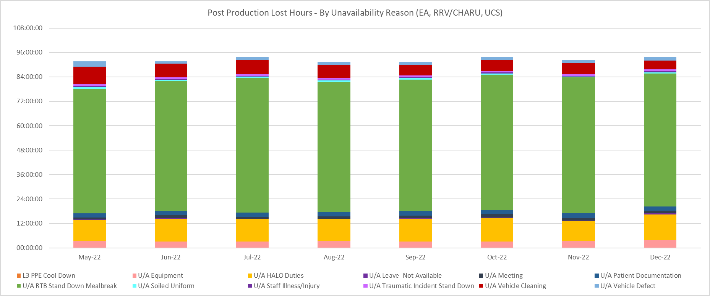

- Efficient and Effective use of resource:
WAST has completed the EMS Response roster review project which has an identified efficiency gain of 72 WTE additional staff. WAST will complete an evaluation of the project in quarter four.
WAST is also engaged in a number of programmes across the unscheduled care system which are designed to shift demand left including:
  - the core 111 service which is now live pan-Wales;
  - WAST has received recurrent funding from EASC to support five mental health professionals into the Clinical Support Desk (CSD), all of whom are now live;
  - WAST also expanded its CSD by 36 FTE Paramedics during 2021/22. These increases will support consult and close rates, but also patient safety netting and other related activities. WAST achieved a consult and close rate of 12.5% in Nov-22 with early indications for Dec-22 suggesting WAST is close to achieving the 15% benchmark.

  - WAST now undertakes seasonal forecasting and modelling as a matter of routine, using information on demand, capacity and efficiency to forecast performance. The modelled prediction for winter with no improvement to handover was Red performance below 40%, which is what has unfolded in Dec-22. WAST is currently focused on modelling where more rapid response vehicles could be placed and also fully operational same day emergency care services (SDECs).
  - In the longer term, WAST is looking to work with health boards to transform its services, in line with the ‘inverting the triangle’ ambition, which will see fewer patients conveyed to an ED and more patients receiving appropriate care closer to their home. The last bid for additional advanced paramedic practitioners (APPs) was unfortunately unsuccessful, and this will need to return for discussion as part of next year’s IMTP.

Red demand is currently subject to a clinical review, there is a Managing Attendance Plan to reduce abstractions with a downward trend in sickness absence; WAST has completed the EMS Response roster review and recruitment into the CSD, WAST has received additional funding to enable 100 FTEs this financial year, but will continue to need to operate its CSP at its higher levels until such time as system pressures reduce, in particular, handover lost hours; because of system pressures, in particular handover delays, WAST is concerned about its ability to discharge its category one responsibilities under the Civil Contingencies Act and is requesting engagement with health board civil contingency officers; and WAST will need to consider the extensive recommendations from the Manchester Inquiry and bring forward a report to EASC in a timely manner.

Ambulance Care (including NEPTS)
  - The NEPTS ambulance quality indicators have now resumed reporting. Key points about NEPTS are as follows:-
- CoVID-19 saw a significant drop-in non-emergency patient transport activity at the start of the pandemic. Levels have increased and are at or in excess of pre-pandemic levels for all journey types apart from outpatient journeys; however, the overall level of activity has still not recovered to pre-CoVID-19 levels due to the reduction in outpatient activity.
- Overall demand for the service had begun to plateau in May-22. Only outpatient activity remains supressed with all other areas at or in excess of pre-pandemic activity levels
- As WAST emerges out of pandemic response and the health system is “re-set” WAST is anticipating further demand increases at which point capacity may be an issue.
- Jun-22 was the first month in which WAST was able to view demand and capacity in a post-pandemic world as social distancing travel restrictions on NEPTS transport were removed.

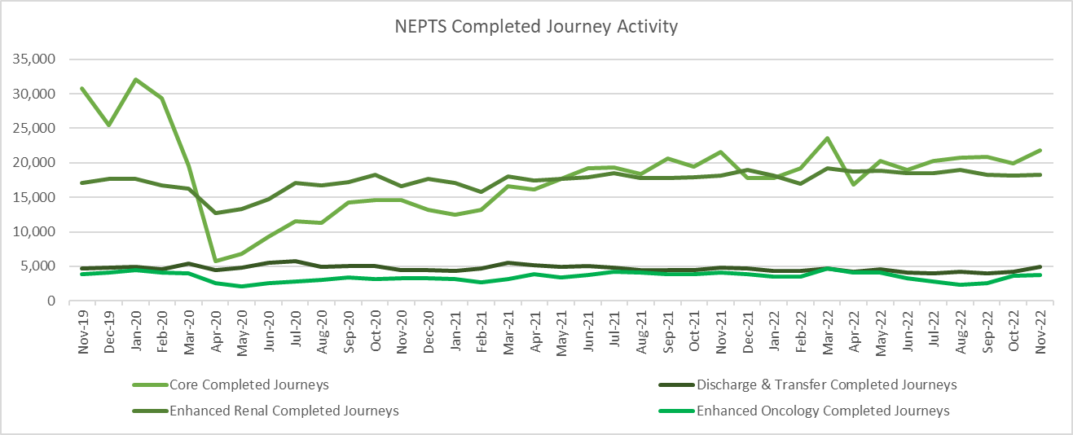

  - 75% of enhanced renal journeys arrived within 30 minutes prior to their appointment time, achieving the 70% target in November 2022. 90% of discharge & transfer journeys were collected within 60 minutes of their booked ready time, therefore achieving the 90% target. Core inbound performance is below target, but within ten percentage points. WAST has funded additional discharge and transfer capacity to support patient system flow.

  - WAST is expecting to bring forward proposals in Q4 for revised performance standards for NEPTS, including oncology transport. This has been identified as an area of focus from the NEPTS Demand & Capacity Review and will more closely align the relationship between realistic service delivery standards focused on patient experience and service funding.

  - The NEPTS Demand & Capacity Review identified two key efficiencies for NEPTS; aligning system generated patient ready times that are currently used for resource scheduling with averages based on real world experience and re-rostering (NET Centre and NEPTS ambulances). WAST is now in the process of revising the accuracy of patient ready times, is expecting to re-roster the NET Centre starting in Q4 and bring forward proposals for re-rostering NEPTS ambulances in Jan-23, with a view to undertaking this work in 2023/24.

  - There is a Welsh Government ambition to see outreach appointments reduce by 50% “in time” (Health & Social Care in Wales – CoVID-19: Looking Forward); however, the short term scenario is that as the health care system emerges out of the pandemic response in 2022/23 this may see pent up demand for NEPTS as the system is switched back on and tries to catch up on certain services. Since Apr-22 the service has been utilising a capacity management plan, which applies eligibility principles from the 2007 Welsh Health Circular (WHC) for NEPTS services, to manage any peaks where demand exceeds capacity. WAST anticipates bringing forward proposals to EASC on demand and capacity management in Q4.

  - All of the above work is captured through an established Ambulance Care Transformation Programme Board, which includes recommendations from the NEPTS Demand & Capacity Review and other key transformation work. Both health boards and the EASC Team are represented on the Board.

EASC is asked to NOTE that: outpatient performance is below target; renal performance is above target; discharge & transfer is close to target and oncology performance remains below target; WAST expects to bring forward proposals in Q4 for revised performance standards for NEPTS; demand remains below pre-pandemic levels, but is expected to increase as the system re-sets; the impact of this is being mitigated through the use of a Capacity Management Plan; WAST is on target with a range of efficiencies linked to the NEPTS Demand & Capacity Review, in particular, re-rostering.

Commissioning, Planning and Service Change

Forecasting & Modelling: Strategic Demand & Capacity Reviews
  - The EMS Operational Transformation Programme (arising from the EMS Demand & Capacity Review) is WASTs main strategic response to patient safety and experience concerns for the EMS five step ambulance care pathway. There is continued work to refine and update the demand and capacity modelling and forecasting, which informs commissioning discussions. WAST is currently developing a terms of reference for a next iteration of the demand & capacity review and expects to proceed with this in January 2023, in collaboration with the Chief Ambulance Services Commissioner (CASC) and the EASC team. WAST is currently modelling, at WG request, the potential impact of SDECs. WAST data indicates that SDECs activity (Nov-22 data) ranges from 0.07% to 0.55% of verified demand. WAST will also commence tactical forecasting and modelling for Q1 this month.
Commissioning Intentions
  - WAST recently reported its quarter two progress on the EMS and NEPTS commissioning intentions to EASC Management Group (20 October 2022), with good progress being made. EASC Management identified good progress with a small number of exceptions, for which WAST has corrective actions in place. The next update (Q3) is due to February’s EASC Management Group.

Integrated Medium Term Plan (IMTP)

  - WASTs IMTP was approved by the Minister with the following conditions:
- The need to articulate how WAST’s contribution to the Six Goals for Urgent and Emergency Care Programme will translate into improved outcomes and performance.
- The adoption of Value Based Health Care needs to be strengthened and progress in reducing variation and removing harm demonstrated clearly.
- Further expansion and completion of the Minimum Data Set in the quarter refresh exercises is required.
- Improvement in sickness and absence rates across the WAST workforce needs to be demonstrated clearly.
- Delivery of workforce efficiencies and the implementation of roster review by end of December 2022.

Progress against these conditions are set out in the following table:-

Six Goals | Further updated the mapping into Six Goals for Urgent and Emergency Care Programme. The programme structure nationally is being embedded, and WAST now has presence on goals 2, 5 & 6 at delivery board level and on the clinical advisory board.  At a local health board level WAST engages in a range of meetings and is working with the EASC Team on the development of Integrated Commissioning Action Plans (ICAPs). These were predominantly developed around Goal 4, however present an opportunity for WAST and health boards to discuss local commissioning opportunities across the breadth of the 6 Goals programmes. WAST is also represented on various health board urgent care forums used for Six Goals for Urgent and Emergency Care Programme delivery.
Value Based Healthcare | The Value Based Healthcare working group continues to develop its work programme alongside Financial Sustainability Programme and other key areas of work, such as Inverting the Triangles benefits. Lead execs have met with members of the working group to update on progress and ensure link across work on all aspects of value based healthcare. There has been some slippage in implementation of PLICs, this is not anticipated to have any adverse impact on next year’s IMTP.  The work to trial Patient Reported Experience Measures (PREMS) with Aneurin Bevan University Health Board has gone live.  WAST has also started work with the Value in Health Centre to explore the opportunity to develop Patient Reported Outcome Measures (PROMS), commencing with a literature review by Cedar (hosted by Cardiff and Vale UHB).
Minimum Data Set (MDS) | This is now being refreshed quarterly with the required data applied. A new MDS will be required as part of the IMTP development for 2023/26.
Improvement in sickness absence | The Managing Attendance programme is working through the actions required to address absences with regular reporting through the WAST Executive Management Team (EMT) and assurance provided at People and Culture Committee. This will also be a key metric at Board level through the Monthly Integrated Quality and Performance Report. Winter has been difficult and there is some adverse movement against trajectory, however this is anticipated to be a result of short term sickness due to high circulation of viruses in the community.
Delivery of workforce efficiencies | A range of efficiencies in EMS have been delivered and resulted in the increase of around 1200 additional shifts (as set out above). This includes the EMS re-rostering, sickness absence reduction, additional WTEs and increase in consult and close rates.

  - The WAST IMTP is delivered through a portfolio of transformation programmes supported by enabling programmes, projects and work-streams, which align to both WAST strategic ambitions and commissioning intentions. This year in recognition of the challenges facing both WAST and the wider NHS, the Trust has established four further key programmes:
• Financial sustainability – established with four work-streams (Best Practice, Efficiency, Income Generation and Benchmarking & Value) to address the current financial challenges to enable WAST not only to meet its statutory requirement for breakeven, but also to establish the financial space to deliver efficiencies, savings and income streams to further strategic ambitions and transformation;
• Transformation Steering & Assurance Group – a senior forum with oversight of the wider programme of work to deliver on the “Inverting the Triangles” ambition, focusing strongly on partnerships and engagement required to bring this ambition to reality. In support of this programme of work a Transformation Delivery Network has been established to drive forward those actions that can be taken as the programme develops, including key aspects of stakeholder engagement;
• Risk Improvement Programme – a comprehensive programme to enhance and develop WAST’s risk management and assurance processes to ensure that risk drives organisational transformation and improvement at a strategic level together with a refreshed Board Assurance Framework to provide the Board with assurance around risks associated with our strategic objectives;
- Managing Attendance Programme – the programme plan pulls together the activities already being delivered across WAST and introduces new activities to support attendance in a connected, supportive and sensitive way.

  - The final Quarter 3 position across these programmes of work are as follows.

- EMS Operational Transformation Recruitment and Training plan off track as attrition rates higher than forecast, however mitigation is in place with revised forecast to deliver establishment by end of Q4.
- Roster abstractions due to sickness are above forecast trajectory but on a downward trend, however RAG status changed from Green to Amber to reflect high sickness rates in Cwm Taf Morgannwg University Health Board (CTM UHB).
- Work to reduce handover delays continues through Health Board Handover Improvement meetings (which will move to the new ICAP arrangements) but RAG status changed from Amber to Red to reflect extreme, and rising delays heading into Winter.
- Challenges continue with recruitment in rural areas impacting red response times and implementation of CHARU.
- Final batch of EMS rosters went live mid-Nov, marking the end of a 2.5yr project including 146 rosters, 80 working parties, and 1,800 staff. The project will now be evaluated to support longer-term benefits realisation and learning.

  - EMS Clinical Transformation
- ePCR is now in operational use and DigiPen commissioning progressing.
- External factors, including funding, has delayed some of our work around mental health but we continue to engage with health boards on opportunities in this area.
- We will be working to align work in EMS clinical transformation with the work to Invert the Triangles in the next iteration of our IMTP.

  - Ambulance Care
- The re-roster of NET centre staff is now on track.
- Transfer of Patient Needs Assessment (PNA) to business as usual is also now on track; updated PNA rolled out with ongoing benefits realisation during Q4.
- Whilst work to maximise discharge lounge usage remains paused at the request of BCUHB, a lead contact has been identified and a meeting was held to progress the work.
- Work finalising the standardised guidance has been delayed due to lead capacity, however work is expected to accelerate during Q4 as lead capacity is released.

  - Due to the continued and ongoing pressures, WAST will prioritise its resources on IMTP delivery where this will make a tangible and significant difference to patients and our people during quarter 4, with a refreshed and renewed focus in next year’s IMTP on priorities relating to the improvement in quality and safety of services for our patients, the wellbeing and experience of our people and value & sustainability in the context of a challenging financial outlook next year.

Health Board Changes
  - WAST will fully engage with the integrated commissioning action plans in each local health board in line with the EMS commissioning framework, the aim as these develop is to incorporate both strategic and operational changes that impact on patient flow across the system.

  - WAST is currently engaged in the following live strategic service change programmes with Health Boards in Wales and Trusts in England:

- Swansea Bay Acute Services Reconfiguration – transfer arrangements have been put in place to support the initial phase of acute service changes from Singleton to Morriston implemented on 05 December with full implementation expected by the end of January. WAST and Swansea Bay UHB will continue to monitor volumes and acuity of activity to ensure longer term transfer services are in place as required.
- A Healthier Mid & West Wales (AHMMW) – WAST has been heavily involved in supporting the site selection work stream, providing detailed travel time analysis using the Optima ambulance modelling software, to compare the impacts for each of the shortlisted site options. This analysis included exploring non-blue light and blue light travel times by Lower Super Output Area for each of the proposed site locations.
- Stroke reconfiguration in Swansea Bay and Hywel Dda - established under the ARCH programme infrastructure which recommenced in June 2022. WAST clinical, operational, and planning leads are continuing to engage as part of the revised programme arrangements.
- Stroke reconfiguration in Cwm Taf Morgannwg and Cardiff & Vale - Discussions have re-commenced between Cwm Taf Morgannwg UHB and Cardiff and Vale UHB on the development of a Hyper-Acute Stroke Unit (HASU) with formal Programme structures now in place with clinical and planning engaged. A joint stakeholder event was held in October with recognition of the need for WAST to enable successful delivery.
- Stroke reconfiguration in Hereford and Worcester - WAST & Powys Health Board have worked collaboratively with the Stroke re-design group to support the development of the future model of care. Historical data projects circa 120 query Stroke patients are conveyed to Hereford per year. The Health Board and Trust will continue to engage to understand implications for the population of Powys of any of the changes proposed.
- South Wales Thoracic Surgical Services Programme - WAST is represented at project and Programme Board level as an enabling partner and in recognition of the potential impact of longer journeys for ambulance care particularly.
- The Spinal Network is developing clinical guidance for management of spinal trauma. It is also establishing a Spinal Operational Delivery Network (ODN) for South Wales, West Wales and South Powys. WHSCC will be funding the network with SBUHB hosting the network. WAST has been invited to join the ODN and is attending and supporting the development of the clinical guidance which will have some impact on hear and treat, face to face and 111. Analysis of the impact on WAST is underway and the Trust is in agreement with proposed MOU.
- South East Wales Collaborative - A regional formal programme structure has now been established, led by a Programme Director, supported by dedicated Programme Managers to enable these programmes to progress; collaborative regional programmes are recommencing and reinvigorating with this additional support for orthopaedics, diagnostics, pathology, endoscopy and ophthalmology programmes. The structure will also encompass regional oncology and stroke. The new programme structures will enable further engagement from a WAST perspective and WAST reps are now being invited into the individual programmes also.
- Aneurin Bevan Clinical Futures Strategy - Continue to liaise with ABUHB on further implementation of their strategy post opening of The Grange University Hospital and any implications including the review of demand for transfers in the future as part of the GUH Evaluation recommendations.
- Radiotherapy Satellite Centre, Nevill Hall Hospital - Business case has now been approved and work is commencing on site, expected to continue for 12 months. Operational discussions underway in terms of impact to the site whilst works are underway and assessment of the longer-term impact for NEPTS with potential for improvements in some patient journey times.

WAST is also monitoring progress of the following service changes and will engage as and when required:
- Regional Treatment Centre in Betsi Cadwaladr UHB
- Future Fit (Shrewsbury & Telford Hospitals)
- Cwm Taf Morgannwg Maternity & Obstetrics (South Powys Flows)
- Cardiff and Vale – Future Clinical Services Programme

  - WASTs Integrated Strategic Planning Group has continued to maintain oversight of health board operational and strategic service changes to comprehend and coordinate implications on WAST and for WAST to support these plans. WAST is currently updating our service change map for inclusion in the IMTP.

  - The key risks to the delivery of the WAST IMTP in 2022/23 include:

- Availability of revenue funding for core and transformational elements of the plan

- The reduction in capital available to NHS Wales, which will impact on delivery of some of the core enabling plans such as WAST’s estates improvement plan, but also poses a risk in terms of transformational elements of the plan
- Securing internal stakeholder support. Work is ongoing ensuring effective collaboration with TU partners in the delivery of its plans
- Securing external stakeholder support, particularly for the Inverting the Triangles ambitions
- Ongoing impacts of CoVID-19 recovery as Health Boards recover their activity
- Capacity within the organisation to deliver the change required, within the resource envelope available. The previously planned growth in corporate support is not currently included in this plan
- Demand for services increasing at a greater rate than the demand and capacity forecasts
- Pressures on the service arising from external factors, particularly the continuing impact of hospital handover delays
- Health and wellbeing of the workforce in the face of continued pressure.

IMTP 2023-26
  - WAST is continuing to develop its next IMTP. Key priorities are emerging around the improvement in quality and safety of services for our patients, the wellbeing and experience of our people and value & sustainability in the context of a challenging financial outlook next year. A near final draft of the plan can be brought to EASC Management Group in February ahead of a final draft IMTP being brought to EASC for endorsement in March. During this time there will be continued engagement with the EASC Team and Health Board commissioners to ensure alignment of IMTPs and Commissioning Intentions.

EASC is asked to note that: WAST is making good progress on both its EMS Operational and Clinical Transformation and Ambulance Care Transformation programmes, albeit challenged by available funding for transition and transformation; the 2022-25 IMTP approval conditions are being monitored and there is progress against each condition; and there is significant planning work around changes in health board configurations some of which feed into the national project to develop transfer and discharge services; WAST is progressing development of its 2023-2026 IMTP with regular engagement with the EASC Team and Health Boards.

Conclusions and Forward Look

  - Current performance levels and patient safety remain very challenging. System pressure, as expressed through handover lost hours, are extreme.

  - WAST is focused at an organisational level on this challenge. It has a comprehensive range of transformational programmes, planned efficiencies and tactical actions to support its services. WAST has received a further £3m to enable the funding of an additional 100 FTEs in Operations Response; however, WAST cannot achieve the patient safety parameters identified in the EMS Demand & Capacity Review, without a transformational reduction in hospital handover lost hours i.e. a reversal of trend and material reduction.

2.58 NEPTS is achieving most of its targets currently, however, core outpatient demand may still be suppressed. As demand increases as the system re-sets and the in-year capacity ends, EASC will need to consider options for balancing demand and capacity. WAST has a comprehensive Ambulance Care (NEPTS + Unscheduled Care Service) in place linking back to the NEPTS demand & capacity review.

- KEY RISKS/MATTERS FOR ESCALATION TO THE COMMITTEE

Members of the EAS Committee are asked to note that:

  - WAST is currently (09 Jan-23) at escalation level 3, expects to remain so for the foreseeable future and may return to maximum escalation (level 4), which WAST moved to during the festive period
  - WAST has had to utilise the highest level of its CSP, which includes screening even Red (immediately life threatening) calls
3.3 Patient safety in the emergency ambulance five step pathway is now very high risk for both EASC and WAST, with response times that are far too long
3.4 There were 797, 12 hour and over patient waits in Nov-22, 40 patient safety incidents were referred to health boards under the joint investigation framework over the last three months to Dec-22 and 10 WAST NRIs were reported to Welsh Government
3.5
3.6 WAST produced 112,225 Response hours in December-22 (all resource types), but lost 32,050 ambulance unit hours to handover delays, a level that WAST cannot offset without radical measures to shift left or improve system flow
3.7 There is a Welsh Government expectation that Immediate Release Directions are always accepted and a separate paper on the agenda regarding a review of the application of the Immediate Release Protocol;
3.8 There is also a Welsh Government expectation for a 25% reduction in handover lost hours (from Oct-21 baseline)
3.9 There is also a separate paper on the agenda regarding WAST’s ability/inability to meet its category one responder responsibilities under the CCA, with system pressures, in particular, working against WAST’s ability to do
3.10 WAST has received funding (payment on results) for the recruitment of +100 FTEs to its emergency ambulance response workforce, which WAT expects to delivery by the end of February 2023 (original target date 23 Jan-23) and WAST should see its staff in post at 100% to establishment for its response workforce
3.11 WAST continues to seek efficiencies, in particular, the pan-Wales EMS Response roster review (complete), PPLH (on hold linked to industrial action and abstractions/sickness absence reduction (on-target)
3.12 The ePCR programme has gone live and operational in every health board, but compliance performance for the clinical indicators have been affected in the short term as the system changes over
3.13 An Ambulance Care Transformation Programme Board has been established to take forward the findings of the NEPTS strategic Demand & Capacity Review and wider NEPTS and transfer and discharge projects and is making good progress
3.14 WAST has reported quarter 2 progress on EASCs commissioning intentions to Oct-22’s EASC Management Group, with good progress being made with a further report on quarter 3 progress expected at Feb-23 EASC Management Group
3.15 WAST is developing its 2023-26 IMTP in close collaboration with the CASC and the EASC team
3.16 WAST in engaged with health boards on a significant range of planning work for reconfigurations, in particular, vascular and time critical transfers and is progressing the proposed national transfer and discharge project, and
3.17 WAST is fully engaged in delivery of and support of the six goals programme.

- IMPACT ASSESSMENT

Quality/Safety/Patient Experience implications | Yes (Please see detail below)
Quality/Safety/Patient Experience implications | Identified within the report
Related Health and Care standard(s) | Timely Care
Related Health and Care standard(s) | And all health and care standards
Equality impact assessment completed | Not required
Legal implications / impact | There are no specific legal implications related to the activity outlined in this report.
Legal implications / impact | Included within the body of the report
Resource (Capital/Revenue £/Workforce) implications /  Impact | Yes (Include further detail below)
 | Included within the body of the report
Link to Main Strategic Objective | The Committee’s overarching role is to ensure its Commissioning Strategy for Emergency Ambulance Services utilising the five step patient pathway outlined within the National Collaborative Commissioning Quality and Delivery Agreement and the related outcomes for each care standard aligned with the Institute of Healthcare Improvement's (IHI) ‘Quadruple Aim’ are being progressed.  This report focuses on all the above objectives, but specifically on providing strong governance and assurance and safe and effective patient care
Link to Main WBFG Act Objective | Service delivery will be innovative, reflect the principles of prudent health care and promote better value for users

- RECOMMENDATION

5.1 The EASC Committee is asked to:
- DISCUSS and NOTE the WAST provider report.

