AGENDA ITEM
2.5.4

EMERGENCY AMBULANCE SERVICES COMMITTEE

welsh ambulance services nhs trust (WAST)
CIVIL CONTINGENCIES ACT

Date of meeting | 17 January 2023

FOI Status | Open/Public

If closed please indicate reason | Choose an item.

Prepared by | Lee Brooks, Executive Director of Operations
Presented by | Jason Killens, Chief Executive WAST
Approving Executive Sponsor | Chief Executive

Report purpose | FOR DISCUSSION / REVIEW

Engagement (internal/external) undertaken to date (including receipt/consideration at Committee/group)
Committee/Group/Individuals | Date | Outcome
- | - | Choose an item.

ACRONYMS
ABUHB  CTMUHB  D&C  EMS  NCCU  NEPTS  NRI  WAST | Aneurin Bevan University Health Board  Cwm Taf Morgannwg University Health Board  Demand and Capacity  Emergency Medical Services  National Collaborative Commissioning Unit  Non-Emergency Patient Transport Services  National Reportable Incident  Welsh Ambulance Services NHS Trust

- SITUATION/BACKGROUND

  - Considering the worsening operational and clinical pressures across health and social care in Wales, WAST is concerned for its ability to provide a major incident and/or mass casualty incident response to the people of Wales in a way that meets the obligations as established within the Civil Contingencies Act (CCA) and as a Category 1 responder. This is a system risk and the operational and clinical pressures also have implications for health boards and their ability to meet their CCA requirements.

  - In November 2022, the Manchester Arena Inquiry reported its outcome, and whilst WASTs assessment of the recommendations requires considerably more work, it is evident that the initial ambulance response to the incident in Manchester was below the necessary standard to save life.

  - WASTs response to incident declaration is set out and contained within the WAST Incident Response Plan (current version 1.1 October 2022). It is a standard industry practice to set out a pre-determined attendance for incident declarations to see that an initial wave of triage, treatment and transport can commence without delay.

- SPECIFIC MATTERS FOR CONSIDERATION BY THIS MEETING (ASSESSMENT)

2.1 The situation in recent weeks has again worsened with December 2022 seeing the worst month on record with 32,020 ambulance unit hours lost to hospital handover. This equates to 37% of WAST’s conveying capacity for December 2022 i.e. 37% being unavailable to respond to patients in our communities.

  - During prolonged periods, WAST has seen more than 50% of its conveying capacity being unavailable to respond to patient incidents due to extreme handover delays with some handovers reaching over 48 hours.

  - Whilst these are new records, the issue of extended handover delays in Wales is deep-rooted and has been consistently poor over a period that pre-dates the pandemic.

  - The chart below shows the total lost hours because of emergency department handover delays nationally by month over the last two years.
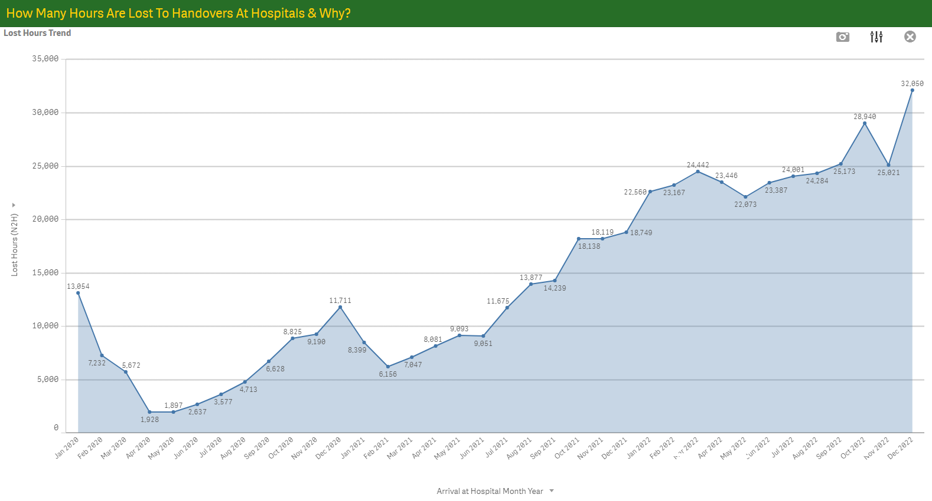
2.5 Taken together with the fact that when business continuity and critical incidents were declared by WAST last month, due to WASTs inability to respond to patients categorised as immediately life threatening, no meaningful improvement to ambulance availability was seen.

2.6 To provide an immediate incident response one of two scenarios is required. The first being, that sufficient available capacity exists to immediately send the available resource to meet the pre-determined attendance, or that resources are immediately redeployed to attend the incident. It is important to note that, if capacity is redeployed, this creates an additional burden as ‘regular’ demand must continue to be serviced.

2.7 WAST is concerned that the health system will not be able to release ambulances held at emergency departments without delay should a major incident be declared. This will delay arrival of life saving care to those sadly caught up in any incident.

2.8 The WAST Major Incident plan, based on sector best practice; national guidance and lessons identified from previous incidents, requires the immediate deployment of the pre-determined attendance shown in the table below followed by further resources should they be necessary.
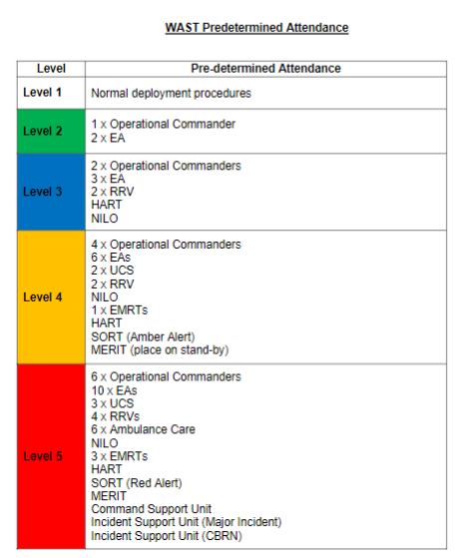
2.9 The current exceptional level of system disruption being seen ultimately leading to ambulances being unavailable to WAST places at risk its ability to respond immediately and without delay to a major incident should one be declared.

2.10 On 3 January 2023, the WAST Chief Executive wrote to health board Chief Executives to seek assurance that health boards, and specifically its emergency department(s), have plans, systems and processes in place, that have been recently tested and exercised, to release without delay any and all emergency ambulances held at them should such an incident occur.

2.11 WAST has developed a new risk for entry on its corporate risk register covering this issue and intends to raise this at the next public Trust Board meeting on Thursday 26 January 2023. It is anticipated that this risk will score as HIGH.

- KEY RISKS/MATTERS FOR ESCALATION TO THE COMMITTEE

Members of the EAS Committee are asked to note that:

  - Within the context of current operational and clinical pressures WAST may fail to meet its CCA Category 1 responder responsibility if inhibited from sending its pre-determined attendance to a declared major incident or mass casualty incident due to emergency department handover delays and hospital over-crowding.

  - Similarly, the current operational and clinical pressures have consequence for health board’s abilities to meet their requirements under the CCA.

- IMPACT ASSESSMENT

Quality/Safety/Patient Experience implications | Yes (Please see detail below)
Quality/Safety/Patient Experience implications | Identified within the report
Related Health and Care standard(s) | Timely Care
Related Health and Care standard(s) | And all health and care standards
Equality impact assessment completed | Not required
Legal implications / impact | Yes (Include further detail below)
Legal implications / impact | Included within the body of the report
Resource (Capital/Revenue £/Workforce) implications /  Impact | Yes (Include further detail below)
 | Included within the body of the report
Link to Main Strategic Objective | The Committee’s overarching role is to ensure its Commissioning Strategy for Emergency Ambulance Services utilising the five step patient pathway outlined within the National Collaborative Commissioning Quality and Delivery Agreement and the related outcomes for each care standard aligned with the Institute of Healthcare Improvement's (IHI) ‘Quadruple Aim’ are being progressed.  This report focuses on all the above objectives, but specifically on providing strong governance and assurance and safe and effective patient care
Link to Main WBFG Act Objective | Service delivery will be innovative, reflect the principles of prudent health care and promote better value for users

- RECOMMENDATION

  - The EASC Committee is asked to:
- NOTE the system risk that WAST may fail to meet its Civil Contingency Act Category 1 responder responsibility if inhibited from sending its pre-determined attendance to a declared major incident or mass casualty incident due to emergency department handover delays.
- AGREE that Health board CCA officers engage with WAST to confirm WAST/health board CCA arrangements and for any issues arising be escalated where needed to EASC Management Group.

