AGENDA ITEM
2.2

EMERGENCY AMBULANCE SERVICES COMMITTEE (EASC)

welsh ambulance services nhs trust (WAST)
provider update

Date of meeting | 12 May 2020

FOI Status | Open/Public

If closed please indicate reason | Choose an item.

Prepared by | Rachel Marsh, Director of Strategy, Planning and Performance (WAST)
Presented by | Jason Killens, Chief Executive WAST
Approving Executive Sponsor | Chief Executive

Report purpose | FOR DISCUSSION / REVIEW

Engagement (internal/external) undertaken to date (including receipt/consideration at Committee/group)
Committee/Group/Individuals | Date | Outcome

ACRONYMS
ABUHB  CTMUHB  CCC  D&C  EMS  NCCU  NEPTS  SAI  WAST | Aneurin Bevan University Health Board  Cwm Taf Morgannwg University Health Board  Clinical Contact Centre  Demand and Capacity  Emergency medical services  National Collaborative Commissioning Unit  Non-emergency patient transport services  Serious Adverse Incident  Welsh Ambulance Services NHS Trust
- SITUATION/BACKGROUND

  - The purpose of this report is to provide EASC with an update on key issues affecting quality and performance for EMS and NEPTS, which will concentrate for this meeting specifically on response during the COVID 19 pandemic.

- SPECIFIC MATTERS FOR CONSIDERATION BY THIS MEETING (ASSESSMENT)

CoVID-19

Pandemic Influenza Plan
  - In early Mar-20, whilst a global pandemic was yet to be declared, it was clear and indeed inevitable that this would be the case and that the domestic impact of what was now known as CoVID-19 would be substantial. On 4 Mar-20 WAST triggered the arrangements within our existing Pandemic Influenza plan. In so doing, two clear corporate objectives were set and communicated widely. These were:

- Take all reasonable, necessary and proportionate measures in all the circumstances to fulfil the objectives set in our pandemic strategy; and

- Continue with recruitment to fulfil the minimum of 136 FTE growth of the EMS service as agreed with EASC for 2020/21. All other, non-essential WAST activity would cease to enable the Trust to focus solely on these two critically important tasks.

  - The Plan was implemented with centrally agreed assumptions whilst retro-fitting modelling was undertaken using the advanced ambulance simulation modelling software available to WAST, combined with available forecasts. WAST commenced planning around six key areas of business:-.
- Ambulance response (EMS, UCS and NEPTS) – arrangements to generate additional capacity to respond to growing demand;
- Fleet – arrangements to ensure maximum fleet and equipment availability;
- Information and Communication Technology – arrangements to protect mission critical systems and support remote and flexible working;

- Supply chain – arrangements to ensure sufficient supplies of necessary equipment and materials such as Personal Protective Equipment (PPE) and enhancements to for emergency front line staff;
- Resource Centre - arrangements to facilitate greater numbers of staff being deployed and maintain core rostering services; and
- Clinical Contact Centre (999, 111, CSD and NEPTS) – arrangements to protect mission critical control functions, grow their capacity and diversify tasks

  - A range of tactical options were developed to give effect to the overall strategy and to protect the delivery of these core service areas. These were most notably, but not limited to:-
- Training and redeployment of substantive staff into core service areas, particularly into call handling and CCC clinician posts;
- Deployment of overtime incentives;
- Use of university students via the bank scheme;
- Use of defence personnel as drivers;
- Extension of St John Ambulance Cymru support, as provided to WAST for winter;
- Contracts secured with private sector NEPTS providers to deliver expected support needed to field hospitals and surge capacity;
- Training and deployment readiness for Fire and Rescue Service personnel across Wales;
- Rapid establishment of additional clinical contact centres and training facilities;
- Rapid deployment of Office 365 across the organisation, and significant increase in home working capability;
- Rebranding of NHSDW website to 111.wales and deployment of new online COVID symptom checker achieving 1 million visits, including use of chatbot.

  - In concert with other UK ambulance services, WAST also introduced a specific pandemic protocol for 999 call handling (Card 36). This 999 call handling triage protocol, which supplements others within the Medical Priority Dispatch System (MPDS) is designed specifically for pandemic management. We will keep this arrangement in place and only withdraw it when the prevalence and risk of CoVID-19 to people in Wales has diminished.

  - As we look ahead, there are a range of choices for WAST to take including redeployed staff being deployed back to core functions, the continued enhancements to PPE for emergency front line staff; the further use of defence personnel, the use of Fire and Rescue Service and the expansion of 111 and 999 call handling capacity (including estate).

  - WAST has maintained a weekly dialogue with the CASC on quality, performance, governance and financial commitments. Financial returns continue to be submitted to Welsh Government / Finance Delivery Unit (FDU) as required.

  - WAST is now turning its focus on planning for recovery, in parallel with the response phase of the pandemic plan. It is accepted and acknowledged that we would not want to return to business as “usual”, but that we will be moving towards a ‘new’ normal. WAST will continue to monitor the system’s requirement from an ambulance transport perspective and flex its capacity in response to changes in demand.

  - A formal debrief / lessons learnt in relation to this first phase of response is underway, due for completion by 31 May-20.

EASC is asked to NOTE: WAST’s effective deployment of its Pandemic Influenza Plan and that the focus is now shifting to planning for flexible recovery.
Quality, Safety & Patient Experience

  - WAST continues to review and discuss potential SAIs at its Serious Case Incident Forum (SCIF). Following the outbreak of the Pandemic, WAST has witnessed a reduction in the volume of adverse incidents being reported by staff though Datix. This has had an impact on the volume of cases being discussed at SCIF, and consequently a reduction in cases being reported as WAST SAIs or being passed to the relevant health board for investigation as a Patient Safety Incident or under the umbrella of the Joint Investigation Framework.

EASC is asked to NOTE: that WAST’s quality, safety and patient experience monitoring arrangements have remained in place during the COVID 19 outbreak.

Activity and Performance
Red Performance
  - Since the beginning of the year, performance has been above 65% in January, February and April, with further improvements being noted into May (it should be noted that the current Welsh Government advice is that there is no formal publication of the monthly statistical release or Ambulance Quality Indicators, so the data is not formally verified at this point in time). There continues to be variation in health board performance.

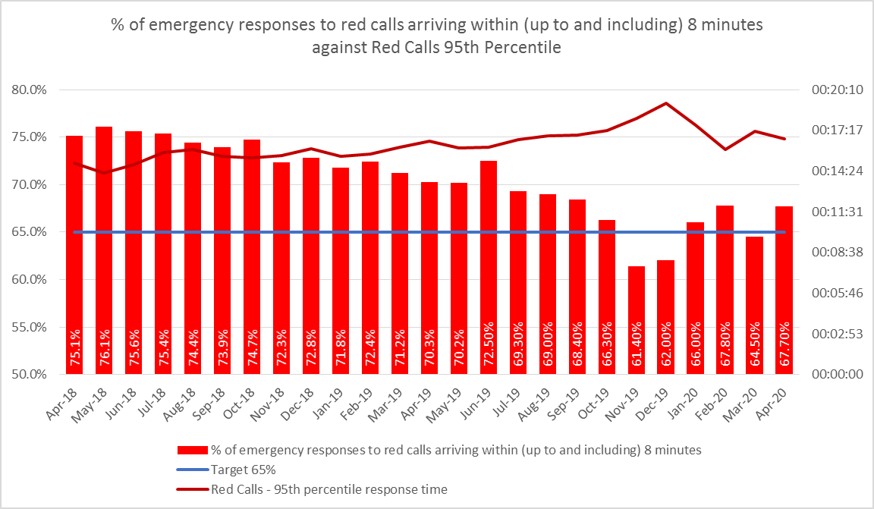

Amber Response times
  - Through the COVID 19 response period to date, significant improvements have been seen in the amber response times, in particular, the Amber tail (the 95th percentile) which is sensitive to changes in demand and capacity.
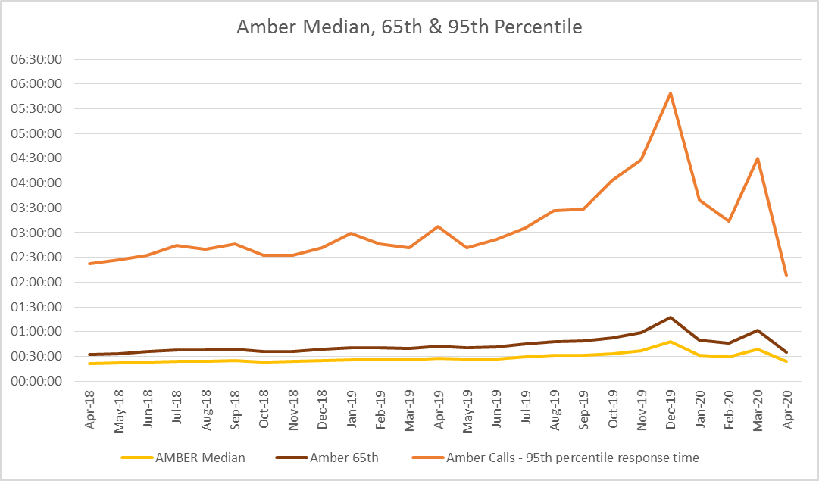

Demand
  - Demand changes are one of the main factors affecting performance for all categories of calls. The graph below demonstrates that there has been a reduction in overall incident demand and responded demand during the pandemic to date.

Production
  - The number of hours produced by WAST is a second major determinant of performance. Through the pandemic period to date, despite staff absence due to COVID, production of Emergency Ambulance hours has been increased through ongoing overtime incentives, use of defence personnel, and by switching Paramedics from Rapid Response Vehicles (RRV) to Emergency Ambulances (EA). Over the period Feb-20 to Apr-20 WAST has produced 105,536 ambulance units, 110,236 ambulance units and 113,947 ambulance units respectively, whilst RRV unit hours has reduced from 17,228 to 12,238. The priority given to production of EA hours has been as a result of the modelled need for an increase in conveying response due to COVID 19. This model of increased EA hours and reduced RRV hours also mirrors the ORH modelling done as part of the D&C review.
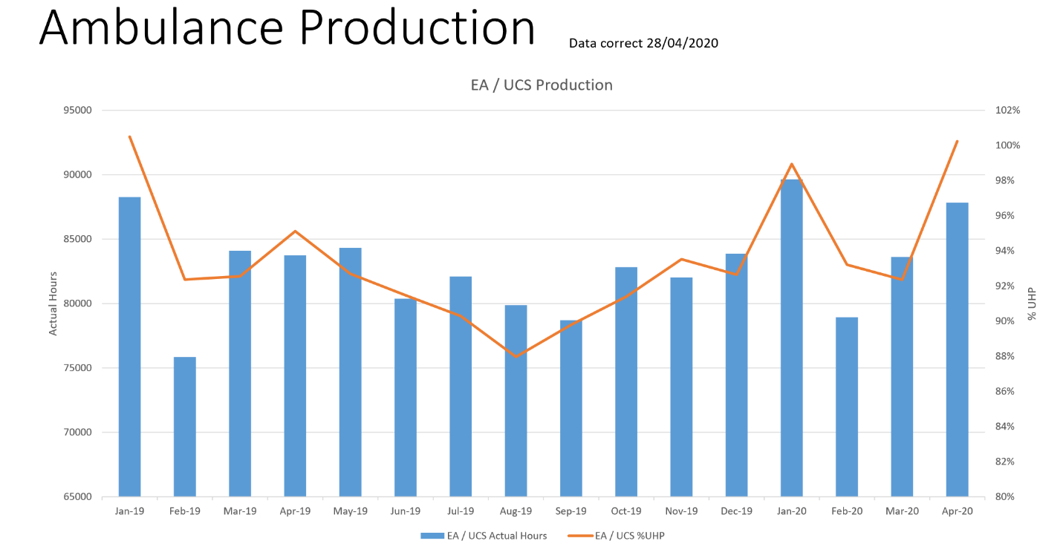
Lost Hours
  - The third key determinant of performance is handover lost hours. The graph below shows the increasing levels of lost hours over the past year, big improvements seen in AB and CTM UHBs as a result of the cohorting initiatives deployed in February, and then further dramatic reductions in March and Apr-20 as a result of the system focus on freeing up capacity for the unscheduled care system to respond to CoVID-19.

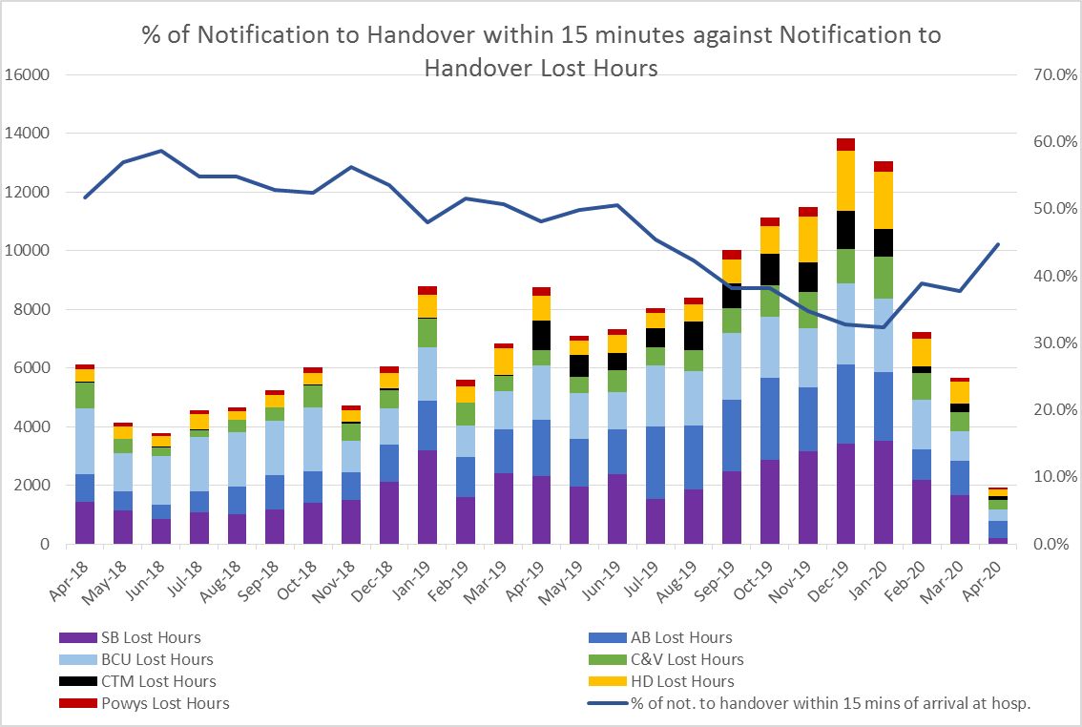
Winter Planning
  - The evaluation of Winter 19/20 has been suspended due to COVID 19. However, discussions will need to continue in terms of planning for Winter 20, which will need to be done alongside modelling for further phases of the pandemic.

EASC is asked to NOTE that: the Red 8 minute 65% target has been met 3 out of the last 4 months; amber response times have improved significantly; performance improvements are as a result of a combination of reduced demand, increased ambulance hours and reduced handover lost hours.

Demand and Capacity Review - Implementation

  - A more detailed report on the programme of work emerging from the Demand and Capacity Review was taken to the CASC Quality & Delivery Meeting (07 May-20). The key issues of note are summarised below.

  - WAST has established an EMS D & C Programme Board, with the NCCU represented, mirroring the collaborative approach adopted for the Review itself.

  - The Programme Board has identified eight inter-connected projects that form the programme with clear lines of reporting and accountability both within WAST and to EASC Management Group. Most of these projects have been suspended due to “lockdown”, but the Recruitment & Training Project has continued.

  - EASC has agreed to fund an additional 136 FTEs, made up of 11.5 Paramedics, 102.4 Emergency Medical Technicians (EMTs) and 22.1 Unscheduled Care Staff (UCS) by March 2021. A Recruitment and Training Plan has been developed which provides sufficient recruits to cover expected turnover, internal promotions and the additional 136 FTEs. It does not include the impact of the opening of the Grange University Hospital or any other major service changes.

  - The Workforce & Organisation Development Department has demonstrated considerable creativity and innovation in switching the recruitment process to a virtual one and also making as much of the training programme as virtual as possible. As result WAST is on-target with 53.97% of the total FTE ask already secured and 30% of the EMS D & C Review FTE “ask” already secured.

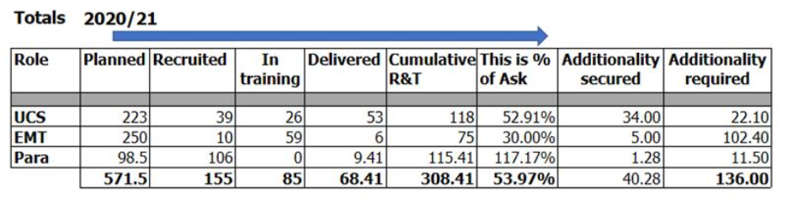
  - The virtual Paramedic Big Bang recruitment event provided the opportunity for WAST to slightly over recruit Paramedics, as a way of providing further assurance that the overall 20/21 recruitment and training plan will be delivered, including the additionality required for the Review. The 136 FTEs are being “landed” in line with the relief gap identified in the Review.

  - As previously mentioned, the above Recruitment and Training Plan FTEs do not include the impact of the Grange University Hospital (GUH). The exact numbers need to be commissioned by ABUHB, but are expected to be at least 84 FTEs. This is a significant additional impact on WAST’s Recruitment and Training Plan and urgent discussions are ongoing with ABUHB to finalise the plans and way forward.

  - In order to make decisions about future FTE requirements, EASC and WAST need to agree on the targeted rate of abstraction, in particular, the treatment of continuing professional development (CPD). This will enable the supplier of the Review to recalculate the FTEs by year, by health board and by station. Further discussions are ongoing on this issue.

  - Whilst WAST is making good progress on the FTE additionality for 20/21, EASC and WAST need to start giving consideration to recruitment and training in future years. As the relief gap closes and we start to recruit over and above the relief gap WAST’s estate and fleet could be a barrier to efficient recruitment, with the estate having much longer lead in times than fleet procurement and recruitment/training. WAST needs to update its strategic outline plan (SOP) for estate during 2020/21 to ensure this does not occur; key to this is agreement with EASC on future FTEs beyond 2020/21.

EASC is asked to NOTE that: a programme management approach has been adopted to implement the recommendations of the EMS D & C Review; despite CoVID-19 good progress has been made on the Recruitment and Training Plan; and further discussions are now required with EASC on future years’ FTEs in order to facilitate timely project initiation on estate changes required to support the increase in establishment.

Developments / Planning
Health Board Service Changes
  - All health board service change work by WAST has been suspended as a result of COVID 19 response with the exception of the GUH.

  - Whilst the business as usual health board change work has been suspended there has clearly been a significant change to the hospital footprint across Wales as a result of CoVID-19. WAST has established, in collaboration with the NCCU, a WAST national health board surge capacity project team with regional cells plugged into health boards, so that WAST can gather intelligence and respond to the transport requirements associated with these field sites (NCCU/WAST currently have 43 sites listed on our database).

  - WAST has forecast and modelled the transport requirements for these surge sites and has been closely monitoring the daily infection data, conveyance levels and bed utilisation information, in combination with intelligence from health boards, to guide whether to turn on the additional transport capacity WAST has had on standby for this eventuality.

  - Whilst the potential flow into these sites has proved low at this point in time, WAST, the NCCU and health boards will need to continue to collaborate in this area, particularly, as we start to plan for winter 2020/21. Clear revised clinical models for each health board which include transport and early engagement with WAST are key.

NEPTS (Non-Emergency Patient Transport Service)
  - Following the decision to suspend much of the normal health board activity, the NEPTS teams areas of work have been focused on ensuring that a high quality service continues to be provided to essential outpatients (as determined by health board clinicians), patients requiring transport to access renal dialysis and oncology treatment and ensuring a timely service for patients requiring discharge home or transfer to an alternative place of care.

  - In order to respond to Welsh Government advice on social distancing and to ensure staff and patient safety the service has had to make or respond to several changes to its normal methods of service delivery, these are:
- Limits on the numbers of patients per vehicle. Maximum loading is now 2 patients per ambulance (previously max of 5) and 1 per car type vehicle (previous max of 3);
- Vehicle screens between the cab and saloon of the vehicle;
- Separating suspected & confirmed CoVID-19 patients to travel alone;
- Additional Personal Protective Equipment (PPE) requirements;
- New booking, planning and allocation processes;
- Reductions in the levels of available volunteers; and
- Increased sickness levels due to a high proportion of staff within the shielded category.

  - These changes have reduced the ability of the service to maximise vehicle utilisation, which has dropped from an average of 2.1 patients per run in April 2019 to 1.4 patients per run in April 2020.

  - Whilst the overall reduction in demand has offset this loss of efficiency during the initial phase of the pandemic, the service’s ability to manage a resumption of business as usual activity without significant additional investment in additional resources is likely to be compromised. It is therefore imperative that health boards ensure that they engage at the earliest possible stage of service planning and include transport support as an integral part of any planning work undertaken. Without meaningful engagement there is a significant risk that an appropriate transport support provision will not be able to be delivered to support health board service delivery. In recognition of this risk and to provide a formal mechanism for engagement and oversight, the NEPTS Delivery Assurance Group (DAG) has recommenced meeting fortnightly n a virtual basis.

  - Following a pause in progress the trust has included the NEPTS Demand & Capacity review as one of its key programs of work within the recovery phase. The review will recommence in May and progress will be reported via the Management Group and through the NEPTS DAG.

IMTP 2020/23
  - WAST’s IMTP was submitted on the 31 Jan-20, endorsed by EASC on 28 Jan-20 with written support from the CASC. The IMTP integrates EASCs commissioning intentions for EMS and NEPTS into a plan which clearly articulates a commitment to quality and delivery of ‘A Healthier Wales’ Quadruple Aim.

  - As part of enacting the trusts Pandemic Plan, the majority of the IMTP priorities were suspended along with the supporting governance and performance management structures, with the bulk of these staff being redeployed to boost core function capacity or strengthen areas for example, infection prevention control and on-line presence. A small number of IMTP priorities continued including: recruitment and training of additional staff in line with demand & capacity programme, ePCR and preparations for the opening of the Grange University Hospital.

  - WAST has identified the following work-streams for scaling back up in the next few weeks:-
  - EMS D & C Review; recommence work on efficiencies as well as recruitment and training element;
  - NEPTS Demand & Capacity Review;
  - ePCR full business case and procurement;
  - 111 system procurement;
  - Clinical Contact Centre Clinical Review – delivery of recommendations;
  - Cardiff Make Ready Depot (dependent on contractors);
  - Putting Things Right / Safeguarding;
  - Estate and fleet SOPs that support the demand & capacity reviews;
  - Digital Strategy (we will need to recast this slightly in light of all the work that has been done to support the CoVID-19 response);
  - Training School relocation capital scheme;
  - Putting the Operational Delivery Unit on a permanent footing; and
  - Workforce wellbeing and organisational development.

Regional Escalation
  - CEOs and Chief Operating Officers (COOs) have previously agreed on the need for greater system leadership around escalation within unscheduled care.

  - WAST implemented the Operational Delivery Unit (ODU) on 27 Jan- 20. Chief Operating Officer (COOs) were engaged in developing the ODU indicators and pre-CoVID-19 there was positive feedback from health boards (and Welsh Government) on the benefits of the ODU: this has continued during the pandemic. To support the initial proof of concept WAST has abstracted key managers to take a lead, but this is not a sustainable long term solution. As a result WAST is now developing an organisational structure to put the ODU on a permanent footing in preparation for next winter.

  - The ODU has been supported during the CoVID-19 period using some redeployed staff who, whilst not from our operational cohort, have proven incredibly valuable to us as we have responded to the pandemic. This has offered useful insight to inform our further development. Operating hours have extended to now cover Mon to Fri 08:00-00:00 and weekends 09:00-21:00. The Regional Escalation Stages went live from Monday 30 Mar-20, and the stage for each region is now settled at the daily regional safety huddles. The procedure document is expected to be represented to the COO group for discussion and agreement as we seek to include a more rapid approach to resus capacity.

  - The ODU is, we believe, beginning to prove its potential, and if EASC want this model of approach to continue we need to determine the funding stream. Discussions will be taken forward with the CASC.

EASC is asked to note that: close attention will need to be paid going forward by both WAST and health boards to the transport implications of revised clinical models/hospital footprints, so that the ambulance transport requirements can be delivered in a timely manner; NEPTS has continued to provide patient critical journeys as determined by health board clinicians ; that the majority of the IMTP priorities were switched off during Apr-20, but an agreed list will now being scaled back up in the coming weeks; and the ODU has continued to prove its worth and now needs to be put on a permanent footing in collaboration with the NCCU and health boards.

- KEY RISKS/MATTERS FOR ESCALATION TO THE COMMITTEE

Members of the EAS Committee are asked to note:

  - WAST’s Pandemic Influenza Plan arrangements have been effective, that WAST continues to work within the framework of these plans/arrangements, that the focus is now shifting to planning for a flexible recovery towards a ‘new’ normal.
  - Quality, safety and patient experience monitoring arrangements have remained in place.
  - Red 8 minute 65% target has been met in 3 of the last 4 months.
  - There has been a significant improvement in Amber performance in Apr-20, in particular, the Amber tail, as a result of reduced demand, increased ambulance production and reduced handover lost hours.
  - The recruitment and training project for the EMS D & C Programme has been maintained during business continuity with excellent progress on delivery against plan.
  - The opening of the Grange University Hospital will have a significant impact on WAST’s recruitment and training programme with a minimum further uplift of 84 FTEs.
  - WAST is monitoring health board requirements for additional ambulance transport required to service revised clinical models/hospital footprints in each health board.
  - Early engagement with WAST on transport needs is key.
  - NEPTS has continued to provide patient critical journeys as determined by health board clinicians.
  - WAST has implemented the ODU to support a system wide approach to escalation/patient flow, which has been well received by the system, and WAST is now working through how to put the ODU on a more permanent footing.

- IMPACT ASSESSMENT

Quality/Safety/Patient Experience implications | Yes (Please see detail below)
Quality/Safety/Patient Experience implications | Identified within the report
Related Health and Care standard(s) | Governance, Leadership and Accountability
Related Health and Care standard(s) | And all health and care standards
Equality impact assessment completed | Not required
Legal implications / impact | Yes (Include further detail below)
Legal implications / impact | Included within the body of the report
Resource (Capital/Revenue £/Workforce) implications /  Impact | Yes (Include further detail below)
 | Included within the body of the report
Link to Main Strategic Objective | The Committee’s overarching role is to ensure its Commissioning Strategy for Emergency Ambulance Services utilising the five step patient pathway outlined within the National Collaborative Commissioning Quality and Delivery Agreement and the related outcomes for each care standard aligned with the Institute of Healthcare Improvement's (IHI) ‘Quadruple Aim’ are being progressed.  This report focuses on all the above objectives, but specifically on providing strong governance and assurance and safe and effective patient care
Link to Main WBFG Act Objective | Service delivery will be innovative, reflect the principles of prudent health care and promote better value for users

- RECOMMENDATION

  - The EASC Committee is asked to:
- DISCUSS and NOTE the WAST provider report.

