AGENDA ITEM
2.3

EMERGENCY AMBULANCE SERVICES COMMITTEE (EASC)
WELSH AMBULANCE SERVICES NHS TRUST (WAST) PROVIDER UPDATE

Date of meeting | 11 May 2021

FOI Status | Open/Public

If closed please indicate reason | Choose an item.

Prepared by | Rachel Marsh, Director of Strategy, Planning and Performance (WAST)
Presented by | Jason Killens, Chief Executive WAST
Approving Executive Sponsor | Chief Executive

Report purpose | FOR DISCUSSION / REVIEW

Engagement (internal/external) undertaken to date (including receipt/consideration at Committee/group)
Committee/Group/Individuals | Date | Outcome

ACRONYMS
ABUHB | Aneurin Bevan University Health Board
CTMUHB | Cwm Taf Morgannwg University Health Board
D&C | Demand and Capacity
EMS | Emergency medical services
NCCU | National Collaborative Commissioning Unit
NEPTS | Non-emergency patient transport services
SAI  SCIF | Serious Adverse Incident  Serious Case Incident Forum
WAST | Welsh Ambulance Services NHS Trust

SITUATION/BACKGROUND

  - The purpose of this report is to provide EASC with an update on key issues affecting quality and performance for emergency medical services (EMS) and Non-Emergency Patient Transport Services (NEPTS) and to provide an update on commissioning and planning for EMS and NEPTS.

SPECIFIC MATTERS FOR CONSIDERATION BY THIS MEETING (ASSESSMENT)

CoVID-19

  - WAST is tracking CoVID-19 and related metrics through its weekly CoVID-19 Intelligence Pack. Throughout the second wave, despite increases in the numbers of infected cases, there has been no material change in 999 call volumes, EMS response or conveyance volumes; however, the impact of the second wave on the roster abstractions has been significant.
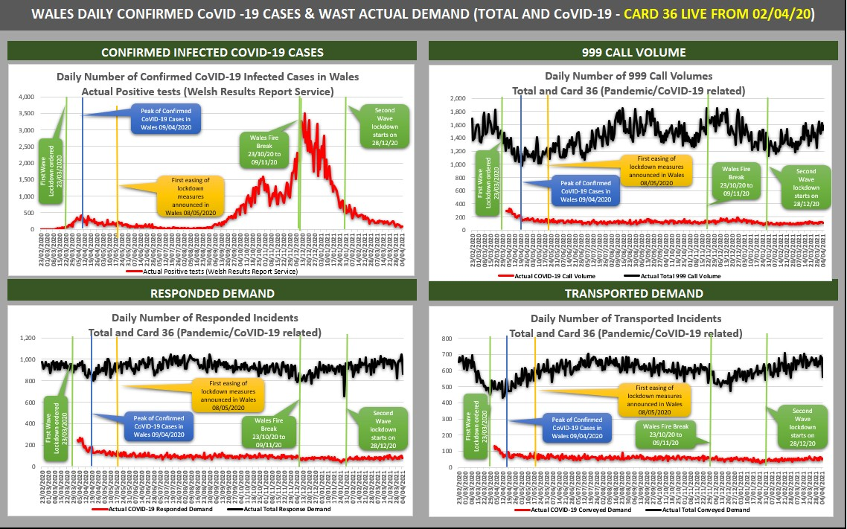

  - Tactical CoVID-19 forecasting, modelling and planning was also undertaken for WAST’s Winter Plan, with further work now being undertaken on WAST’s Summer Plan, both of which are described in more detail later in the report.

EASC is asked to NOTE that: WAST is currently back in Monitor mode (Pandemic Influenza Plan); the increase in positive test results has not had a significant impact on call demand, response demand or conveyance demand, but CoVID-19 has had a significant impact on roster abstractions and capacity.

Quality, Safety & Patient Experience

Patient Response Times in the Community

  - One of the key indicators which measures the quality of the service provided is the timeliness of the response by WAST to patients waiting in the community. The graphs below show the current response times performance for Red calls and for Amber calls. Both graphs show that during the first wave of the pandemic, response times improved significantly, with Amber response times particularly improved; however, response times worsened during the second wave before beginning to recover again in quarter four. Inevitably these worsening times have had an impact on patient safety.

  - The Red 8-minute target was not achieved in Mar-21. The percentage of emergency responses to Red incidents within 8 minutes was 62.5% (target 65%) with 95% of Red calls receiving a response within 18 minutes. The Amber median percentile in Mar-21 was 36 minutes and the Amber 95th percentile was three hours and six minutes.
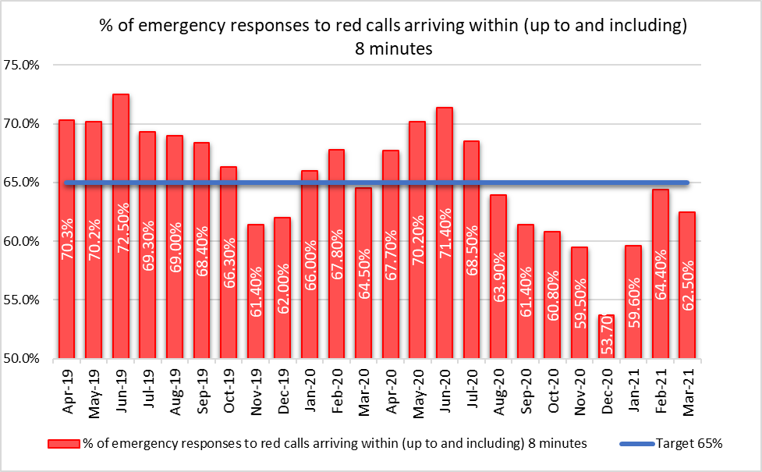

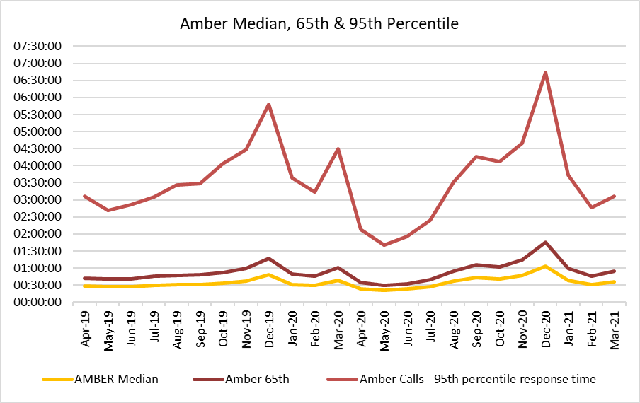

  - WAST also continues to monitor the longest patient responses. The table below shows the number of patients who had to wait 12 hours or over, and again, it shows that very long waits were almost eliminated during the first wave, but subsequently returned as system pressures increased. There were 606 long waits in Dec-20 (the highest recorded), before a significant improvement in quarter four as both WASTs and health board pandemic response actions took effect.

Patients Waits 12 Hours and Over (EMS Service)
Date | 12 | 13 | 14 | 15 | 16 | 17 | 18 | 19 | 20 | 21 | 22 | 23 | 24 | 25 | 26 | 27 | 28 | 29 | 30 | 31 | 32 | 33 | 34
Apr-19 | 28 | 29 | 20 | 10 | 9 | 11 | 4 | 5 | 2 | 2 |  |  |  |  |  |  |  |  |  |  |  |  |  | 120
May-19 | 30 | 25 | 18 | 16 | 10 | 13 | 2 | 7 |  | 1 |  |  |  |  |  |  |  |  |  |  |  |  |  | 122
Jun-19 | 26 | 16 | 10 | 13 | 5 | 10 | 8 | 8 |  | 1 |  |  |  |  | 1 |  |  |  |  |  |  |  |  | 98
Jul-19 | 45 | 28 | 22 | 14 | 9 | 14 | 5 | 4 | 4 | 1 |  | 2 | 1 | 1 | 2 | 1 | 1 |  |  |  |  |  |  | 154
Aug-19 | 43 | 43 | 22 | 23 | 10 | 13 | 7 | 3 | 4 | 3 |  |  | 1 |  |  |  |  |  |  |  |  |  |  | 172
Sep-19 | 44 | 24 | 24 | 14 | 18 | 12 | 5 | 5 | 3 | 3 | 2 | 1 |  | 1 |  | 1 |  |  |  |  |  |  | 1 | 158
Oct-19 | 67 | 50 | 31 | 26 | 28 | 25 | 19 | 14 | 18 | 9 | 5 | 1 | 1 | 1 |  |  |  |  | 1 |  |  |  |  | 296
Nov-19 | 62 | 64 | 45 | 41 | 25 | 19 | 15 | 12 | 11 | 10 | 6 | 7 | 3 | 1 |  | 3 |  | 1 |  |  |  |  |  | 325
Dec-19 | 103 | 79 | 68 | 47 | 48 | 51 | 39 | 23 | 25 | 17 | 8 | 14 | 8 | 3 | 2 | 1 | 1 |  | 1 | 2 |  |  |  | 540
Jan-20 | 50 | 44 | 40 | 36 | 34 | 32 | 16 | 15 | 8 | 7 | 7 |  | 2 |  | 4 |  |  |  |  |  |  |  |  | 295
Feb-20 | 39 | 23 | 20 | 10 | 10 | 9 | 7 | 1 | 1 |  | 2 | 1 | 1 | 1 |  |  |  |  |  |  |  |  |  | 125
Mar-20 | 52 | 49 | 43 | 23 | 15 | 15 | 11 | 9 | 2 | 2 | 1 | 1 | 3 |  | 1 |  |  |  |  |  |  |  |  | 227
Apr-20 | 6 | 1 | 1 | 2 | 2 | 2 | 3 |  |  |  |  |  |  |  |  |  |  |  |  |  |  |  |  | 17
May-20 | 2 | 1 |  |  |  |  |  |  |  |  |  |  |  |  |  |  |  |  |  |  |  |  |  | 3
Jun-20 | 2 |  | 1 | 2 |  |  |  |  |  |  |  |  |  |  |  |  |  |  |  |  |  |  |  | 5
Jul-20 | 7 | 6 | 5 | 1 | 1 |  |  | 2 |  | 1 |  |  |  |  |  |  |  |  |  |  |  |  |  | 23
Aug-20 | 30 | 25 | 30 | 22 | 9 | 10 | 13 | 2 | 1 | 3 | 1 | 2 |  |  |  |  |  |  |  |  |  |  |  | 148
Sep-20 | 49 | 59 | 42 | 35 | 25 | 21 | 16 | 13 | 6 | 3 | 1 | 1 |  | 1 |  | 1 | 1 | 1 |  |  |  |  |  | 275
Oct-20 | 46 | 39 | 38 | 27 | 15 | 21 | 13 | 9 | 4 | 1 | 4 | 3 | 1 |  | 1 | 1 | 2 |  |  |  |  | 1 |  | 226
Nov-20 | 76 | 56 | 58 | 34 | 43 | 21 | 12 | 11 | 5 | 5 | 3 | 2 | 4 | 1 |  |  |  |  |  |  |  |  |  | 331
Dec-20 | 109 | 78 | 69 | 68 | 66 | 45 | 46 | 28 | 29 | 18 | 20 | 9 | 12 | 1 | 1 | 2 | 3 | 1 |  |  | 1 |  |  | 606
Jan-21 | 29 | 12 | 20 | 10 | 7 | 5 | 3 | 1 | 1 |  | 1 |  |  |  |  |  |  |  |  |  |  |  |  | 89
Feb-21 | 10 | 7 | 9 | 3 | 3 | 3 | 1 | 1 | 3 |  | 1 |  |  |  |  |  |  |  |  |  |  |  |  | 41
Mar-21 | 31 | 23 | 14 | 5 | 5 | 2 | 3 |  |  | 2 |  | 1 |  |  |  |  |  |  |  |  |  |  |  | 86
Grand Total | 986 | 781 | 650 | 482 | 397 | 354 | 248 | 173 | 127 | 89 | 62 | 45 | 37 | 11 | 12 | 10 | 8 | 3 | 2 | 2 | 1 | 1 | 1 | 4482

  - The high number (606) of long waits experienced in Dec-20 was caused by pre-CoVID-19 (there were 540 waits underlying issues) being addressed through the collaborative EMS Demand & Capacity Programme (closing the relief gap, handover lost hours, reducing conveyance) which was compounded by CoVID-19, in particular, very high roster abstractions in the second wave. These long response times impact on patient safety and outcomes. WAST has been supplying weekly information on quality, safety and patient experience to the Chief Ambulance Services Commissioner (CASC) and monthly information through the CASC Assurance Meeting mechanism. This information includes more detailed analysis, patient stories (positive and negative) and patient feedback from surveys.

  - In Nov-20 the Trust started producing monthly quality, safety & patient experience (QSPE) reports for each health board, detailing ambulance performance and patient safety concerns for each health board’s population.

  - In extreme cases, long response times can lead to Serious Adverse Incidents. In the last 3 months, 29 patient safety incidents have been passed to health boards as part of the joint investigation framework (Appendix B), compared to zero for the three months: May-20 to Jul-20.

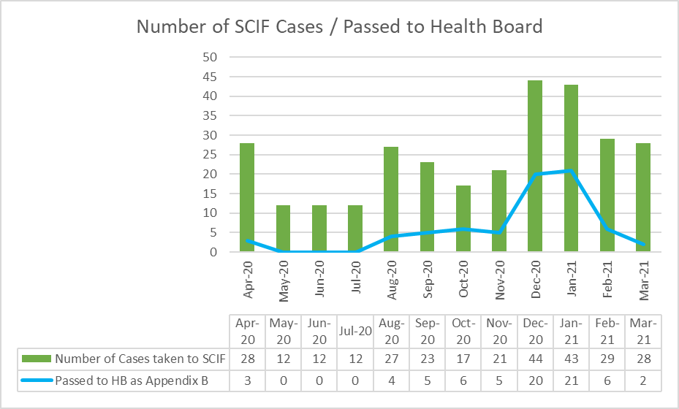

  - Whilst there are many factors affecting response times, which are described later in this report, one of the factors outside WAST’s control is the number of ambulances which wait longer than 15 minutes to transfer patients into secondary care at Emergency Departments (EDs). The graph overleaf shows the number of ambulance hours that are lost outside EDs which, if released earlier would have reduced patient waits in the community. As with the other graphs, during the first wave of the pandemic, the number of lost hours decreased very significantly, but in quarter three built up again to pre-CoVID-19 levels.

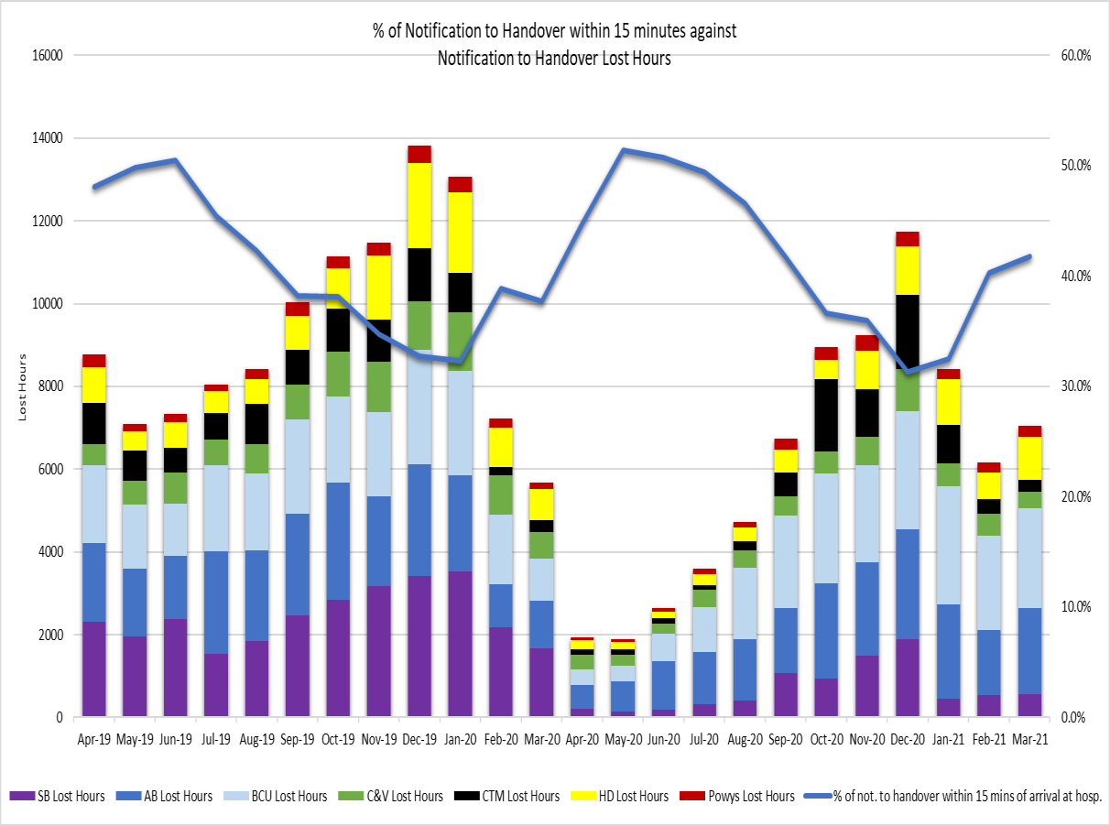

  - 7,052 hours were lost to handover in Mar-21, compared to 11,708 in Dec-20 and 1,900 in May-20. 64% of these lost hours are attributable to two health boards. The 2021/22 EASC EMS commissioning intentions include: “NHS Wales is a significant outlier in the UK and Internationally for lost productivity due to extended notification to handover times. By the end of 2021/22 NHS Wales will have reduced 1 hour waits to less than 5% of total arrivals and ensured that total lost hours at Welsh Hospitals do not exceed 150 hours per day on 95% of the year”. Application of this commissioning intention would mean c.5,000 hours per month lost. Through the Chief Operations Officers (COOs) Group there has been a recent improvement in the application of the immediate release procedure for Red calls.

  - In the last three months WAST has reported 20 SAIs to Welsh Government and continues to have regular dialogue with EASC through the National Collaborative Commissioning Unit (NCCU).

Health & Safety

  - There have been 807 reported staff positive CoVID-19 since the start of the pandemic (Mar-20 to Mar-21) with significant reduction in staff confirmed as COVID positive from 69 in Feb-21 to 19 in Mar-21. Performance indicators measuring progress of investigations and RIDDORs submitted to the Health & Safety Executive (HSE) are presented monthly at Senior Pandemic Team meetings. A Workplace risk assessments priority schedule has been developed with local risk assessments being reviewed by health and safety practitioners.

Subsequently the Health & Safety function and Trade Union Partners are providing further support via the undertaking of regular CoVID-19 premise inspections with compliance reports submitted to Quality, Safety and Wellbeing Advisory Cell for noting and assurance. Performance indicators measuring progress against workplace risk assessment schedule also presented at Senior Pandemic meetings on a regular basis.

Clinical Outcomes

  - This report includes an update for the clinical indicator measures Oct- 20 to March-21.

  - Currently, WAST reports on seven clinical indicators. Five of these are care bundles for specific conditions; a care bundle requires each and every specific criterion of care to be met. Six of the clinical indicators have a commissioning intention of 95%, the exception being the return of spontaneous circulation (ROSC) indicator.

  - Of the six, three achieved the 95% in the period Oct-20 to Mar- 21 (Quarter 3 & 4), two others were above 80%. The ST segment elevation myocardial infarction (STEMI) indicator is an area of concern achieving less than 80% through quarters 3 & 4. These percentages refer to the application of a whole bundle of care. For each of the individual elements, apart from Dec-20 and Feb-21 the percentage compliance is consistently above 84%. A deep dive of the STEMI compliance is being undertaken to inform focused improvement work.

  - The percentage of patients with attempted resuscitation following cardiac arrest, documented as having a ROSC at hospital door was 6.6% in Mar-21. Rates of ROSC are complex and determined by a number of factors which contribute to the speed of response and the application of early defibrillation and chest compressions. These factors can include location of the incident, resource availability, public access defibrillation, willingness of bystanders to engage in resuscitation. As part of its plans for 2021/22, the Trust is developing the concept of Cymru High Acuity Response Units for implementation. This concept is in place in several areas across the UK and has been very successful in increasing ROSC rates. These units supplement the response to critical incidents and are crewed by a mix of Senior Paramedics and selected paramedics, maximising the provision of enhanced clinical care and ensure the consistent delivery of core critical care requirements across the whole of Wales.

  - A new chronic obstructive pulmonary disease (COPD) clinical indicator has been developed, to support the Band 6 Paramedic project. The specification for this indicator has been sent to Health Informatics to build the report. The onward referral aspect of this indicator is work in progress and forms part of the national COPD pathway development. The Clinical Indicator Review Group has not met due to the pandemic, but meetings are being scheduled as part of the recovery process within the Medical and Clinical Services Directorate.

  - The longer term ambition for WAST is to link its patient and CAD data with health board patient data so that WAST can report on time-based aspects of clinical indicators and track the eventual patient outcome once conveyed into a hospital. The ePCR project will be critical to delivering this ambition. The contract has now been awarded and the project is in delivery phase.
EASC is asked to NOTE that: quarter four has seen a reduction in the longest waits in the community and a downward trend in SCIFs passed to health boards under the Appendix B arrangement; of the six clinical indicators with a 95% target three achieved the target and three missed, with one – STEMI – being a particular concern which is being investigated; and the ePCR project has moved into the delivery phase with the appointment of the successful supplier.

  - WAST is EASC commissioned for two patient flows (journeys) within the unscheduled and scheduled care systems: the 999 Emergency Medical Services (EMS) and the Non-Emergency Patient Transport Service (NEPTS). These patient flows and their safety are now looked at in turn.

EMS Performance

Response Times

  - As outlined earlier in the report, response times for both Red and Amber calls saw a slight improvement in quarter 4 but waiting times remain too long.

  - There are a range of factors that affect response times:

    - Demand: comparing demand is difficult because of the pandemic, but WAST has previously identified that Red demand has increased significantly over the last few years as a result of a change in the way

the Medical Prioritisation Dispatch System (MPDS) treats breathing difficulty calls (an improved approach to patient safety). This is a major contributing factor in relation to Red performance.
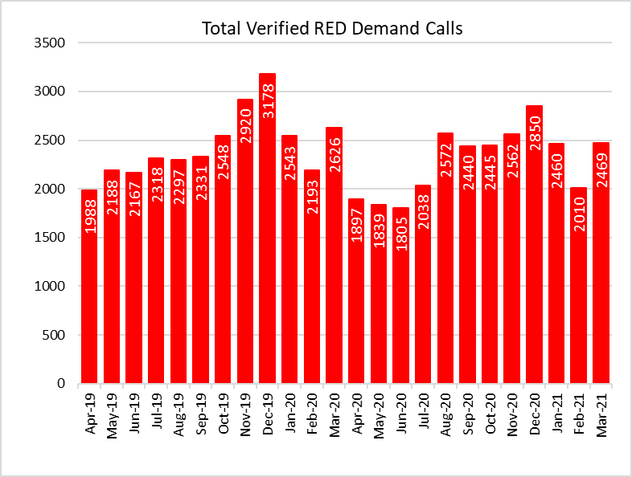
- It should be noted that overall demand has almost recovered to pre- pandemic levels, but remembered that this does include CoVID-19 demand so there is still some suppression in core demand as this point in time.

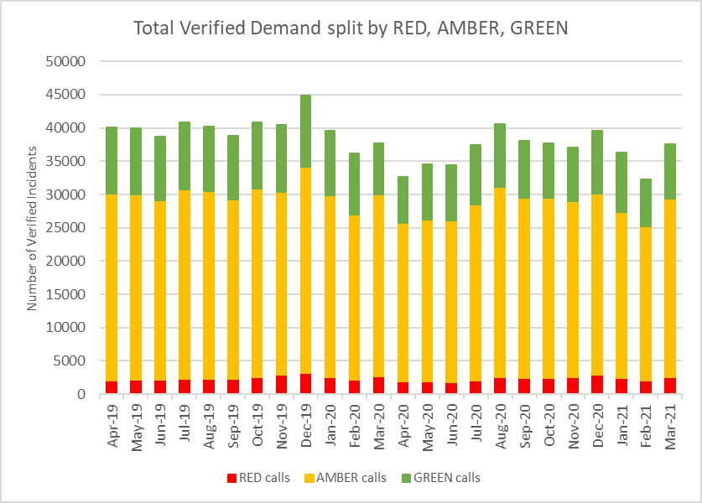

  - The number of Response hours produced: whilst varying month on month, on average the Trust has produced 113,059 unit hours per month over the two years to Mar-21. Over the same period, a further 6,404 hours would have been needed to be produced each month to reach 95% unit hours production (UHP) (the benchmark) for the three main ambulance resource types. In Mar-21 the Trust produced 119,327 hours, continuing to be above the average. As the EMS Demand & Capacity Programme takes effect (see paragraph 2.29) EASC should expect to see the 95% UHP benchmark consistently achieved and an uplift in hours produced; however, it is difficult to evaluate the impact of the additional investment during a pandemic period with high abstractions and a focus on protecting conveying resource over Rapid Response Vehicles (RRVs), the support of the Fire & Rescue Services (FRS) and the military; in Mar-21 WAST received 6,262 unit hours from FRS and the military, 660 hours were provided by students.

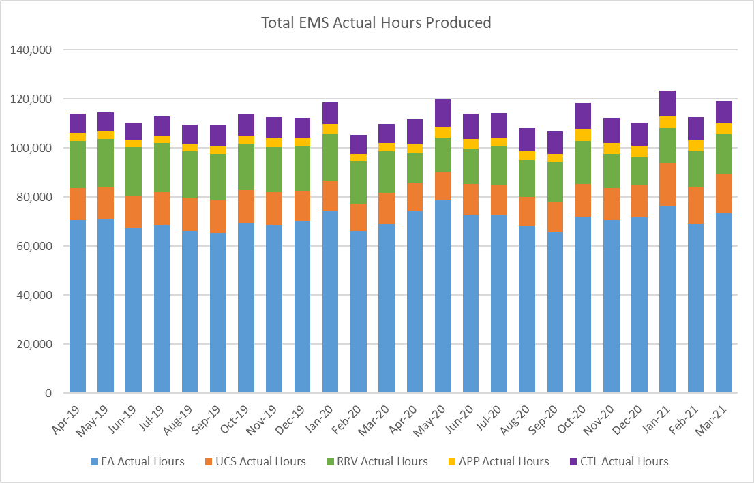

  - The number of hours lost each month due to hospital handover delays. See paragraphs 2.9 and 2.10 above.

  - Multiple “suspected” variables: for the CASC Assurance Meeting WAST provides in month data. The CASC has requested WAST to review the causes of in month day to day Red variation. 23 “suspected” variables have been identified by WAST, with four: demand, utilisation, handover and time as scene considered key. Further analysis is currently being undertaken around these variables as an aid to reducing variation and increasing performance and patient safety.

  - WAST is also engaged in a number of programmes across the unscheduled care system which are designed to “shift left” (i.e. to shift left patient demand left on the emergency ambulance care pathway, where it is clinically safe including): the National Respiratory Work Programme, Contact First, Consultant Connect and WAST continues the process of refining a proposal for EASC and Welsh Government on expanding the Clinical Support Desk (CSD) / 111 capacity to support psychiatric calls. Contact First went live for 01 Sept-
20 (current 111 demand only) in Aneurin Bevan Health Board on 15 Dec-20 and Swansea Bay on 23 Feb-21.

The model of care and operational processes are working effectively with a positive impact to signpost the patient to the right place of care. Aligned to the continuing rollout of 111 in Betsi Cadwaladr Health Board on 22 June-21, preparatory work is continuing to launch the full service (step 2 – public communications) in Aneurin Bevan on the 05 May-21 and also the roll out of the service (Step 1) in Cwm Taf Morgannwg and Hywel Dda in Quarter 2 (dates to be confirmed). The CSD and NHSDW (Hear & Treat) achieved a combined rate of 9.3% in Mar-21 the same as Feb-21. The EMS Demand & Capacity Review identified a benchmark of 10.2% (modelled to be achieved by Dec-21).
  - As shown in WAST’s Winter Plan forecasting and modelling, which was shared by WAST with health boards in Oct-20, if mitigating actions agreed / funded are not sufficient, the WAST demand management plan (DMP) will be enacted. The use of the DMP is now reported each month to the CASC Assurance meeting, WAST provided a detailed presentation to 18 Dec-20 EASC Management Group on the use of the DMP, which moves through a set of action cards (based on agreed triggers) with an increasing focus on patients most at risk during high periods of demand.
EASC is asked to NOTE that: WAST has not achieved the Red 8 minute 65% target for the last eight months; that there are a range of factors affecting Red performance (and Amber); WAST has sought to mitigate the impact of CoVID-19 through a range of actions, in particular, boosting production, minimising lost hours to handover and shift left actions.

NEPTS Performance

  - The NEPTS ambulance quality indicators have now resumed reporting. Key points about NEPTS are as follows:-

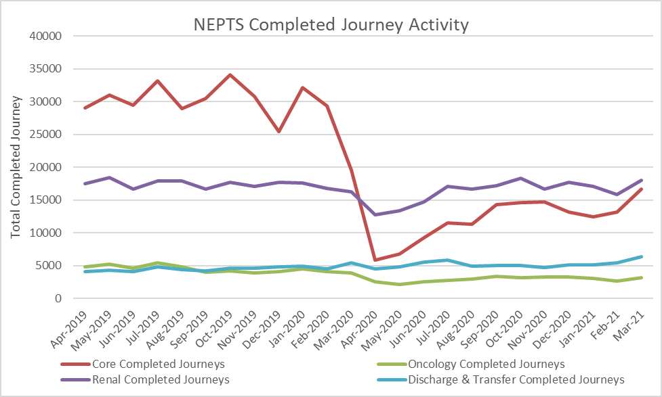

    - CoVID-19 saw a significant drop-in patient transport activity at the start of the pandemic. Levels have begun to increase, but they still have not recovered to pre-CoVID-19 levels; in Mar-21 there were 44,200 completed journeys across the NEPTS service;
    - CoVID-19 abstractions and social distancing has been challenging, but NEPTS has seen a continued improvement in key areas of service delivery particularly discharge and transfer journeys;
    - Enhanced services performance has improved with some tailing off in recent months;

Social distancing means that the number of patients than can be transported per journey has reduced, which has a significant impact on NEPTS capacity;
    - In the first wave there was a significant reduction in outpatient transport activity, which meant that the impact of CoVID-19 on NEPTS capacity could be offset by the reduced demand; however, core demand is now on a clear upward trend;
    - NEPTS capacity is also adversely affected by other CoVID-19 factors: journeys taking longer due to PPE, staff sickness, staff shielding, staff training and testing, infection prevention and control arrangements and so on; and
    - NEPTS continues to liaise closely with the commissioning process.

  - 86% of core journeys arrived within 30 minutes (+/-) of their appointment time in Mar-21; 79% of enhanced renal journeys arrived within 30 minutes prior to their appointment time; and 54% of enhanced oncology journeys arrived within 30 minutes prior to their appointment time. Oncology has been identified as an area of focus from the NEPTS Demand & Capacity Review and will require changes in the way WAST works with the voluntary and community sector (VCS) to improve performance.

  - Whilst there is a Welsh Government ambition to see outreach appointments reduce by 50% “in time” (Health & Social Care in Wales – CoVID-19: Looking Forward), the short term scenario is that as we emerge out of the pandemic response in 2021/22 and the health system is “re-set” EASC may see pent up demand for NEPTS as the system is switched back on and tries to catch up on certain services. This is a significant risk to the system as social distancing/PPE has reduced NEPtS capacity. WAST is currently modelling this scenario and will report the results to the CASC as soon as they are available. In the interim the CASC has reiterated to health boards the need to collaborate with WAST on outpatient health boards services that have a transport dimension.

  - Finally, the NEPTS Demand & Capacity Review is complete and was reported to EASC Management Group (29 Apr-21). WAST will now establish a NEPTS Transformation Programme Board (similar to the one in place arising from the EMS Demand & Capacity Review) to take forward the findings from the review. The NCCU will be in attendance at the programme board. Any decisions arising from the programme that need EASC agreement will be brought to the relevant EASC group. By way of reminder, WAST identified the benefit of this review as a response to the various NEPTS commissioning intentions and resourced it internally, but it has been completed with full engagement from NCCU colleagues and shared along the way with NEPTS DAG members.
EASC is asked to NOTE that: NEPTS has been able to maintain performance through the pandemic period; however, there is a concern that as we emerge from the pandemic and the system is “re- set” and switched back on the combined impact of continuing social distancing and pent up demand could mean a level of patient demand that NEPTS is unable to manage; tactical forecasting and modelling on this scenario is required (and is currently being undertaken); and the strategic NEPTS Demand & Capacity Review has been completed, has been reported to NEPTS DAG and presented to the EASC Management Group with a collaborative NEPTS Transformation Programme Board now being established.

Commissioning, Planning and Service Change

Forecasting & Modelling: Strategic Demand & Capacity Reviews

  - The EMS Transformation Programme (arising from the EMS Demand & Capacity Review) is the Trust’s main strategic response to patient safety and experience concerns for the EMS five step ambulance care pathway.

  - EASC has supported WAST with investment which has enabled WAST to meet its ambulance response 2020/21 recruitment and training target of 136 FTEs. As part of the 2021/22 EASC commissioning intentions EASC has identified the closing of the relief gap as key and has provided further funding in 2021/22 to support the recruitment of a further 127 response FTEs in support of this intention. WAST has clear plans to deliver this further additionality. The programme board meets every three weeks (with the NCCU represented) and reports formally to EASC Management Group bi-monthly. Whilst the programme has made excellent progress on recruitment and training, elements of the programme timeframes have had to be re-cast due to the pandemic response. Key areas of the programme for 2021/22 include:-
    - Closing the “relief gap” (an EASC commissioning intention for 2021/22);
    - Re-rostering the response workforce (WAST has a project board in place and has appointed a change agent third party, with support from EASC, to aid the delivery of this complex project);
    - Deliver an estates contingency plan so that there is sufficient estate to take the FTE additionality planned for 2021/22;
    - A expansion and reconfiguration of clinical services in 111 and CCC in support of hear & treat and see & treat services;
    - CCC transformation, in particular, the reconfiguration of dispatch boundaries and changes to working practices, for example, the single allocator model; and
    - A range of efficiencies (including the re-rostering above, but also reduced roster abstractions and post production lost hours).

  - Whilst the 2020/21 programme was disrupted as a result of the pandemic response and the recruitment and training process had to be digitalized the 2021/22 programme is more complex; the 2021/22 programme has two key strategic risks: trade union support and estate availability, both of which are being actively managed.

  - As part of WAST’s 2021/22 workforce planning, WAST has identified that there is an opportunity to recruit Paramedics over and above the FTEs required to close the relief gap as above. WAST identified this in its 2021-24 IMTP and in subsequent discussions with the CASC. The CASC requested that WAST write out to health boards regarding this opportunity and potential use to support the wider unscheduled care system, which it has done so. WAST is currently waiting on responses to this.

  - As per 2.27 above the NEPTS Demand & Capacity Review has been completed. The Review focused on modelling performance parameters that considered the whole patient journey, from initial pick up, treatment and return to home. A NEPTS Transformation Programme Board is now being established along the lines of the EMS Transformation Programme.

  - WAST undertook innovative forecasting and modelling in support of the seasonal plan (winter). The modelling focused on Dec-20, traditionally the month with the highest demand. The modelling predicted Red 8 minute performance of 53% (actual 53.7%) and use of high levels of the DMP. Further forecasting and modelling was completed for Apr-21 (actual within forecasted range) and further forecasting and modelling has just been completed for WAST’s Summer Plan (21 May-21 to 30 Sep-21). The main focus is now Aug-21 when WAST anticipates high seasonal demand (staycations) coupled with high abstractions (annual leave). In each instance WAST aims to put in place tactical mitigations based on the information received.

  - The 2020/21 EMS and NEPTS commissioning intentions include the development of a “Demand and Capacity Strategy” - a collaboratively developed demand and capacity strategy will set out the ongoing arrangements for proactively undertaking this work for the next decade, this will include the use of forecasting, modelling and health economic evaluations.

Integrated Medium Term Plan (IMTP)

  - The Trust submitted an IMTP to Welsh Government on the 31st March 2021 incorporating year 1 actions to support the Planning Framework for annual plans in 2021/22; however, the IMTP has maintained deliverables spanning 3 years to maintain momentum in realising WAST’s long term strategy. The IMTP was endorsed by EASC on 9th March 2021 and approved by Trust Board on 26th March 2021.

  - The IMTP sets out the Trust’s strategic ambitions, described in four integrated service offers, in support of the EMS and NEPTS five step models, as well as its offer to the wider health and care system as NHS Wales starts to recover from the pandemic response. This is supported by a set of enabling programmes including the realisation of the Trust’s important people, digital, estates and fleet strategies.

  - The plan therefore set out actions for recovery and key programmes of work in year 1 of the plan, with further information about years 2 and 3 in an appendix. The focus is very much on a “shift left” in activity alongside increasing the capacity and capability across EMS, NEPTS and the Trust’s call taking functions supported by a mobile urgent care offer that aims to see and treat more people at home or in the community without the need for secondary care conveyance.

  - The plan is underpinned by a set of fundamental principles of quality, clinical leadership and value including a particular focus on Working Safely, incorporating learning during the pandemic around Health, Safety and Welfare of the workforce. A key area of work in quarter 1 will be to establish the benefits measures that provide assurance the Trust Board and EASC that the plan delivers the intended impact in line with commissioning intentions.

Health Board Changes
  - The Grange University Hospital inter-site transfer service has been live since Nov-20. The Commissioning Agreement for the service has been signed by WAST’s CEO and is awaiting final sign off by commissioners. There have been a number of operational issues to work through over the past 6 months as well as significant learning opportunities and this will be encapsulated in a formal review during May and June in line with the Commissioning Agreement.

  - The South Wales Trauma Network went live in Sep-20. WAST has now established regular reporting arrangements into the network for EASC / WHSSC assurance meetings. Compliance with eLearning has improved with an additional 414 (1,649 in total) people have completed the trauma tool e-learning module, a further 112 have also enrolled on the module. A plan for face to face learning has been established following a year of disruption due to the pandemic. eLearning was used to support the management of major trauma during 2020/21 and face to face learning is now due to commence in May 2021. An internal governance structure for major trauma has now been established and WAST will work with NCCU to establish the ongoing model for transfer and discharge.

  - WAST continues to maintain a line of sight across Health Board strategic and operational service changes. There is a particular need to ensure that WAST is able to support the pandemic recovery, particularly in respect of planned care recovery in Health Boards. The detail is not contained within the shortened annual plans developed for this year, therefore WAST will write out to Health Boards to understand the detail and the impact on EMS and NEPTS services.

  - A summary of the strategic Health Board service change initiatives that WAST is engaged with can be seen in the following map:
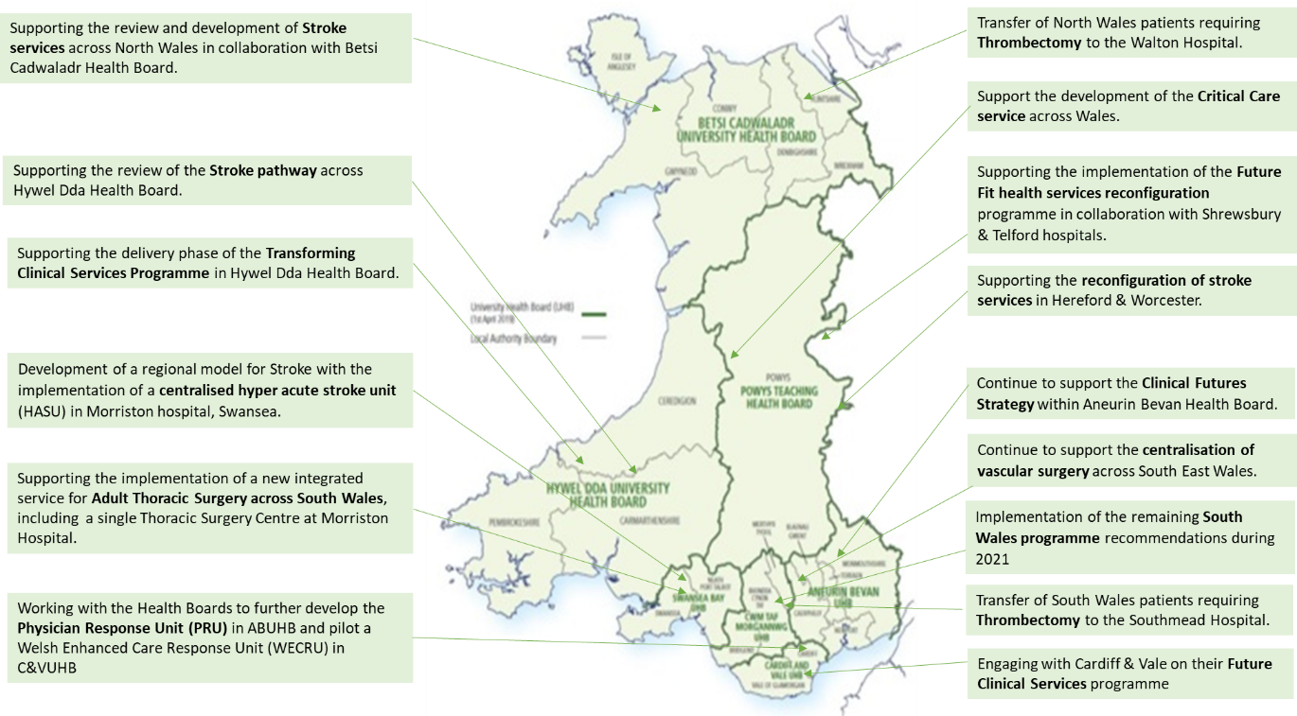

WAST has clear plans in place for year 2 of the EMS Demand and Capacity Programme (2021/22) and has established programme arrangements for implementation of the NEPTS Demand and Capacity Review; WAST has made further progress on forecasting and modelling informing our operational and tactical plans in 2021/22; the Trust has submitted its IMTP for 2021-24; the IMTP will deliver an integrated service offer to commissioners and the wider NHS system in support of strategic service change and pandemic recovery.

Conclusions and Forward Look
  - Performance and patient safety has improved since the very difficult month of Dec-20 and has both WAST’s and the wider health care systems responses to the second wave have taken effect. WAST predicted how difficult Dec-20 was going to be. Whilst performance levels have improved, Red performance has remained below the 8 minute 65% target, but there has been a significant improvement in the “Amber tail” i.e. the longer waiting times for Amber patients normally associated with the 96th to 100th percentiles on the Amber waiting times distribution curve, and therefore patient safety.

  - As WAST moves into 2021/22 it will retain a focus on further tactical responses to the pandemic and its after effects, for example, seasonal planning (summer), but also re-focus on addressing the fundamentals in the EMS five step ambulance care pathway, in collaboration with health boards who have a critical role to play in supporting WAST with investment, holding WAST to account on delivering its planned efficiencies and delivering reductions in handover lost hours. For NEPTS the focus will be on a tactical response to the system “re-set” and potential pent up demand, whilst putting in programme arrangements for transformation linked to the NEPTS Demand & Capacity Review.

  - The WAST IMTP sets out the key programmes of work in support of EASC commissioning intentions, wider NHS Wales service pressures and strategic change ambitions as well as its long term strategy. Year 1 of the IMTP will focus both on recovery from the pandemic and supporting health boards and other partners in their recovery effort, but also in implementing change across its four main service lines, “shifting left” in the five step model where possible and safe to do so.

  - Overall WAST: anticipates remaining in monitor mode as the system emerges from the pandemic; will maintain a strong tactical focus and respond early to any predicted changes to demand or loss of capacity linked to CoVID-19; whilst pushing ahead with its 2021/22 IMTP deliverables.

KEY RISKS/MATTERS FOR ESCALATION TO THE COMMITTEE

Members of the EAS Committee are asked to note that:
  - WAST is now back in a period of monitor as the health care system emerges from the second wave;

  - Quality, safety and patient experience monitoring arrangements have remained in place through the CoVID-19 response and have been enhanced, in particular, monthly reporting to health boards. WAST remains very concerned at the patient safety risks associated with response times that are too long;
  - There was a reduction in long waits in quarter four, after the very difficult month of Dec-20, and 29 SCIF cases were passed to health boards in the last three months to 31 Mar-21;
  - The Red 8 minute 65% target has been missed for the last eight months, with significant health board variation;
  - WAST is currently reviewing historic Red performance data to identify causes in variation and the identification of tactical improvements that could move Red performance above target again;
  - The Amber tail (an area of focus e.g. the Amber Review) has significantly decreased (improved) in quarter four as both WAST and the wider health care system responded to the second wave;
  - WAST remains concerned at the number of hours lost outside EDs and their impact on patient safety, with two health boards being a particular concern (accounting for 64% of the losses), , but notes that there is an explicit EASC 2021/22 commissioning intention to reduce handover lost hours, which WAST will look to actively support;
  - There is a continued focus on strengthening WAST’s health & safety
arrangements;
  - Clinical indicator performance has been reported for quarter four with one indicator, STEMI, being significantly off target and subject to further investigation;
  - The ePCR project is in delivery phase and will enable the linking of ambulance patients with patient outcome data;
  - NEPTS capacity is a significant risk to the system as the system “re- sets” and demand is switched back on to pre-CoVID-19 levels (or higher) as the system attempts to catch up. This scenario is currently being modelled;
  - A NEPTS Transformation Programme Board is currently being established to take forward the findings of the NEPTS strategic Demand & Capacity Review and related projects;
  - Through the commissioning intention process there is a clear collaborative commitment to increasing capacity in the five step EMS ambulance care pathway through a combination of investment and efficiencies (WAST and health board);
  - The EMS Demand & Capacity Programme is making good progress, but estate and trade union engagement are potential strategic risks to the programme, both of which are being actively managed;
  - There is an opportunity to recruit over and above closing the relief gap in 2021/22 and support the wider unscheduled health care system;

  - WAST has just completed tactical forecasting and modelling for its Summer Plan, which is focused on the impact of staycation demand and higher abstractions;
  - The outcome of the Grange University Hospital inter-site transfer service review may result in further work around a transfer and discharge model that is fit for purpose in Aneurin Bevan University Health Board, but also offers the opportunity for learning in developing national models and commissioning arrangements.
  - Change resulting from health boards’ pandemic recovery plans need to be factored into WAST operations and detailed analysis is critical at a health board level and will need to be undertaken to understand the impact of recovery plans on EMS and NEPTS, as well as the consequential impact on 999 and NEPTS control.
  - NEPTS has continued to provide patient critical journeys as determined by health board clinicians, but social distancing has significantly reduced NEPTS capacity and is a risk to the system;
  - An update on WAST’s 2021-24 IMTP will be prepared for the end of quarter 1, including an update on benefits measures.

IMPACT ASSESSMENT

Quality/Safety/Patient Experience implications | Yes (Please see detail below)
Quality/Safety/Patient Experience implications | Identified within the report
Related Health and Care standard(s) | Timely Care
Related Health and Care standard(s) | And all health and care standards
Equality impact assessment completed | Not required
Legal implications / impact | There are no specific legal implications related to the activity outlined in this report.
Legal implications / impact | Included within the body of the report
Resource (Capital/Revenue  £/Workforce) implications / Impact | Yes (Include further detail below)
 | Included within the body of the report

Link to Main Strategic Objective | The Committee’s overarching role is to ensure its Commissioning Strategy for Emergency Ambulance Services utilising the five step patient pathway outlined within the National Collaborative Commissioning Quality and Delivery Agreement and the related outcomes for each care standard aligned with the Institute of Healthcare Improvement's  (IHI) ‘Quadruple Aim’ are being  progressed.  This report focuses on all the above objectives, but specifically on providing strong governance and assurance and  safe and effective patient care
Link to Main WBFG Act Objective | Service delivery will be innovative, reflect the principles of prudent health care and  promote better value for users

- RECOMMENDATION

  - The EASC Committee is asked to:

    - DISCUSS and NOTE the WAST provider report.

