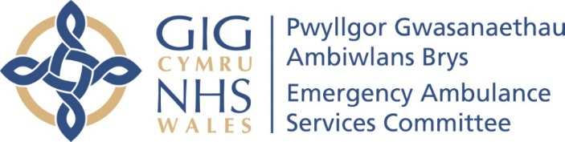

EASC ACTION PLAN – March 2022 Update
Ref | Issue | Action | Lead | Start Date | End Date | Current Position
1 | Enhancing Ambulance Capacity | Additional Emergency Medical Technicians recruitment | WAST | Now | March 2022 | Current Position  17 now operational from November 2021 cohort.  86 will be operational in May 2022.  This ends the 2021/22 EMT recruitment and training.  Previous Position  105 Trainee EMTs currently in training;  17 will become operational in March 2022  88 will become operational in May 2022
1 | Enhancing Ambulance Capacity | Relief gap recruitment | WAST | Apr 21 | March 2022 | Current Position  WAST have reported the forecast position for 31 March 2022 is 1,632 versus the relief gap closed target of 1,691, as reported to the EMS Operational Transformation Programme Board on 1 April 2022. The actual staff in post at 28 February 2022 was 1,639 FTEs.  In addition, 36 FTE Paramedics have been recruited into the CSD 24 operational, 8 in training, 4 hired start next week and five mental health professionals two live and remaining three started on 04 April 2022. This brings the total up from 1,632 to 1,673 against the target of 1,691 with the Trust delivering a +245 FTE establishment uplift over the last two years. Because funding may not be available in 22/23 for the backfill of the 36 FTEs Paramedics recruited into the CSD, the Trust may need to make a saving (£1.8m) by holding open vacancies in the Response workforce. This is still under discussion internally between WAST and the EASC Team.  Previous Position  WAST aim to recruit an additional 127 WTE by end of March 2022. Current additionality is forecast to be 116 WTE.  In year, WAST have agreed to work to recruit a further additional 36 staff, on top of the 127, to allow WAST to backfill an expansion of paramedics into the clinical support desk. WAST have successfully recruited and trained additional emergency medical technicians, but have not been able to recruit the required level of ACA2s (Band 3s), due in the main to insufficient applicants having a C1 licence. WAST have not therefore achieved the 36 additionality overall. WAST have been putting in place mitigating actions to address the C1 licence issue, and are anticipating that they will be able to recruit and train the numbers required early in the first quarter of 2022/23. This will allow WAST to fully close the EMS relief gap on top of the expansion of CSD in Q1.
1 | Enhancing Ambulance Capacity | Agency staffing | WAST | Now | March 2022 | Current Position  Currently been extended unfunded till end of April 2022.  Previous Position  WAST is currently using agency staff to support with cohorting at Morriston and GUH. This is being provided by ID Medical.  Discussions ongoing around the impact and continuation around plans for quarter one.
1 | Enhancing Ambulance Capacity | Increase payment to double time | WAST | Now | March 2022 | Current Position  Currently stopped.  Previous Position  No Change.
1 | Enhancing Ambulance Capacity | Military support | WAST | Now | March 2022 | Current Position  Closed - MACA provision ceased on 30 March 2022.  Previous Position  WAST are currently being supported by an average 232 military personnel under the MACA provision until 31 March 2022. There is a planned withdrawal via a phased approach by locality every two days which will commence on 21 March 2022, reducing availability by 63% (147 military personnel) over the first 7 days:  - Last shift 20 Mar-22 – 54 military;  - Last shift 22 Mar-22 – 46 military; and  - Last shift 24 Mar-22 – 47 military.  Week commencing 28 Mar-22 the final 37% (85 military personnel) will depart as follows over 3 days:  - Last shift 28 Mar-22 – 41; and  - Last shift 30 Mar-22 – 44.  WAST has undertaken forecasting and modelling for April 2022 which includes estimated levels of UHP after the MACA and related metrics.  WAST have supplied the CASC with the results of the forecasting along with possible mitigations if funding is available.
1 | Enhancing Ambulance Capacity | Fire service support | WAST | Now | Ongoing | Current Position  Closed - Ceased on 31 March 2022.  Previous Position  A revised tactical approach to production is under discussion by WAST Senior Pandemic Team for introduction from 01-Apr-22, but the WAST also needs to consider the validity of continued FRS under the current memorandum of understanding (MOU). The current FRS MOU is for CoVID-19. A new MOU will be required to support the Trust with wider system pressures e.g. handover lost hours, and possible refresher training in some areas.
1 | Enhancing Ambulance Capacity | Reduce post production lost hours | WAST | Sep 21 | Ongoing | Current Position  WAST continue to work with Trade Unions on a range of issues including the Rest Break Policy, in particular, return to base meal breaks. Modelling has indicated that the performance/patient safety gain is relatively small. Timescales continue to be worked through.  The Trust has recently agreed and launched a seven work-stream Managing Attendance Project Plan, which is being reported into EMT every two weeks alongside the Performance Improvement Plan, together with an improvement trajectory agreed through the IMTP.  Previous Position  WAST have been working in partnership with Trade Unions on a range of modernisation practices, including return to base meal break lost hours, which form part of post-production lost hours (PPLH).  This work is now coming to a conclusion with Executives now considering proposals, further information on PPLH data and modelling results on proposed changes.
1 | Enhancing Ambulance Capacity | Roster review | WAST | Sept 21 | 22/2023 | Current Position  Roster review has now moved to the fourth stage of the working parties with stage one, two and three completed. Working party four commenced on 4 April. The project is on target for the go live between September 2022 and November 2022. The project will see a significant (+30) uplift in EAs at peak, aimed at reducing Amber 1 waiting times.  However, it should be noted that the roster review and the predicted levels of performance/patient safety were based on handover lost hours in December 2018 (6,038). In March 2022 24,418 hours were lost to handover or 2,123 11.5 hour shifts i.e. any benefit from the roster review will be more than offset by the increase in handover lost hours.  The roster keys include the new CHARU resource, plus an agreed adjustment for Hywel Dda (no reduction in EAs) which are not funded at this time. These, along with the possible need to hold vacancies open to fund the uplift of Paramedics into CSD, will mean that the relief gap will re-open.  Previous Position  WAST held working party 3’s (28 Feb-22) as planned in what is a four stage working party (engagement) process. The project is on target for the go live in Sep-22 to Nov-22. There are some political concerns in CTM North and Monmouthshire, as a result of the planned removal of RRVs, however, the WAST is proceeding with the roster keys as proposed through the independent collaborative review i.e. based on the sophisticated modelling the WAST uses. WAST has organised extensive internal communications and engagement for staff on these changes, including one to ones for some affected staff groups; however, WAST does expect some continued resistance both externally and internally, which the WAST is responding to with various briefings and communications.
 |  | St John support | WAST | Sep 21 | Mar 2022 | Current Position  Extended till end of April 2022. Three vehicles per days for 12 hours.  Previous Position  St John still providing an average five 12 hour crews per day. This is due to end on 31 March 2022 due to current funding.  Discussions ongoing around the impact and continuation around plans for quarter one.
2 | Winter Forecast | Winter forecast - using optima predict software to understand forecast demand, performance and escalation levels | WAST | Sept 21 | Oct 21 | Current Position  Closed  Previous Position  Forecast available and in use for planning.
 | Quarter 1 Forecast | Optima predict software to understand forecast demand, performance and escalation levels for quarter 1. | WAST | April 22 | June 22 | Current Position  Forecast available and in use for planning.
3 | System Escalation | Emergency Department Escalation Tool and Demand Management Plans | NCCU | In development |  | Current Position  Being progressed under the Urgent Emergency Care Programme.  Previous Position  Continuing to work on the EDQDF implementation towards the goal 4 priorities. Linking in with Health Boards to ensure their IMTPs are aligned to the goal 4 strategic priorities.
3 | System Escalation | System wide escalation | NCCU | In development |  | Current Position  Supported by NHS Wales Leadership Board. Focused meetings taking place between CASC, Health Boards and WAST meetings twice each within the next month.  Previous Position  Continuing to engage with stakeholders. Paper was taken to NHS Wales Leadership Board 22 February 2022. Final comment to be received from CEOs this week. Implementation plan will be developed following final comments.
3 | System Escalation | WAST Clinical Safety Plan | WAST | Live |  | Current Position  No Change  Previous Position  Live as of 13 January.
4 | Cohorting | Cohorting - Utilising ambulance service staff to hold multiple patients, allowing ambulances to return to community response | Ysbyty Glan Clwyd, BCUHB | TBC |  | Current Position  Over taken by local handover development plans.  Previous Position  Handover remains extremely challenging.  Letter from CASC to CEOs regarding handover improvement plans sent on 4 February 2022.
4 | Cohorting |  | Grange University Hospital, ABUHB | Live |  | Current Position  Currently temporarily been extending till end of April 2022.  Previous Position  Issues around sourcing agency staff remain but the position has improved with the addition of agency nurses to the rotas. Weekly meetings with agency to deal with live issues.
4 | Cohorting |  | Morriston, SBUHB | Live |  | Current Position  Currently temporarily been extending till end of April 2022.  Previous Position  Issues around sourcing agency staff remain but the position has improved with the addition of agency nurses to the rotas. Weekly meetings with agency to deal with live issues.
4 | Cohorting |  | System Deployable Assets | As per above. |  | Current Position  Private provider has units available, interested HBs made aware.  Previous Position  Project currently paused. Alternative arrangements in place and additional vehicles available on a temporary basis if required.  Cost benefit analysis of undertaken, on capital purchase. Alternative provider quotes received. Capital case being submitted to WG official’s w/e 19 November.
5 | Handover Delays | Reduce to sustainable levels | ABUHB | Current Position  Handover remains extremely challenging. Responses received from each health board to the CASC on Handover Improvements. EASC Team currently collecting responses into single action plan.  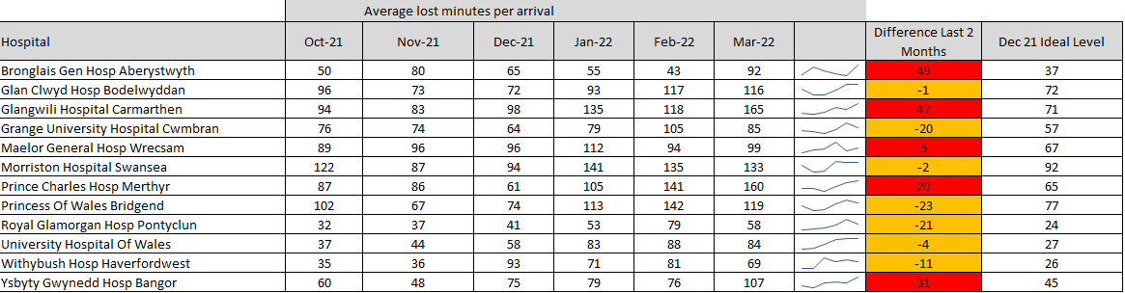  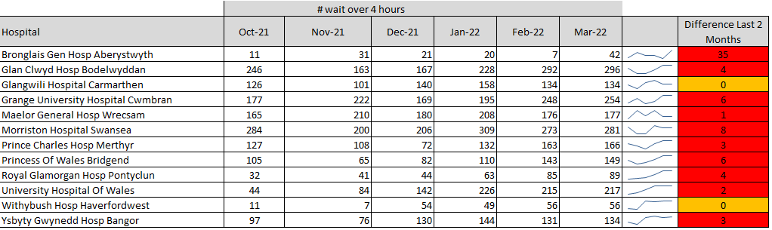  Agreed Commitment  The committee agreed to the following deliverables as the start point of their commitment to reducing handover delays:  - No ambulance handover will take more than 4 hours.  - We will reduce the average lost time per arrival by 25% from the October 2021 level at each site (from 72 minute to 54 minutes at an all Wales level).
5 | Handover Delays | Reduce to sustainable levels | C&VUHB
5 | Handover Delays | Reduce to sustainable levels | CTMUHB
5 | Handover Delays | Reduce to sustainable levels | HDUHB
5 | Handover Delays | Reduce to sustainable levels | SBUHB
5 | Handover Delays | Reduce to sustainable levels | BCUHB
6 | Demand & Capacity Review Update | Demand & Capacity Review Update modelling to reflect system changes since 2018 | WAST/EASC | 19-Aug-21 | Ongoing | Current Position  The Trust has received the final draft report from ORH on the full inversion of the triangle i.e. maximum shift left. The formal steering group to receive the report is on 11 April 22 and is attended by members of NCCU.  The draft report has already been shared with the Deputy Chief Ambulance Services Commissioner. It identifies that WAST could reduce conveyances to EDs and reduce handover lost hours through this increased non-conveyance. This is modelled on a significant expansion in APPs responding to a wider code set and suggests that in order to address handover, WAST does need investment to make this change. Focused meetings taking place between CASC, Health Boards and WAST meetings twice each within the next month.  Previous Position  Discussions remain on going regarding capacity requirement for 2022/2023
7 | Remote Clinical Support | Emergency Communications Nurse System (ECNS) - Implementation | WAST | 01-Sept –21 | 17 May 2022 | Current Position  WAST expect to go live 17 May following testing of the software which is currently being undertaken. WAST have faced challenges around providing the training due to service demand, annual leaves and the requirements to maintain a safe level of UHP.  Previous Position  WAST are currently recalculating the go live date based on the progress of training for staff and auditors and there are some ICT requirements which need to be met to make the system available to the teams once trained.  WAST are expecting a go live date in late April which will be informed in the short term once the plan is finalised.
8 | Physician Triage, Assessment and Screening | PTAS (Physician Triage, Assessment and Screening) provides direct access to the WAST incident stack to manage appropriate patients | ABUHB | TBC | Ongoing | Current Position  Proposed go live date 7 April, WAST awaiting signed MOU from ABUHB.  Previous Position  Potential go live date of 14 March. WAST have requested the signed JCA to support the go live date.
8 | Physician Triage, Assessment and Screening |  | BCUHB | Live | Ongoing | Current Position  Live – WAST and BCUHB working on finalising documentation.  Previous Position  Live – WAST awaiting signed MOU from BCU.
8 | Physician Triage, Assessment and Screening |  | C&VUHB | TBC | Ongoing | Current Position  No change.  Previous Position  WAST awaiting documentation C&V. Arrangements being made for training within the next two weeks for approximately 25 users.
8 | Physician Triage, Assessment and Screening |  | CTMUHB | TBC | Ongoing | Current Position  WAST and CTM meeting to discuss PTAS on 20th April.  Previous Position  Paper has been submitted to the CTM Board for approval. WAST have shared MOU and JAC and are being review by the CTM governess process.
8 | Physician Triage, Assessment and Screening |  | HDUHB | Live | Ongoing | Current Position  No Change – Live  Previous Position  Training took place for an additional users 26 January. Arrangements ongoing for additional IT equipment and training.
8 | Physician Triage, Assessment and Screening |  | SBUHB | TBC | Ongoing | Current Position  WAST working with SBUHB on dates around availability over the next two to three weeks to hold training sessions.  Previous Position  A list of users has been provided and accounts created. WAST currently liaising with Swansea Bay to agree training dates. Some users have previously received training and we will share the training video with them.
8 | Physician Triage, Assessment and Screening |  | PTHB | TBC | Ongoing | Current Position  Meeting held on 23 March to discuss PTHB demand data and how to progress with PTAS. WAST will narrow down the data by postcode to allow PTHB to discuss with HDUHB and BCUHB around the process for PTAS. Follow up meeting currently being arranged.  Previous Position  The demand data has been shared with Powys.  A meeting is scheduled with Powys for the 23 March to follow up on this.
8 | Physician Triage, Assessment and Screening |  | Health Boards | Now | 3 Nov 2021 | Current Position  Firewall issue resolved.  Previous Position  Current firewall issue preventing some HBs access to the system, WAST working with DHCW to explore national solution.
8 | Physician Triage, Assessment and Screening |  | EASC Team |  |  | Current Position  EASC Team continues engaged with WAST and HBs colleagues to expedite the delivery of PTAS model across Wales.
9 | Mental Health | Mental Health Support to CSD | WAST | Now | Ongoing | Current Position  Five out of six Mental Health Practitioners have commenced their induction programme. Post to be re-advertised to fill the remaining vacancy.  Previous Position  Four Mental Health Practitioners have been recruited. Two MHPs start on the 7th March and two start on the 4th April. Interviews are taking place on the 11th March for the remaining one vacancy. The MHPs will be in training for the first eight weeks. With an operational go live day of 2nd May 2022.
10 | Same day emergency Care | Increase opportunities for direct access to same day emergency care | NCCU | Now | Ongoing | Current Position  Action now under the remit of the Urgent and Emergency Care Programme.  Previous Position  The All Wales WAST (Paramedic) Direct Referral to SDEC Policy had been finalised and sent to Andrew Sallows and Frank Atherton for approval. Health Boards first set of returns on the SDEC investments were due back at the end of January. The measurements to be reported were agreed with Health Boards in their investment letters.  The 2021 SDEC benchmarking project opened on 15th November 2021 for all Welsh HBs and Trusts. Data collection closed on 10th January 2022. NHS Benchmarking are in the process of producing a comparison report for each Health Board based on each hospital footprint. The Benchmarking team will host a webinar on 1 March to present the SDEC findings.
11 | Specialist Advice and Guidance | Specialist Advice and Guidance (Consultant Connect) | Joint WAST /EASC | Now | Ongoing | Current Position  Current service provider extended by Welsh Government until new provider has been sourced. Procurement Process had started with WAST representation on the scoring panel. Anticipate that new provider will be confirmed in Q1.  Previous Position  Further update will be provide following SAG Project Board on 11 March 2022.
12 | Utilisation | Utilisation measure development | WAST | Now | Ongoing | Current Position  WAST have recently started trialling a live utilisation report; however, there are still some data issues for utilisation reporting, in particular, relating to PPLH. Health Informatics have made available new reporting which is an improvement on the previous report, however the ultimate fix is required from our CAD supplier and a date for this is not currently known.  The Trust is keen to develop utilisation reporting, as a key part of its emerging Forecasting & Modelling Framework (EASC commissioning intention for 22/23); however, it is likely to indicate that the levels of utilisation are far too high, for example, an EA could be 100% “utilised” sat outside an ED for an entire shift.  Previous Position  WAST is now in a position to re-start utilisation reporting for the weekly operations meeting using Net Utilisation. The new net utilisation report is still limited to "looking back at the past week", not yet for "looking at the forecast for the next few weeks", but this is under-development and will provide the third level of forecasting/modelling for the EMS service i.e. strategic, tactical and operational.

