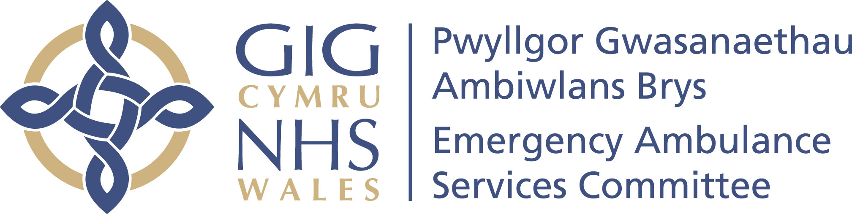 | Your ref/eich cyf:
 | Our ref/ein cyf:
 | Date/dyddiad: | 18 February 2020
 | Tel/ffôn: | 01443 744945
 | Fax/ffacs:
 | Email/ebost: | Stephen.Harrhy@wales.nhs.uk

By Email

Dear Colleagues,

RE: EASC and WAST Quality and Delivery meeting held on 14 February 2020

I am writing following the Q&D meeting on 14 February 2020 which was attended by:

For EASC: Stephen Harrhy, Julian Baker, Ross Whitehead, James Rodaway, Gwenan Roberts and Jonathan Jones.
For WAST: Rachel Marsh, Chris Turley, Claire Vaughan, Brendan Lloyd, Louise Platt and Steve Johnson.

Thank you for the helpful presentation. For future meetings, it was agreed that the WAST presentation would be sent to the EASC team no later than one week before the next meeting (required no later than 6 March 2020). I would expect your presentation to not only cover a description of the current position but also the root causes of issues of concern and the mitigating actions being taken. It would also be helpful when you are presenting information to include your forecast of future trends and not just a review of past performance.

The following issues were discussed and noted:
- It was reassuring that ‘Red’ performance was over 65% in January and the service attended more red calls within 8 mins in December than previous; ‘Amber’ performance was also improving
- The potential approach to incentives and sanctions
- Variation in the immediate release information
- EASC had commissioned a staff engagement & experience survey from Picker (Europe) for emergency ambulance services (timing to align with NHS Wales staff survey)
- Concerns raised by WAST in relation to staff for the service change for the Grange development
- Frontline staff additionality: need to establish an agreed baseline; reduced vacancy factor; turnover; internal promotion and backfill; baseline data; retire and return; reduced overtime; total training capacity; assumptions about resources needed to train and real time forecasting which will lead to an increase in training costs.
- Ministerial Ambulance Availability Taskforce and progress to date
- Significant variation in serious adverse incidents (SAIs) with the highest incidents in the Swansea Bay SBUHB area
- Awaiting the submission of the breach report as recommended in the Amber Review for patients waiting for very long periods
- Flu vaccination rates for staff disappointingly low, but overall 5% higher than last year
- Ongoing work related to the preparations for the Coronavirus
- Overview of the winter plan – 111 call abandonment rate increasing; increased user left call rate in EMS (reported in AQIs)
- Issue in Powys PTHB and BCUHB re falls service not yet commenced
- Fit to sit guidance completed
- Role and effectiveness of HB Clinicians in CCC to be looked at further
- Mental health portal developed; all resources to support staff available
- Winter evaluation for Health and Social Care will be undertaken by the NCCU
- Unscheduled care system leadership for the daily regional escalation calls had commenced led by WAST
- Draft report for NEPTS D&C will be available in July 2020.
Actions for the WAST Team were agreed as follows:

- The WAST Presentation to be received no later than one week before the meeting and all graphs to be comparable (and include forecast information where applicable). The root causes of issues of concern and the mitigating actions being taken should also be included.
- The impact of safe cohorting of patients to be clarified
- Consistency and clarity on issues impacting on ‘Red’ and ‘Amber’ performance required
- Immediate release information to be shared
- Monthly information on sickness absence and mitigation to be provided
- Training plan for new starters to be provided in more detail
- Information related to serious adverse incidents which is presented to the WAST CEO to be shared
- More information on the management of concerns to be provided at next meeting
- Quarterly report on patient experience and engagement (starting at the next meeting) this needs to include the breakdown of Coroner’s requests and actions
- Receive the scenarios from WAST related to plans re the Coronavirus
- High levels of EMS ‘user left call’ abandonment in the AQIs to be investigated and reported at the next meeting
- Receive the actions from the winter plan.
Future Meetings

- Receive information about the NEPTS in more detail
- Receive information on clinical indicators and clinical performance management
- Receive a presentation on tools and methods used for patient experience
The EASC Team agreed to share work on ‘good days and bad days’ and would need to work with WAST in relation to the linked data sources and combine with work of Optima.

The actions and plans for future meetings will be added to the action log and forward look which will follow.

Yours sincerely
Stephen Harrhy

Prif Gomisiynydd y Gwasanaeth Ambiwlans / Chief Ambulance Services Commissioner

cc
Andrew Sallows Welsh Government
Aled Brown Welsh Government
Ross Whitehead EASC Team

