AGENDA ITEM
3.2

EMERGENCY AMBULANCE SERVICES COMMITTEE

welsh ambulance services nhs trust (WAST)
provider update

Date of meeting | 10 March 2020

FOI Status | Open/Public

If closed please indicate reason | Choose an item.

Prepared by | Rachel Marsh, Director of Strategy, Planning and Performance (WAST)
Presented by | Jason Killens, Chief Executive WAST
Approving Executive Sponsor | Chief Executive

Report purpose | FOR DISCUSSION / REVIEW

Engagement (internal/external) undertaken to date (including receipt/consideration at Committee/group)
Committee/Group/Individuals | Date | Outcome
(Insert Name) | (DD/MM/YYYY) | Choose an item.

ACRONYMS
ABUHB  CTMUHB  D&C  EMS  NCCU  NEPTS  SAI  WAST | Aneurin Bevan University Health Board  Cwm Taf Morgannwg University Health Board  Demand and Capacity  Emergency medical services  National Collaborative Commissioning Unit  Non-emergency patient transport services  Serious Adverse Incident  Welsh Ambulance Services NHS Trust
- SITUATION/BACKGROUND

  - The purpose of this report is to provide EASC with an update on key issues affecting quality and performance for Emergency Medical Services (EMS) and Non-Emergency Patient Transport Services (NEPTS) and also to provide an update on strategy and planning for EMS and NEPTS respectively.

- SPECIFIC MATTERS FOR CONSIDERATION BY THIS MEETING (ASSESSMENT)

Quality, Safety & Patient Experience

Serious Adverse Incidents
  - WAST continues to review and discuss potential Serious Adverse Incidents (SAIs) at its Serious Case Incident Forum. The themes and trends from those cases reported as SAI’s include response delays, call categorisation, missed allocation and clinical practice issues.

  - The following table shows the total numbers of SAIs reported to Welsh Government by WAST, by Health Board area. A closer review of the learning from these SAIs will be undertaken at a future Quality and Delivery Assurance meeting.

SAIs Reported to Welsh Government
 | ABUHB | SBUHB | BCUHB | CVUHB | CTMUHB | HDUHB | PTHB | Total
2017/18 | 17 | 10 | 12 | 6 | 2 | 1 | 0 | 48
2018/19 | 11 | 7 | 13 | 15 | 1 | 4 | 0 | 51
2019/20 to date | 10 | 13 | 1 | 5 | 5 | 3 | 1 | 38
  - Following a Patient Safety event held in October 2018 with Welsh Government and the Delivery Unit, a Joint Investigation Framework has been developed and implemented. Since ratification this has clarified the process to be followed where a potential SAI relates to a delayed ambulance response as a consequence of identified hospital notification to handover delays. This was agreed at the Directors of Nursing forum, and outlines which organisation will be responsible for the investigation and the potential reporting of the SAI.

  - In addition to the volumes reported above, the Trust has passed 34 incidents in 2019/20 to the Health Boards for investigation.

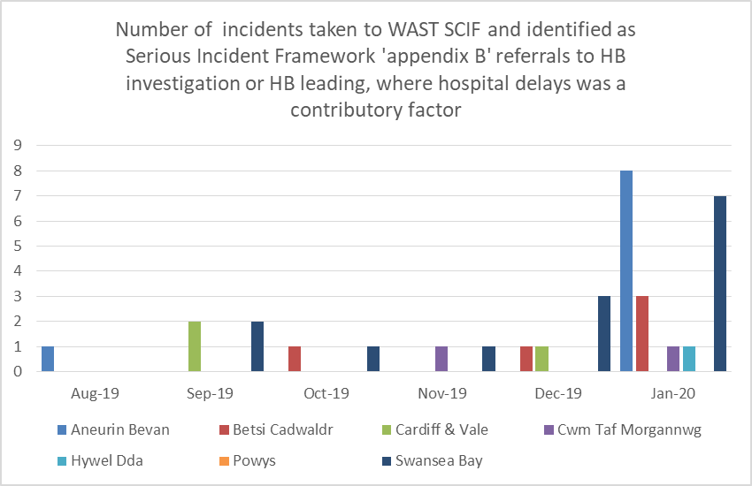

  - There have been some very difficult patient experience stories which have played out in the media. Events like these are extremely distressing to the families concerned and also to the clinical colleagues involved, which is beginning to cause burnout and departures from the service.

Coroners’ Activity
  - WAST is continuing to receive large numbers of requests for information from coroners. During 2019-20 (February to January), a total of 232 requests have been received relating to HM Coroner requests for information / requesting staff attendance / informing WAST they are an interested party. Again, the majority of these cases relate to incidents where there was a delayed ambulance response to a patient in the community. Work will be underway in the near future to reconcile Datix, ensuring that WAST hold up to date and accurate information.

Longest Waits
  - The Patient Safety Team are now undertaking regular reviews of the longest responses to patients, even where no complaint or concern has been received or raised, this is to provide assurance around the quality of the care that they received. The following table details patient waits 12 hours and over.

  - Numbers have increased over the winter months, although the January figures have come down from the high of 540 in December. This remains one aspect of patient experience, and a further analysis of the full range of work undertaken within WAST in this regard will be taken to a future Quality and Delivery Assurance meeting.

EASC is asked to NOTE: the high numbers of patients waiting 12 hours or over for a response, the continuing risks to patient safety and the number of SAIs and HM Coroners’ activity.

Performance

Red Performance
  - In Nov-19 and Dec-19 Red 8 minute performance was less than 65% for the first time since the move to the Clinical Response Model in Oct-15. However, performance recovered in January 2020 at 66% and early indications are that February performance will be above 65%, although the data will not be formally verified and reported until the 3rd week in March. There continues to be significant variation in health board performance with Cardiff & the Vale the highest performer and Hywel Dda and Powys the lowest performers.

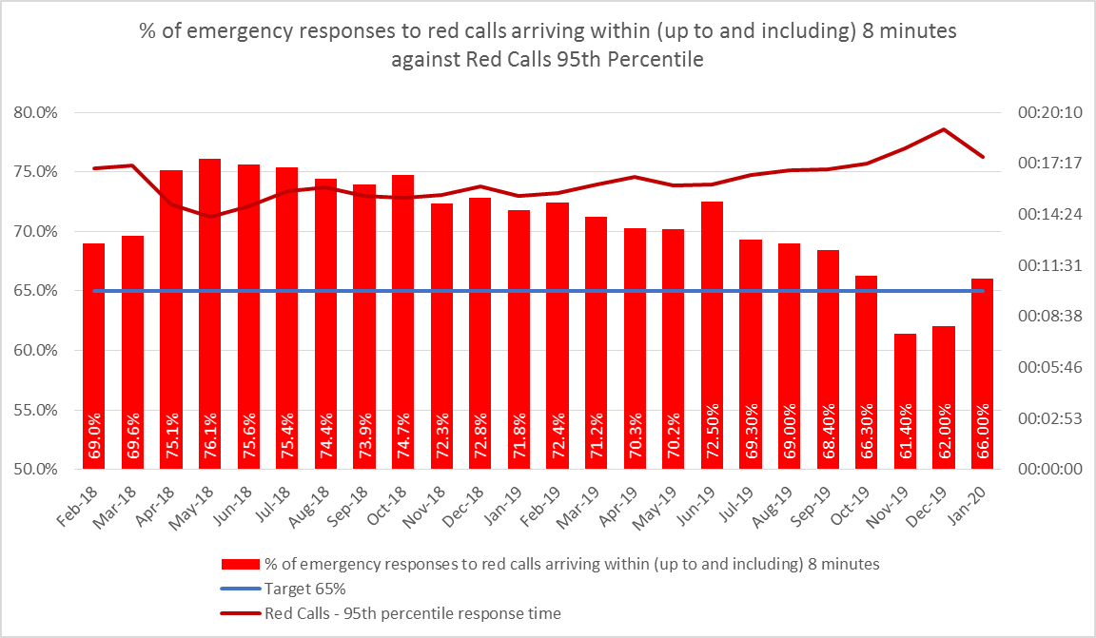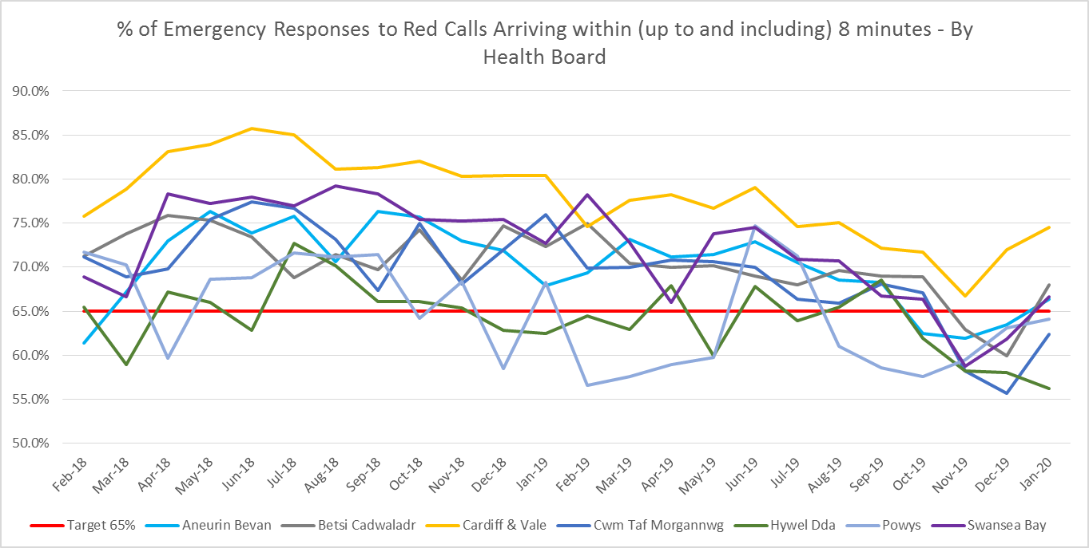

  - Demand changes are one of the main factors affecting performance for all categories of calls. The increase in red demand is shown in the graph below, and is as a result in a change in application of the Medical Priority Dispatch System (MPDS) which is seeing a greater proportion of breathing difficulties coded as Red. The change was introduced as a result of a visit from the Academy and the Trust is working closely with them to ensure that the guidance is being applied appropriately. It is likely that this level of Red demand will continue into the future.

  - The number of hours produced by WAST is a second major determinant of performance. As a result of detailed winter planning discussions internally and with the CASC, a series of incentives have been put in place to increase overtime uptake at key times. This has been very successful and has seen hours produced in January 2020 much higher than in previous years. The scheme in continuing into February, but will end in March.

  - The third key determinant of performance is handover lost hours. The graph below shows the increasing levels of lost hours over the past year, but a significant reduction to date in February, with big improvements seen in AB and CTM UHBs as a result of the cohorting initiatives deployed.
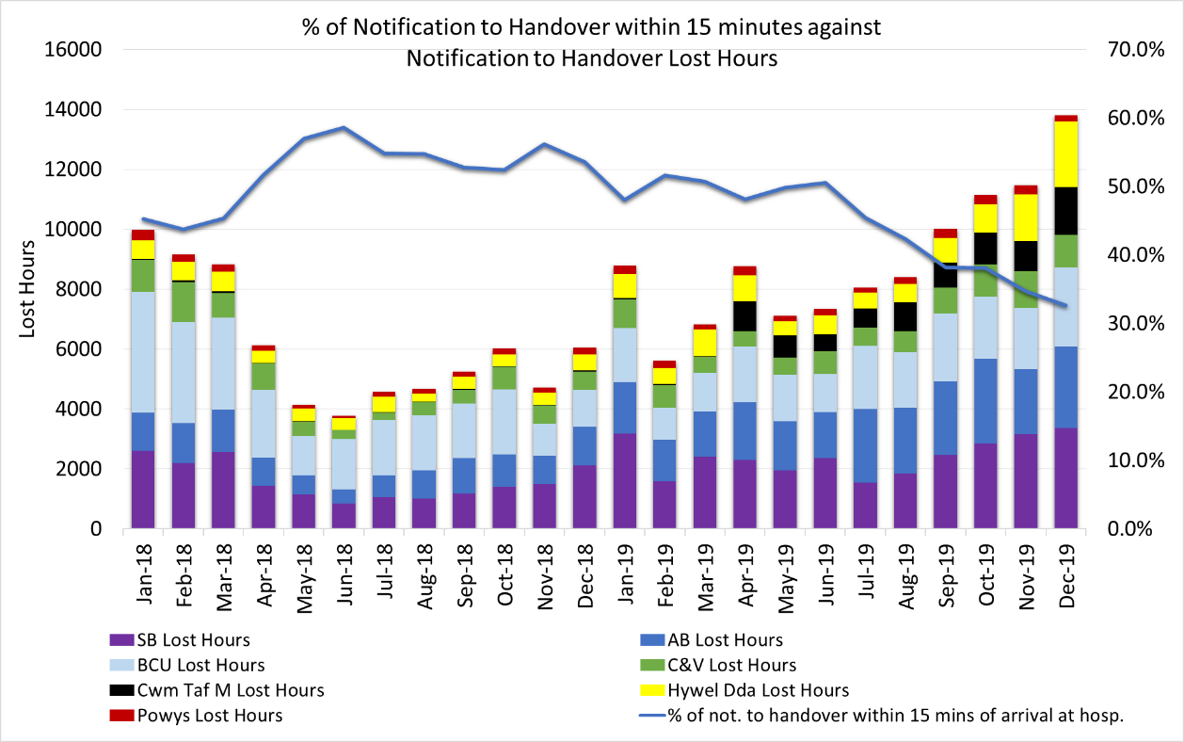
  - The internal Red Improvement Plan continues to be reviewed weekly by the WAST Director of Operations.

  - As reported to Sep-19 EASC, WAST has recently revised its process for Managing Immediate Release Requests. The revised process has allowed improved accuracy of reporting with effect from 30 Jul-19. The graph below shows the number of requests split by those declined and accepted.

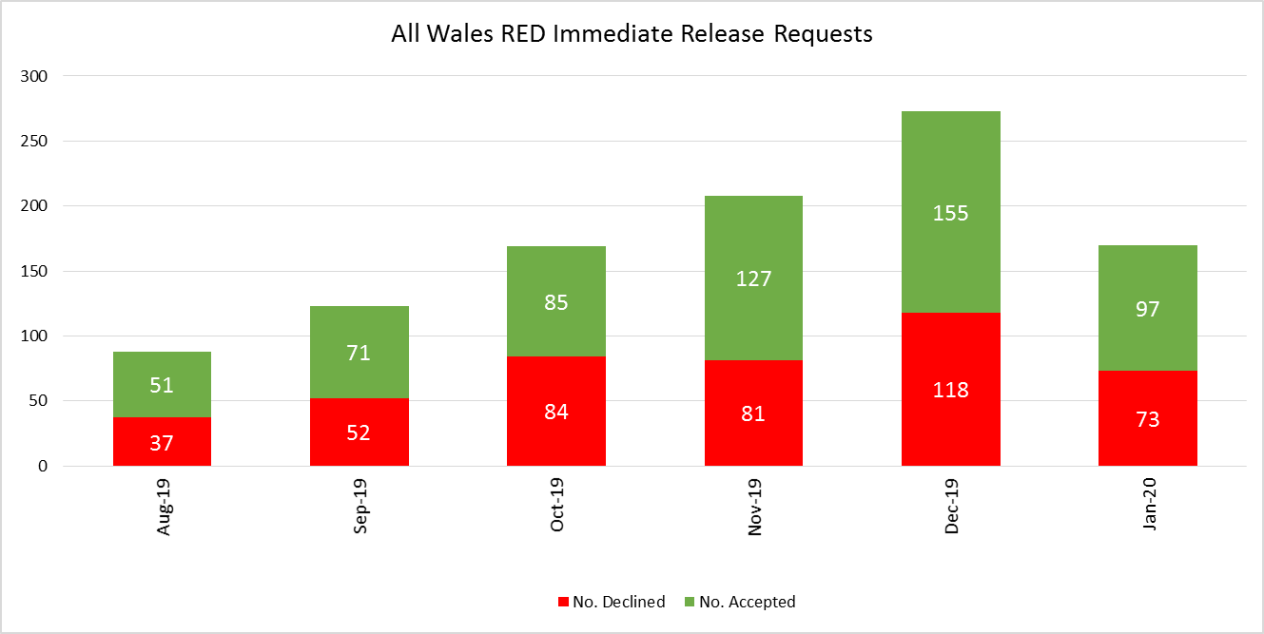

Amber Response times / Amber Review
  - Amber response times remain an area of significant concern although, in line with red performance times, Amber median, 65th centile and 95th centile times have decreased in the last 2 months.

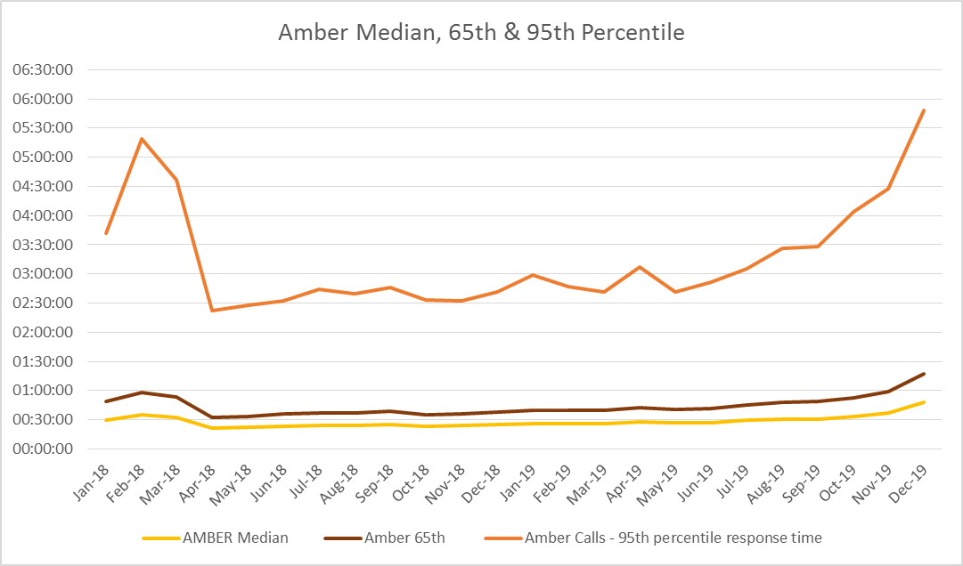

  - The key action in the Amber Review Implementation Programme was the EMS Demand & Capacity Review. A summary of progress to date in implementing the outcome of the D&C review is included later in this report.

Winter Planning

  - As part of the WAST Winter Plan, a range of key initiatives were agreed with EASC to support performance which have been pro-actively managed through the winter to date. These include:-
- Improved access to clinical information, patient records and senior decision making in support of on-scene clinical assessment via Clinical Support Deck (CSD)/NHSDW (implemented in Jan-20 and available from 08:00 to midnight);
- Single Integrated Clinical Assessment and Triage (SICAT) model (GP in Clinical Contact Centre (CCC)) in operation in Betsi Cadwaladr UHB, Swansea Bay UHB operating similar model and Aneurin Bevan UHB continue to pilot an approach from the Clinical Contact Centre in Vantage Point House;
- Patient Flow Co-ordinators in Aneurin Bevan UHB and Swansea Bay UHB;
- Additional Unscheduled Care Service (UCS) capacity via St John Cymru (an extra 377 hours per week);
- Level 1 Falls Assistants rolled out to most of Wales via St John Cymru, with between 7 and 10 vehicles operational each month through the winter plan period. There has been a delay in rolling out the service to Powys and BCU due to difficulties in recruitment in these geographical locations;
- Patient Cohorting at key emergency department sites: YGC: live 16 Dec-19, RG: live early Feb-2020, POW: live 20 Jan-20; work continuing in Morriston to develop additional capacity;
- NEPTS additional discharge and transfer capacity: offered to every health board and taken up by Swansea Bay UHB and Hywel Dda UHB with Cwm Taf Morgannwg making their own arrangements.

EASC is asked to note that the Red 8 minute 65% target has been met in January and early indications are that February performance will be above 65%, with performance improvement due in large part to a reduction in handover lost hours and an increase in hours produced.

EASC is asked to note the continued concerns around Amber response times, noting however the improvements in January and February.
Demand and Capacity Review - Implementation

  - EASC approved the final full report of the independent collaborative EMS Demand & Capacity Review at its Jan-20 meeting. At this meeting, EASC agreed to provide non-recurrent funding in 2020/21 to WAST to support the increase in its front line establishment by 136 full time equivalents by March 2021. The Trust will also be contributing to the funding of this increased number of staff.

  - A more detailed reported on the programme of work emerging from the Demand and Capacity Review was taken to the EASC Management Group in February. The key issues of note are summarized below.

  - WAST has established an EMS Demand & Capacity Programme Board, with the National Collaborative Commissioning Unit (NCCU) represented, mirroring the collaborative approach adopted for the Review itself.

  - The Programme Board has identified eight inter-connected projects that will form the programme with clear lines of reporting and accountability both within WAST and to EASC Management Group.

  - EASC has agreed to fund an additional 136 FTEs, which will include 11.5 Paramedics, 102.4 EMTs and 22.1 UCS by March 2021. A recruitment and training plan has been developed which provides sufficient staff to cover expected turnover, internal promotions and the additional 136 FTEs. It does not include the impact of the opening of the Grange University Hospital or any other major service changes.

  - One of the key actions on the critical path is to determine where these 136 staff will work across Wales i.e. the geographical areas that they will be recruited to. Optima Predict is currently modelling a range of options, which will be considered by the CASC and WAST CEO. This modelling is critical to the Training Plan (which includes recruitment) as the decision on where to “land” the 136 FTEs will determine recruitment drives and training locations.

  - In order to make decisions about future FTE requirements, EASC and the Trust need to agree on a targeted rate of abstraction, including the treatment of continuing professional development. The target sickness rate has been agreed (5.99%), but training, CPD and other abstraction rates will need to be agreed. This will enable the supplier of the Review to recalculate the FTEs by year, by Health Board and by station. Further discussions are ongoing on this issue.

EASC is asked to note that a programme management approach has been adopted to implement the recommendations of the D&C review, including the recruitment and training of an additional 136 FTE staff by 31 Mar-21 and the delivery of a range of WAST and system-wide efficiencies.

Developments / Planning
Health Board Service Changes
  - The most imminent strategic service change which is of material importance to WAST relates to the launch of a South Wales and South Powys Major Trauma network. The WAST business case has previously been considered by EASC and ‘in year’ funding was provided to support the establishment of the Major Trauma desk in the Clinical Contact Centre, Vantage Point House, Cwmbran.

  - Ongoing funding of the Major Trauma desk, anticipated journeys and training time and resources has been agreed and included in WAST’s IMTP. WAST hosted its State of Readiness visit on 26 February 2020 and was able to offer a good level of assurance around its key role in the network. Recruitment to the Trauma desk is almost complete and face to face and eLearning programmes will be available before the commencement of the network.

  - The decision to “go live” will now take place at Major Trauma Network Programme Board on 8 April 2020 and the lead in time for go live will be informed by the final preparations across the network and within WAST.

  - The other key system wide service change relates to the development of The Grange University Hospital. The proposed clinical model will fundamentally alter flows in the area and significantly increase demand on transfer and discharge activity.

  - WAST remains fully engaged in fortnightly meetings with both Health Board leads and officers from the NCCU to understand and agree the activity implications for The Grange. Optima has modelled the ABUHB requirement and these will be presented as a range of options with associated costs and performance impacts. The required ambulance FTEs for The Grange could be a significant additional requirement on top of the total FTEs for the EMS Demand & Capacity Implementation Programme.

All Wales Transfer and Discharge Service
  - Both the WAST and NCCU (EASC) Integrated Medium Terms Plans (IMTP) articulate a commitment to develop a single “All Wales” transfer and discharge service. It is noted that the NCCU IMTP confirms the intention that NCCU provides a leadership role in developing the service and WAST will work closely with NCCU to develop the model throughout 2020/21. The Major Trauma network, Critical Care network and Clinical Futures model for the Grange offer opportunities for learning in order to develop an All Wales model which can meet local needs.

Electronic Patient Clinical Records (ePCR)
  - The ePCR Outline Business Case (OBC) was submitted to Welsh Government (WG) in Jun-19. The preferred option in the OBC is to procure a commercial product from the frameworks available to NHS Wales. Welsh Government feedback in Aug-19, requested further work on the OBC, in particular, to scope the feasibility of an additional fifth option to “extend the Welsh Clinical Portal out of hospital” by developing an in-house portal solution for the WAST’s ePCR rather than purchasing a commercial product. It has now been concluded and agreed that it is not feasible to develop and implement an in-house solution by March 2021 and WAST are therefore progressing the development of the full business case.

NEPTS (Non-Emergency Patient Transport Service)
  - NEPTS is supported with a unique 5 step model and a set of NEPTS ambulance quality indicators (AQIs). WAST has recently updated its Board Quality & Delivery Report with improved information on NEPTS using these NEPTS AQIs.

  - The NEPTS management team are focused on delivering key elements of the NEPTS Business Case and the NEPTS Commissioning Intentions:

  - Completing the remaining transfers of work.
  - Reducing bookings made by fax (by March 2020)
  - Reducing aborted journeys.
  - Reducing non-eligible patient journeys.

NEPTS has been awarded funding from ‘A Healthier Wales’ to develop a Transport Solutions Service to support patients who may not be eligible for NEPTS services. NEPTS resource will be focussed on patients who are eligible for transport as described in WHC 2007(05). The Model focuses on Step 1 and Step 2 of the NEPTS 5-Step Pathway, identifying key messages for patients to enable them to make informed decisions about NEPTS to access healthcare provision. The Model will introduce NEPTS ‘help me choose’ messaging to meet patient need and deliver a system that is clear, well publicised and reflects actual service provision. The Model, once fully operational, will signpost non-eligible patients to alternative transport options.

A benefits realisation workshop is being held on 12 March 2020 to ensure a clear focus on what is important to patients and the public as well as the benefits for our colleagues and commissioners.

  - Improving performance levels for discharge and transfer journeys across Wales. Health boards that have enacted the ‘plurality model’ have already seen improvements in discharge and transfer performance. To support this work WAST is working with Health boards through the EASC NEPTS Delivery Assurance Group to develop interventions to reduce failed discharges.
We are also working collaboratively with EMS and Health Boards to develop a National Discharge and Transfer Model.

  - National Call Taking
WAST is committed to developing a ‘Once for Wales’ National Call Taking Service to ensure patients and Health Care Professionals (HCP’s) can access NEPTS provision in a clear and consistent way. NEPTS continues to work in partnership with Cwm Taf Morgannwg and Powys Health Boards, to transfer their individual call taking services into ours to achieve the ambition of ‘Once for Wales’. Discussions with Powys THB are in advanced stages and the transfer of PTHB call centre is due to transfer by Mar-20 as part of the transfer of work plan.

  - The NEPTS Demand & Capacity Review formally commenced on 3 February with ORH Ltd. The purpose of the review to re-examine the levels of capacity and efficiency required to meet future forecast demand and stakeholder requirements. It will also increase WAST’s (and stakeholders) understanding of NEPTS. The review is currently in the data collection phase with NCCU colleagues sitting on both the weekly project call and Steering Group. The first Steering Group is scheduled for 10 March, for which the terms of reference went to NEPTS DAG on 7 February to request a Health Board representative to join the group.

IMTP 2020/23
  - WAST’s IMTP was submitted on the 31 Jan-19, endorsed by EASC on 28 January 2020 and with written support from the CASC. The IMTP integrates EASCs commissioning intentions for EMS and NEPTS into a plan which clearly articulates a commitment to quality and delivery of ‘A Healthier Wales’ Quadruple Aim. WAST will work with the NCCU to develop an IMTP Delivery Plan which will allow EASC Management Group to monitor delivery of the EASC Commissioning Intentions.

EASC is asked to note:
- the imminent go live of the Major Trauma Network in South Wales;
- the potentially significant impact of The Grange clinical transport model on the required ambulance FTEs;
- the continued work on the All Wales Discharge & Transfer Service;
- the Welsh Government advice to move to the full business case stage of the ePCR solution;
- the complexities associated with the health board transfers of work to NEPTS and the four remaining transfers;
- the forthcoming NEPTS Demand & Capacity Review;
- and WAST’s progress on completing its 20-23 IMTP.
Regional Escalation
  - A new system of unscheduled care calls and procedures is being progressed which will see a greater collaborative and action focused response to pressures and risks across the system, based on an agreed set of principles. These have been agreed through meetings between CEOs and also a series of detailed discussions with Chief Operating Officers (COOs).

  - The system will be implemented incrementally from 27 January 2020, with the full impact taking place in 2020/21. COOs have been engaged in developing the indicators further and a detailed operational procedure will be developed in support. To support this work and to get the system off the ground, WAST has abstracted key managers to take a lead, and further discussions will take place with the commissioners on the scale and scope of the longer term implications.

  - It is worth noting that the continued spread of the coronavirus could lead to increased system pressures across Wales and the UK.

- KEY RISKS/MATTERS FOR ESCALATION TO THE COMMITTEE

Members of the EAS Committee are asked to note:
  - That the Red 8 minute 65% target has been met in January and early indications are that February performance will be above 65%, with performance improvement due in large part to a reduction in handover lost hours and an increase in hours produced.

  - The continued concerns around long Amber response times, noting however the improvements in January and February 2020.

  - That a programme management approach has been adopted to implement the recommendations of the D&C review, including the recruitment and training of an additional 136 FTE staff by 31 Mar-21 and the delivery of a range of WAST and system-wide efficiencies over the coming IMTP period.

  - The imminent go live of the Major Trauma Network in South Wales; the potentially significant impact of The Grange clinical transport model on the required ambulance FTEs; the continued work on the All Wales Discharge & Transfer Service; the Welsh Government advice to move to the full business case stage of the ePCR solution; the complexities associated with the health board transfers of work to NEPTS and the four remaining transfers; the forthcoming NEPTS Demand & Capacity Review; and WAST’s progress on completing its 20-23 IMTP.
  - That the implementation of new regional escalation procedures commenced on the 27 January, with the full impact to be seen in 2020/21. Further discussions will be required with commissioners on the longer term resource impact of these new arrangements.

- IMPACT ASSESSMENT

Quality/Safety/Patient Experience implications | Yes (Please see detail below)
Quality/Safety/Patient Experience implications | Identified within the report
Related Health and Care standard(s) | Governance, Leadership and Accountability
Related Health and Care standard(s) | And all health and care standards
Equality impact assessment completed | Not required
Legal implications / impact | Yes (Include further detail below)
Legal implications / impact | Included within the body of the report
Resource (Capital/Revenue £/Workforce) implications /  Impact | Yes (Include further detail below)
 | Included within the body of the report
Link to Main Strategic Objective | The Committee’s overarching role is to ensure its Commissioning Strategy for Emergency Ambulance Services utilising the five step patient pathway outlined within the National Collaborative Commissioning Quality and Delivery Agreement and the related outcomes for each care standard aligned with the Institute of Healthcare Improvement's (IHI) ‘Quadruple Aim’ are being progressed.  This report focuses on all the above objectives, but specifically on providing strong governance and assurance and safe and effective patient care
Link to Main WBFG Act Objective | Service delivery will be innovative, reflect the principles of prudent health care and promote better value for users

- RECOMMENDATION

  - The EASC Committee is asked to:
- DISCUSS and NOTE the WAST provider report.

