EASC Work Programme

Background
The Emergency Ambulance Services Committee (“Joint Committee”) was formed by statutory instrument 2014 No. 566 (W. 67) on the 10th May 2014. The Joint Committee is made up of the Chief Executives of the seven Local Health Boards, Chief Ambulance Service Commissioner (CASC) and an Independent Chair both appointed Ministerially.

The seven Local Health Boards in Wales are required under the legislation to work jointly to exercise functions relating to the planning and securing of emergency ambulance services. The CASC exercises these duties on behalf of the Joint Committee. EASC support the commissioning intentions and the financial envelope required to improve and deliver ambulance services across Wales.

EASC Key Deliverables
The key deliverables for the EASC work programme can be found in Appendix 1.

EASC Collaborative Commissioning Integrated Delivery Model
This is the model by which the NCCU commission:
- Emergency Medical Services (EMS)
- Non-Emergency Patient Transport Services (NEPTS)
- Emergency Medical Retrieval Transfer Services (EMRTS)

The NCCU commissions services through an integrated delivery model. The collaborative commissioning process deploys its 3 capabilities and is supported by the EASC Model Standing Orders.

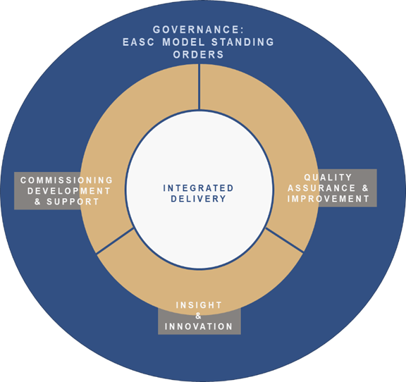

Figure 16: EASC Collaborative Commissioning Integrated Delivery Model

Commissioning Development & Support

Commissioning Development & Support (EASC)
The Commissioning Development Support Service delivers the following capabilities:
  - Defines the quality and safety expectations for EMS, NEPTS and EMRTS in the form of standards.
  - Ensures these standards are in accordance with Welsh Government standards, regulatory and statutory requirements, and best practice; and are regularly reviewed and kept up to date for each service.
  - Determines the activity currencies which are used to measure the work of EMS, NEPTS and EMRTS.
  - Ensures the activity is regularly counted and reported, and is also used to support demand and capacity work for each service.
  - Identifies all available resources for EMS, NEPTS and EMRTS, including revenue, capital and alternative funding sources.
  - Ensures the resources and financial value payable is agreed between all applicable parties to all the frameworks. This includes each Health Board, WAST, Velindre NHS Trust, WHSSC and the Air Ambulance Charity.
  - Leads the designing of the service model(s) to operate across EMS, NEPTS and EMRTS. Ensuring that these are presented in a way which is understandable to the public and patients.
  - Ensures the component parts of the service model(s) are understood and agreed, and the activity, resources and performance of each service is measured and performance managed.
  - Articulates how the interactions between professionals between parties to the frameworks across EMS, NEPTS and EMRTS operate to support delivery of the service model.
  - Defines performance measures to evidence whether the standards for each of the EMS, NEPTS and EMRTS are being met and that a balance is being achieved between improved clinical outcomes, better patient experience and value for money and are regularly reported and acted upon to ensure continuous improvement.

National Collaborative Quality and Delivery Frameworks

The NCCU is responsible to EASC via the CASC for the creation, development, operation, refresh and evaluation of National Collaborative Commissioning: Quality & Delivery Frameworks for ambulance services within NHS Wales this includes:
- Emergency Ambulance Services (EMS)
- Non-Emergency Patient Transport Services (NEPTS) Figure 17: CAREMORE® Logo
- Emergency Medical Retrieval and transfer Services (EMRTS)

National Collaborative Commissioning Frameworks are developed and maintained using the award winning CAREMORE® methodology.

National Collaborative Commissioning Quality & Delivery Framework: EMS

Commissioning value of £158.809m. The NCCU is responsible to EASC via the CASC for the creation, development, operation, refresh and evaluation of CAREMORE® National Collaborative Commissioning: Quality & Delivery Frameworks for Emergency Ambulance Services within NHS Wales. Figure 18: 5 step Emergency Ambulance Patient Care Pathway

National Collaborative Commissioning Quality & Delivery Framework: NEPTS
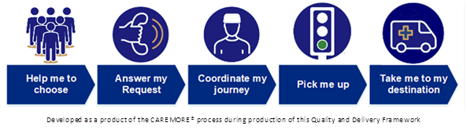
Commissioning value of £20.893m, the CAREMORE® National Collaborative Commissioning: Quality & Delivery Frameworks for Non-Emergency Patient Transport Services has been operational from October 2019 covering WAST, all Health Boards, WHSSC and Velindre NHS Trust, it reflects the ‘plurality model’ required by The Minister for Health & Social Services and is exceptionally complex given the variety of current contractual arrangements operated by WAST, all Health Boards, WHSSC and Velindre NHS Trust, between each other and with external providers. Figure 19: NEPTS Steps patient Care Pathway

The work programme for NEPTS for the duration of this IMTP are listed as Appendix 6: NEPTS Storyboard

National Collaborative Commissioning Quality & Delivery Framework: EMRTS

EMRTS Cymru is a pre-hospital critical care service for Wales which has been operating since 2015 with four helicopters and five Rapid Response Vehicles (RRVs) to “To provide advanced decision making and critical care for life or limb-threatening emergencies that require transfer for time critical specialist treatment at an appropriate facility”. It is a partnership between Wales Air Ambulance Charity, Welsh Government and NHS Wales. Figure 20: EMRTS Cymru fleet

EMRTS has been developed to bring specific benefits to Wales, there is also a service provision for the enhancement of neonatal and maternal pre-hospital critical care (both for home deliveries and deliveries in free-standing midwifery-led units (MLUs), specifically:
  - reductions in geographical inequity for patients with critical care needs
  - health gains by improving clinical outcomes, and
  - improved clinical and skills sustainability – improving the clinical skills, recruitment and retention in key acute care areas.

The service provides a highly-trained Critical Care team comprising of Consultants (from an emergency medicine, anaesthesia and intensive care background) and Critical Care Practitioners (including paramedics and nurses). The service has two main areas of activity:
  - Pre-hospital critical care for all age groups (i.e. interventions/decisions that are outside standard paramedic practice).
  - Undertaking time-critical, life or limb-threatening adult and paediatric transfers from peripheral centres for patients requiring specialist intervention at the receiving hospital.

Commissioning value of £3.833m, not including the contribution from the Wales Air Ambulance (WAA) Charity of circa £4m, the Framework will be operational from quarter 4 2019/20 and will be between EASC and the host of EMRTS, ABMU Health Board; its development utilises the approach used for creating the emergency ambulance services framework.

EASC Strategic Commissioning Intent 2020/21 onwards
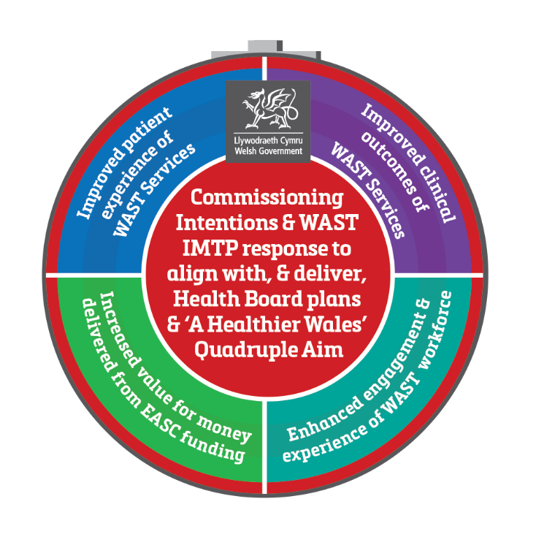
The 2019/22 NCCU/EASC IMTP articulated the development of a strategic commissioning plan for EASC. In November 19 EASC Joint Committee approved the plan. The strategic commissioning intentions were issued to WAST and Health Boards through the EASC Management Group. These strategic intentions will enable:
- Revision of NCCU Memorandum of Understanding with Welsh Government.
- Alignment of Quadruple Aim across care standards for services.
- Production of a Quadruple Aim Benefit Map enabled through the delivery of the care and core standards for each service.
- Delivery of Ministerial expectation and alignment across A Healthier Wales and the Wellbeing of Future Generations Act.
- A whole system risk reduction approach and closer alignment between the work of EASC and the National Programme for Unscheduled Care. Figure 21: EASC Strategic Commissioning Plan

EASC Annual Commissioning Intentions, Financial Assumptions and IMTP Alignment 2020/21
The 2020/21 EMS & NEPTS commissioning intentions were accepted by EASC on 12th November 2019. They were shared with WAST and EASC Management Group following EASC. A response has been received by WAST and the finalised commissioning intentions were agreed by the EASC Management Group on 20th December 2019. They will be shared nationally by NCCU through the Directors of Planning; Finance; Primary Community & Mental Health as well as Chief Operating Officers.

NCCU will share a standard descriptor of EASC Commissioned Services and the below process guidance for inclusion in Health Board IMTPs, as well as details of the financial payable to EASC for each Health Board.
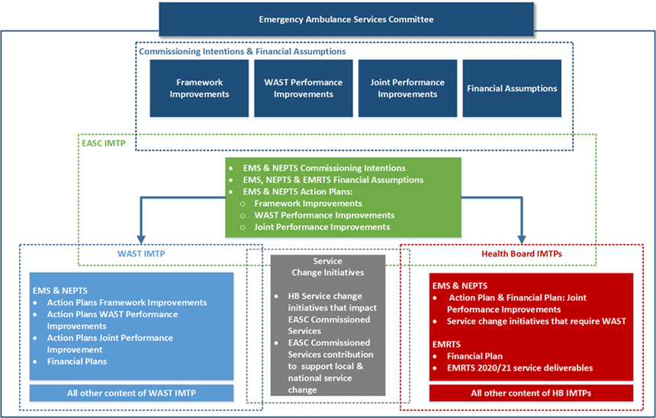

Figure 22: EASC Commissioning Intentions, Finance & Value IMTP alignment process

The commissioning intentions set annually by NCCU on behalf of the CASC contain 3 components:
- Framework Improvements – updates to the framework agreement
- WAST Performance Improvements – the performance improvements WAST are expected to make
- Joint Performance Improvements - the joint WAST and Health Board improvements that need to be undertaken.
These action plans in response to the commissioning intentions actions are documented within WAST, EASC and Health Boards IMTPs and progress on the delivery of the 2020/21 commissioning intentions will be through the EASC Management Group.
NCCU have also supplied each Health Board with a standard descriptor of EASC commissioned services for their IMTP in 2019/22.

- EMS 2020/21 Commissioning Intentions are attached as Appendix 2
- NEPTS 2020/21 Commissioning Intentions are attached as Appendix 3
- Actions Plans in response to these are attached as Appendix 4 (EMS) & 5 (NEPTS)

Future Developments and EASC Commissioned Services
The Commissioning Development and Support Service will begin scoping and support existing work on behalf of EASC As well as supporting the scoping of new all Wales services, namely:

National Collaborative Commissioning Discharge and Transfer Quality & Delivery Framework
To scope and deliver a dedicated discharge and transfer service across Wales we will work with Welsh Ambulance Service Trust and Partners to develop a detailed during 2020 a business case and to develop a National Collaborative Commissioning Quality and Delivery Framework using the CAREMORE® method. This service will include the following components:

Critical Care transfers
The Task and Finish Group on Critical Care: Final Report (Welsh Government, July 2019) set out the case for further improvements across critical care services in Wales. A written statement by the Cabinet Secretary in July 2018 announcing the establishment of a nationally directed programme for critical care and £15m additional funding for critical care services in Wales from 2019-20 emphasised this as a priority in Wales.

Further, correspondence from the Deputy Chief Medical Officer in September 2019 provided confirmation of an indicative allocation of £1.7m to the Emergency Ambulance Service Committee (EASC) to develop a national transfer service for critically ill adults. An implementation plan has been submitted to WG with the proposal that the new service operates as a parallel organisation within the EMRTS, delivered using a national collaborative commissioning quality and delivery framework under EASC.

Inter Hospital Transport Grange University Hospital
NCCU are working with Aneurin Bevan UHB and WAST to commission the new transport model for the Grange University Hospital opening April 2021.

Building on existing Emergency Ambulance and Non-Emergency Patient Transport services on behalf of EASC and with WAST and Health Boards the NCCU will develop this model through the work it is undertaking to support the transport workstream of the Clinical Futures programme within Aneurin Bevan UHB for the Grange University Hospital.

This work will inform the development of the National Transport and Discharge service and the implementation of the clinical model across Aneurin Bevan UHB.

Thrombectomy Repatriations
The NCCU will be funded by and take commissioning responsibility from WHSSC for Stroke Thrombectomy patients who require cross border repatriation.

Neonatal Transfers
NCCU will work with WHSSC and other colleagues on the potential transfer of commissioning arrangements to EASC.
Major Trauma repatriations
The work will include ensuring patients requiring repatriation following major trauma are delivered effectively.

National Call Hander of Choice Quality and Delivery Framework
This work identified in the 2019/20 IMTP has already began. Within this IMTP round we will work collaboratively with WAST and Health Boards to define what good looks like for call handling services across NHS Wales. The insight gained through the EASC 1% Heathier Wales Commissioning allocation bidding process has seen innovative schemes from BCUHB & SWUHB that use GPs to answer calls from the 999 stack and avoid hospital conveyance. These schemes identified through the Healthier Wales process have been agreed by EASC and by Welsh Government as WAST priority development areas. We will further look to maximising opportunities from existing services, i.e. 111, NHS Direct into the National Framework.

National Enhanced Clinical Capacity & Support Services Quality and Delivery Framework
We will develop a framework to deliver high quality, sustainable and efficient enhanced services that could be rapidly deployed to support a reduction in unscheduled care system pressures or proactively reduce demand. Years 1 and 2 of this IMTP will focus on the development of;
- Clinical capacity intervention service
- All Wales non-injury falls provision (Level 1 – 3)
- End of Life Services
- Priority developments by WAST using multi-disciplinary teams to prevent hospital conveyance.

Supporting the national commissioning of transport to support major service change
EASC will support the commissioning of the transport component of major service change across Wales. These include:

EMRTS Hours expansion
The service, in collaboration with EASC and the Wales Air Ambulance Charity, has developed a fully costed proposal for a staged 24-hour operation. The EMRTS Service Expansion Review has been approved by Welsh Government with the 24-hour service commencing on 1st April 2020.

The service expansion project is currently the focus for the service with good progress having been made in planning for the expanded service and in recruiting the required additional staff.

The preferred option presented by the Review provides (in addition to the existing 12-hour 3 base model):
- 2000-0800: Consultant, CCP at a North Wales base
- 2000-0800: Consultant, CCP at a South Wales base
- 2000-0800: Double pilot crew and aircraft, available at a South Wales base to support either crew
- 1400-0200: Consultant, CCP and RRV to meet the main peak of unmet demand
- Extension of operating hours of Air Support Desk to cover whole 24 hour period

The preferred option includes 3 operational rotas with an indicative implementation timescale of 12 months per rota/phase. The timescale will ensure:
- delivery of a robust implementation plan
- appropriate evaluation
- minimal impact on the existing core EMRTS 12 hour service
- consolidation of the expanded service before progressing to the next phase as directed by EMRTS DAG

Phase 1 will deliver the following:
- 2000-0800: Consultant, CCP, RRV, dual pilot crew and aircraft at Cardiff Heliport with the ability to be tasked anywhere in Wales
- Extension of ASD to 24 hour working to support the above operation in terms of communications, logistics, liaison with emergency agencies.
- Recruitment of support staff

It is important to note that all regions of Wales will benefit from each implementation phase and the 3 operational rotas included within the preferred option demonstrate a commitment to ensuring equity for the population of Wales, in line with the key investment objectives.

The funding requirements for the preferred option are:
- Initial capital costs of £0.707m and subsequent costs of £1.61m over a ten year period
- One-off revenue costs relating to recruitment and training of £0.564m over the project phases
- Recurring revenue costs of £3.1m (£3.162m from year 4)
- Non-recurring costs of £91k

South Wales Major Trauma Network
The NHS Wales Health Collaborative has been developing a Trauma Network for South and West Wales and South Powys. One of the key enablers of introducing a successful trauma network in South Wales has been identified as the availability of 24/7 enhanced care teams (NHS Clinical Advisory Group Report 2010). The EMRTS already provides pre‐hospital critical care and advanced decision-making to this subset of patients, and provides time-critical transfers to those patients requiring a higher level of care. This provision would be strengthened with a 24/7 service but EMRTS may also play a role in the coordination of major trauma patient’s care via the ASD, consultant advice and ensuring that smaller hospitals are supported in the care and onwards transfer of these patients via EMRTS clinical teams.

We have also supported the WAST component and business case submissions for the ambulance contribution to the South Wales Major Trauma Network.

Health Board strategic change
There are many strategic change programmes underway across NHS Wales. These for ambulance services are captured as part of the commissioning process. A list of these schemes is attached as Appendix 7. Some of these have clear implications for the transfer of critically ill and injured patients around the clock and EMRTS is committed to supporting these where appropriate.

Quality Assurance & Improvement

Quality Assurance & Improvement Services (EASC)
The CASC has the authority and responsibility to hold WAST to account for delivery of services in respect of performance, service delivery, and quality and safety. This is alongside responsibility for holding Health Boards to account for their role in enabling timely ambulance response to be delivered.

The NCCU is responsible to EASC through the CASC for the quality assurance and improvement of the EASC commissioned services. We deliver this responsibility through:

- Quarterly CASC / EASC Quality and Delivery meetings with Welsh Government
- Incidents and complaints reporting and reviews
- Daily performance reviews
- Clinical risk assurance reviews
- Enactment of the recommendations from PACEC Review and expectations of The Minister for Health & Social Services
- Published reporting of accurate Ambulance Quality Indicators (AQI) including enhanced user friendly reporting of AQIs
- Development of a comprehensive suite of performance and outcome measures across clinical, patient experience and value for money which are regularly reported
- Development, operation and enhancement of the electronic Benchmarking Toolkit.

Enhanced Assurance & Evaluation

Enhanced role of the CASC
In line with the recommendations featured in the McClelland Strategic Review of Emergency Ambulance Services and in addition to the Model Standing Orders, Welsh Government requested the CASC and EASC to take on an enhanced role in performance management of WAST citing:
“There is a need for simple governance and accountability for planning and delivery of emergency ambulance services. Ministerial expectation is clear; he expects greater ownership of the emergency medical services (EMS) commissioning process through the EASC mechanism with the Chief Ambulance Services Commissioner (CASC) empowered to hold both Health Boards and WAST to account for delivery of agreed commissioning intentions and agreed actions.”
In order to develop the enhanced assurance and performance management arrangements, the NCCU, on behalf of EASC, will work collaboratively with WAST to develop the documents required to support the Model Standing Orders and a set of Key Performance Indicators which will be reported into EASC Management Group in order to provide assurance to EASC Joint Committee on the performance of WAST as an organisation. It is expected that as part of an integrated approach these measures will be aligned to the strategic commissioning intentions and designed to cover quality, safety, risk, finance and value.
To enable this the NCCU will develop the performance management framework to support the CASC; this will include:
- Developing a formal communication mechanism between the commissioner and WAST.
- Enhanced commissioning and performance focused reporting to EASC across all EASC Commissioned Services.
- Full utilisation of the EASC Governance structures to make effective decisions

Enhanced role of EASC
The key deliverables for enhancing the role of EASC, through chairs objectives, can be found in Appendix 21.

Enhanced EASC Governance Arrangements
In September 2019, Welsh Government issued an updated version of Model Standing Orders for EASC. As part of Joint Committee’s governance and accountability framework the Standing Orders require a set of Standing Financial Instructions to be in place alongside other documents such as a Scheme of Delegation, Values and Standards of Behaviour Framework, Risk Register and Key Policy Documents. These documents require development in order to enhance the governance and accountability framework.. It is expected that as part of an integrated approach these measures will be aligned to the strategic commissioning intentions and designed to cover quality, safety, risk, finance and value.

EMS Ambulance Quality Indicators (AQIs)
EASC through the EMS commissioning framework requires that WAST maintain a repository of data to allow the production of AQIs. EASC will continue to be an official publisher of Ambulance Quality Indicators. EASC will work to report the EMS AQIs monthly via StatsWales.

Expanding the role of the Clinical Director NPUC
2020/21 onwards will see the opportunity to close align the work of EASC through the clinical director for NPUC working closer with EASC. This opportunity enables stronger clinical leadership and oversight for the Joint Committee as well as supporting delivery of the EASC Chair’s actions from the Minister around closer working and alignment between EASC and the National Programme for Unscheduled Care.

Enhanced Research capability
During 2020/21 we will continue to work with the C3 Faculty to provide support to EASC in terms of the Winter Planning Evaluation 2019/20 and to inform the future direction of EASC and support the evaluation of ambulance and Unscheduled Care Services service change initiatives in order to share and spread nationally an understanding of what works and doesn’t work.

We will look to develop the concept of the embedded researcher and develop a model that enables research staff to work alongside programme staff. This will deliver the benefits of fully embedded research and evaluation across EASC and EDQDF work programmes. The roles will also support NPUC in the evaluation of specific targeted initiatives.

Maximising ambulance Productivity availability programme
We will scope and implement a programme of work to address ambulance performance and to maximise ambulance availability across Wales. This work will contain a number of elements of existing work to include:

Ambulance Productivity and Availability
We will deliver a programme of work to understand the current levels of productivity delivered by emergency ambulance services in Wales, and describe the service model required to deliver a more equitable and efficient level of productivity to support the whole unscheduled care system.
Availability of ambulances is the most important determinant of an effective and efficient ambulance service. We will deliver an improvement plan for increasing ambulance availability this work will focus on 4 major themes:
  - Core functions of the Emergency Ambulance Service
  - Workforce, recruitment and wellbeing
  - Digital change and technology
  - Measurement for improvement

EMS Demand & Capacity Review 2019
We will enact the implementation of the Demand and Capacity review of the emergency ambulance service in Wales, our focus will be on maximising the efficiency of current and additional investment to support improved performance and clinical outcomes. This will include the development of in house capability to support the ongoing delivery of demand and capacity management.

NEPTS Demand & Capacity Review 2020
NCCU will work collaboratively with WAST to scope and implement the 2020 NEPTS Demand & Capacity. This review will be key to realising the efficiencies described in the NEPTS Business Case.

Amber Review Implementation Programme (ARIP)
This programme will address any legacy issues arising from the completion of the ARIP. This will include developing and implementing a long wait reduction programme and a review to support health boards to minimise hours lost to handover delays.

Insight & Innovation

1% a Healthier Wales Awarding Evaluation Panel (HWAEP)
In 2019/20 the NCCU formed the Heathier Wales Awarding Evaluation and process for WAST and Health Boards to bid against the EASC 1% A Healthier Wales Commissioning Allocation. This process saw 9 schemes agreed for funding.
The process will be repeated within each IMTP year and will provide the opportunity for submitting organisations share ideas and concepts and to enable collaboration to develop these regionally and nationally.
The process will support the EASC Chair’s objectives around closer working between EASC and NPUC, it will promote closer working between WAST and Health boards and will support the identification of innovation. The NCCU researcher will support the evaluation of all agreed and new schemes. The HWAEP principles developed to support this process will remain

HWAEP Principles
- Total sum of EASC 1% set aside for ‘additionality’ of all EASC commissioned services.
- Service Initiatives to be considered consistently and in the context of the 1% allocation available not the contribution for that particular service.
- Service Initiatives related to Joint Improvements for EMS & NEPTS 2020/21 Commissioning Intentions and IMTPs to be identified and considered; plus the IMTP related additional APP development.
- A Standardised EARTH Template for proposed Service Initiatives to be completed.
- Funding may be used for: a) ‘pump priming’ initiatives, b) non-recurrent pilot initiatives, and c) recurrent initiatives – though evidence base needs to be sound for such a commitment
- Health Boards may wish to provide extra funding (e.g from their own transformational funds) to the Service Initiatives identified through this process.
- As detailed within the Commissioning Intentions for WAST and the EASC / WAST IMTPs, WAST are required to improve their existing resource utilisation towards supporting performance improvements.
- As an all Wales discharge & transfer service of the future is yet to be scoped and commissioned by EASC through WAST then this is not to be included.
- Tertiary related service changes via WHSCC which have a transport element should be considered by WHSSC and not to be included.
- An equitable approach to Service Initiatives by Health Boards should be adopted – so for example a) those that are scalable across Wales to be favoured, and b) Health Boards can supplement baseline provision through additional local funding as per 6) above.

Research & Evaluation
The Healthier Wales long-term plan for better population health centralises the Quadruple Aim for health care. Similar aims have been adopted worldwide and increasingly health care research adopts a quadruple aim perspective (cf. Liddy and Keely 2018). Similarly, the NCCU will deliver a framework that provides stakeholders with a Quadruple Aim perspective on health care initiatives across Wales, allowing for a fair comparison of initiatives. Due to its unique position as a collaborator working across health boards, the NCCU is able to find similar initiatives and analyse the commonalities and differences to support the sharing of knowledge and expertise, leading to the overall improvement of health care programmes. Ultimately, this framework will:

• Provide an easy to read comparative analysis of initiatives across Wales
• Ensure that like is compared with like
• Support the sharing of knowledge with regard to what works well and why
• Provide a Quadruple Aim perspective in line with government policy

EASC Evaluation Activity
During 2020/23 we will continue to work with the C3 Faculty to provide support to EASC in terms of the EASC 1% A Healthier Wales Commissioning Allocation, Winter Planning Evaluation 2019/20 and to inform the future direction of EASC and support the evaluation of ambulance and Unscheduled Care Services service change initiatives in order to share and spread nationally an understanding of what works and doesn’t work.

Evaluation of WAST Initiatives
NCCU has delivered evaluation of the WAST initiatives around the expansion of the clinical desk, National Falls Schemes and Advanced Paramedic Practitioners. Utilising baseline measures and a mixed methods evaluation approach as well as being clear around the benefits that will be realised to ensure that funded schemes provide the value to the system.

EMRTS Formal Service Evaluation
The independent EMRTS Cymru Service Evaluation is being undertaken by Swansea University to produce a comprehensive evaluation of three years of EMRTS service activity and outcomes. The review is being undertaken against the agreed benefits realisation plan and key investment objectives of Health Gain, Equity and Clinical & Skills Sustainability.

EMRTS is well placed to develop research and quality improvement initiatives to improve knowledge and treatment of critically ill patients. A research and development strategy will be developed in 2020/21.This has supported the development and approval of the business case for 24/7 EMRTS operating hours. It will also support evaluation on the impact of 24/7 operating.

An EMRTS Research & Audit Group has been established to lead on this work, reporting to the EMRTS Clinical & Operational Board. A key initial output will be the ongoing data analysis and evaluation of the service performed in partnership with Swansea University. Work is also underway with national partners to deliver research relating to technological innovation, wellbeing, equipment and clinical care. It is anticipated that future research activities will include working in partnership with Welsh Ambulance Service, other pre-hospital services and academic institutions.

CASC advice to stakeholders on EMS, NEPTS & EMRTS
Chief Ambulance Services Commissioner (CASC) provides advice on ambulance services to a wide range of stakeholders. A list of current EASC Chair actions can be found in Appendix 10.

Engagement with Key Strategic Partners
Our collaborative approach support local and strategic engagement with Community Health Councils (CHC) regarding the transformation of NEPTS services across Wales. NCCU facilitates an all Wales strategic meeting with CHC's and supports Health Boards with local meetings to share information on service development.

EASC Model Standing Orders
These Model Standing Orders are issued by Welsh Ministers to Local Health Boards using powers of direction provided in section 12 (3) of the National Health Service (Wales) Act 2006. When agreeing SOs Local Health Boards must ensure they are made in accordance with directions as may be issued by Welsh Ministers. Each Local Health Board (LHB) in Wales must agree Standing Orders (SOs) for the regulation of the Emergency Ambulance Services Committee’s (the EASC or the Joint Committee) proceedings and business.

These EASC Standing Orders (EASC SOs) form a schedule to each LHB’s own Standing Orders, and have effect as if incorporated within them. They are designed to translate the statutory requirements set out in the Emergency Ambulance Services Committee (Wales) Regulations 2014 (2014 No.566 (w.67)) and LHB Standing Order 3 into day to day operating practice. Together with the adoption of a Schedule of decisions reserved to the Joint Committee; a Scheme of delegations to officers and others; and Standing Financial Instructions (SFIs), they provide the regulatory framework for the business conduct of the Joint Committee.

EASC Governance Arrangements
As outlined in the EASC Model Standing Orders the responsibility for EASC will move from Cwm Taf UHB to the NCCU. In response to this change the NCCU will produce a governance programme of work to meet the requirements outline in the Model Standing Orders.
Figure 23: EASC Governance Arrangements

EASC Committee Secretariat
NCCU will take responsibility from CTUHB corporate directorate for the EASC Committee Secretariat. NCCU will maintain the structures to ensure effective functioning of the EASC subcommittees in relation to EMS, NEPTS & EMRTS. The structure and groups are outlined below:

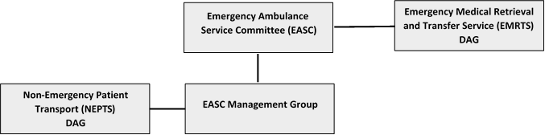
Figure 24: EASC Subgroups & reporting routes

EASC Integrated Medium Term Plan
We will continue to develop an NCCU EASC IMTP submission in line with Welsh Government planning guidance. We will work collaboratively to ensure that the policy leads for the sections of our plan within Welsh Government are sighted through the development process.

EASC Risk Management Framework
EASC as a commissioning body has an approved IMTP 2019-2022. The IMTP lays out in detail the existing and planned activity for EASC commissioned services and the National Programme for Unscheduled Care (NPUC).

The Chair of EASC, has had his objectives for 2020/20 agreed by the Minister for Health and Social Care. Core to these are the delivery of EASC & WAST IMTP actions and the closer alignment between the work of EASC and NPUC.

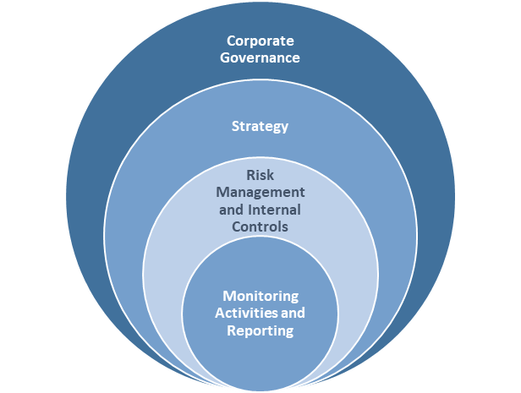
An effective approach to risk management is required to provide assurance to the committee that risks and opportunities in relation to the strategic objectives of EASC are:

1. Identified
2. Assessed
3. Planned
4. Implemented

The development of an integrated risk management framework for EASC seeks to strengthen the control environment and sustain good corporate governance, implement effective internal controls and monitoring activities which support the running of EASC and the delivery of strategic commissioning plans.

Figure 25: EASC Risk Management Framework

Implementation of Audit Findings
In July 2017 the Auditor General published the National Audit Office Review of Emergency Ambulance Services Commissioning Arrangements in Wales. One of the key recommendations identified in the report was:

“The subgroup structure of EASC lacks clarity and purpose which is impacting on the ability of the subgroups to make a meaningful contribution to the commissioning agenda. EASC should urgently review the structures, roles and memberships of its three subgroups to ensure they are mutually exclusive, have a clear purpose and appropriately support the work of EASC.”

The NCCU will work with WAST & Health Board representatives to ensure the functioning of the subgroups listed in Figure 20 delivers against the recommendations.

NCCU will work to implement the 2019 NEPTS Internal Audit Findings and will report progress through the NEPTS Delivery Assurance Group.

Implementation of EASC Governance Statement Actions.
EASC is required to produce an annual governance statement which is included as part of the annual account process. Actions contained within the governance statement are included in the delivery plan for EASC and progress is reported to the Joint Committee via the CASC report on a regular basis.

EASC Financial Values

EASC NCCU 2020/21 Summary Financial Values

Emergency Ambulance Services Committee /  National Collaborative Commissioning Unit  2020/21 Summary | Swansea Bay UHB | Aneurin Bevan UHB | Betsi Cadwaladr UHB | Cardiff & Vale UHB | Cwm Taf UHB | Hywel Dda UHB | Powys THB | Velindre NHS | EASC
 |  |  |  |  |  |  |  | Trust | Requirement
 | £m | £m | £m | £m | £m | £m | £m | £m | £m
EASC: WAST EMS Provision 2020/21 | 17.114 | 27.962 | 43.090 | 20.054 | 21.568 | 22.973 | 12.479 | - | 165.239
EASC: NEPTS Provision 2020/21 | 3.767 | 2.804 | 4.927 | 4.663 | 1.373 | 2.106 | 1.075 | 0.679 | 21.394
EASC: EMRTS Provision 2020/21 | 0.488 | 0.749 | 0.947 | 0.612 | 0.570 | 0.517 | 0.203 | - | 4.087
NCCU 2020/21 | 0.150 | 0.247 | 0.379 | 0.177 | 0.190 | 0.201 | 0.109 | - | 1.453
EASC and NCCU Total Requirement 2020/21 | 21.519 | 31.761 | 49.342 | 25.507 | 23.700 | 25.798 | 13.866 | 0.679 | 192.173
Recurrent Financial Values at Risk * | 1.098 | 1.795 | 2.771 | 1.287 | 1.385 | 1.475 | 0.802 | - | 10.613
Total inc. Financial Values at Risk | 22.618 | 33.556 | 52.113 | 26.794 | 25.085 | 27.273 | 14.668 | 0.679 | 202.786

Emergency Medical Services 2020/21 Financial Values
*To be confirmed - this will not exceed the financial value at risk set out below

Non-Emergency Patient Transport Services 2020/21 Financial Values
EASC: NEPTS Provision 2020/21 | SBUHB | Aneurin Bevan UHB | Betsi Cadwaladr UHB | Cardiff & Vale UHB | Cwm Taf  Morgannwg UHB | Hywel Dda UHB | Powys  THB | Velindre NHS | EASC
Quality & Delivery Framework Agreement |  |  |  |  |  |  |  | Trust | Requirement
 | £m | £m | £m | £m | £m | £m | £m | £m | £m
2019/20 NEPTS Requirement through EASC | 3.679 | 2.738 | 4.811 | 4.554 | 1.341 | 2.057 | 1.049 | 0.663 | 20.893
Healthier Wales 1% System Reallocation (recurrent) | - 0.034 | - 0.025 | - 0.044 | - 0.042 | - 0.012 | - 0.019 | - 0.010 | - 0.006 | - 0.192
2019/20 NEPTS Adjusted requirement 2019/20 | 3.645 | 2.713 | 4.767 | 4.512 | 1.328 | 2.038 | 1.040 | 0.657 | 20.701
Pay Award (Per Pay Funding Matrix 2020/21) | 0.049 | 0.037 | 0.064 | 0.061 | 0.018 | 0.027 | 0.014 | 0.009 | 0.279
2% uplift | 0.073 | 0.054 | 0.095 | 0.090 | 0.027 | 0.041 | 0.021 | 0.013 | 0.414
2020/21 NEPTS Requirement through EASC | 3.767 | 2.804 | 4.927 | 4.663 | 1.373 | 2.106 | 1.075 | 0.679 | 21.394
Proportions | 17.61% | 13.11% | 23.03% | 21.80% | 6.42% | 9.85% | 5.02% | 3.18%

Emergency Medical Retrieval Transfer Services
EASC: EMRTS Provision 2020/21 | Swansea Bay UHB | Aneurin Bevan UHB | Betsi Cadwaladr UHB | Cardiff & Vale UHB | Cwm Taf Morgannwg UHB | Hywel Dda UHB | Powys  THB | EASC
Quality & Delivery Framework Agreement |  |  |  |  |  |  |  | Requirement
 | £m | £m | £m | £m | £m | £m | £m | £m
2019/20 EMRTS Requirement through EASC | 0.468 | 0.716 | 0.897 | 0.588 | 0.544 | 0.491 | 0.190 | 3.893
Healthier Wales 1% System Reallocation (recurrent) | - 0.004 | - 0.007 | - 0.008 | - 0.006 | - 0.005 | - 0.004 | - 0.002 | - 0.036
Healthier Wales 1% System Reallocation (recurrent) | 0.016 | 0.025 | 0.039 | 0.018 | 0.020 | 0.021 | 0.011 | 0.150
19/20 EMRTS Revised Baseline | 0.479 | 0.735 | 0.928 | 0.600 | 0.558 | 0.507 | 0.199 | 4.007
2 % uplift | 0.010 | 0.015 | 0.019 | 0.012 | 0.011 | 0.010 | 0.004 | 0.080
2020/21 EMRTS Requirement through EASC | 0.488 | 0.749 | 0.947 | 0.612 | 0.570 | 0.517 | 0.203 | 4.087

National Collaborative Commissioning Unit 2020/21 Financial Values
National Collaborative Commissioning Unit 2020/21 | Swansea Bay UHB | Aneurin Bevan UHB | Betsi Cadwaladr UHB | Cardiff & Vale UHB | Cwm Taf Morgannwg UHB | Hywel Dda  UHB | Powys  THB | EASC
 |  |  |  |  |  |  |  | Requirement
 | £m | £m | £m | £m | £m | £m | £m | £m
2019/20 NCCU Baseline
EASC Commissioning Support | 0.052 | 0.086 | 0.132 | 0.061 | 0.066 | 0.070 | 0.038 | 0.506
NPUC Clinical Lead | 0.006 | 0.010 | 0.016 | 0.007 | 0.008 | 0.008 | 0.005 | 0.060
Quality Assurance & Improvement Services - MH and LD | 0.081 | 0.132 | 0.203 | 0.094 | 0.102 | 0.108 | 0.059 | 0.779
2019/20 NCCU Baseline | 0.139 | 0.227 | 0.351 | 0.163 | 0.175 | 0.187 | 0.102 | 1.345
Healthier Wales 1% System Reallocation (recurrent) | 0.008 | 0.014 | 0.021 | 0.010 | 0.010 | 0.011 | 0.006 | 0.080
2019/20 NCCU Revised Baseline | 0.147 | 0.241 | 0.372 | 0.173 | 0.186 | 0.198 | 0.108 | 1.425
2 % uplift | 0.003 | 0.006 | 0.006 | 0.004 | 0.004 | 0.003 | 0.002 | 0.028
2020/21 NCCU Requirement through EASC | 0.150 | 0.247 | 0.379 | 0.177 | 0.190 | 0.201 | 0.109 | 1.453

