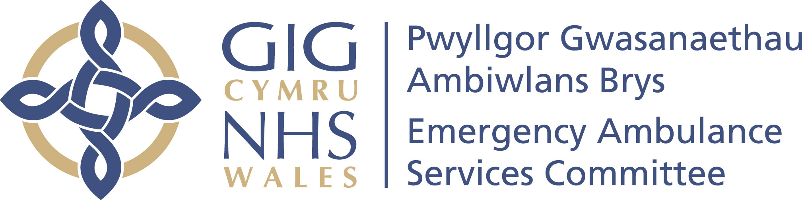

Emergency Ambulance Services Committee
Annual Plan – 2021-2022
DRAFT
Published date: February 2021
Review date: February 2022

Table of Contents
Table of Figures 3
Introduction 4
Resetting and Recovery 4
Message from the EASC Chair and Chief Ambulance Services Commissioner 5
Emergency Ambulance Services Committee 6
Background 6
EASC Governance 6
EASC Team Quality Assurance Roles and Responsibilities 7
EASC Risk Management Framework 8
Commissioned Services in 2020-21 8
Priorities for Commissioned Services 8
EASC Financial Plan 2021-22 11
Emergency Ambulance Services Allocation 11
Demand and Capacity Programme in 2021-22 11
Grange University Hospital 11
NEPTS Allocation 12
EMRTS Allocation 12
EASC Ring-Fenced Commissioning Allocations 12
EASC Specialist Commissioning Allocation 12
EASC Team resourcing 12
EASC Commissioned Services – Efficiency Programmes 12
Transformational Work Programmes 13
Ministerial Ambulance Availability Taskforce 13
South Wales Major Trauma Network Services 13
Critical Care Transfer Service 14
National Transfer and Discharge Services 14
Developing the Commissioning Cycle 16
Conclusion 17
Appendices 18
Appendix 1-EMS Overview 2020-21 19
Appendix 2-NEPTS Overview 2020-21 20
Appendix 3-EMRTS Overview 2020-21 21
Appendix 4-EMS Commissioning Intentions 2021-22 22
Appendix 5-NEPTS Commissioning Intentions 2021-22 30
Appendix 6-EMRTS Commissioning Intentions 2021-22 32

Table of Figures
Figure 1: EASC Governance Processes 6
Figure 2: Overview of Commissioning Intentions 9
Figure 3: Initial Allocation 12
Figure 4: Overview of Transformational Work Programmes 16
Figure 5: Commissioning Cycle Process 17

Introduction

In line with the NHS Wales Annual Planning Framework 2021-22, the Emergency Ambulance Services Committee (EASC) Annual Plan will set out our expectations and deliverables for the coming year.

The EASC Team is responsible through the Chief Ambulance Services Commissioner (CASC) for the commissioning, quality assurance and improvement of EASC commissioned services. The portfolio of EASC commissioned services currently include:

- Emergency Ambulance Services (EMS)
- Non-Emergency Patient Transport Services (NEPTS) and the
- Emergency Medical Retrieval and Transfer Service (EMRTS Cymru).

Our plan this year presents in a short and succinct format and will centre on the following areas:

- Priorities for commissioned services
- Transformational work programmes
- Alignment with re-setting of NHS and Social Care post Covid-19 pandemic
- Development of the commissioning cycle.

The assumptions made within this Annual Plan are consistent with those of the Welsh Ambulance Services NHS Trust, the Emergency Medical Retrieval and Transfer Service and Health Boards.

Resetting and Recovery

Throughout this plan the EASC Team have taken a pragmatic and considered approach to the impact of resetting and recovery on commissioned services.

We have sought to reduce the impact of the commissioning process on commissioned services, through the streamlining of our commissioning intentions, utilising existing information flows and adopting a more agile approach to our commissioning oversight.

Further to this we have adopted the concept of 2021-22 as a transitionary year for our commissioned services with a focus on delivery of existing work streams and consolidation of service provision.

Message from the EASC Chair and Chief Ambulance Services Commissioner

We are pleased to introduce the EASC Annual Plan for 2021-22.

In reflecting on the last year, it is important to acknowledge the impact of the COVID-19 pandemic and the significant effect that it has had on us all. The EASC Team has consciously adopted a supportive role concentrating on reducing harm to reflect the extraordinary pressures placed on frontline services and the significant effort made across the NHS in Wales in response to the COVID-19 pandemic.

The pandemic has allowed us the opportunity to introduce and test new initiatives at pace and scale such as Welsh Ambulance Services NHS Trust’s (WAST) role in developing the Contact First approach to urgent and emergency care in collaboration with the National Programme for Unscheduled Care and with all Health Boards.

Ahead of another challenging year, we would like to acknowledge and thank operational services and staff for the way in which they have addressed the significant challenges presented over the course of the last year. We are also grateful to the military, third sector, other NHS staff and other emergency services for their support to WAST during this extraordinary time.

We are confident that this EASC Annual Plan for 2021-22 achieves the appropriate balance of strengthening the approach to quality and safety, realising the real opportunities that have presented themselves, addressing immediate operational pressures and ensuring a flexible process of stabilisation, reset and recovery.

  Christopher Turner | Stephen Harrhy
Chair  Emergency Ambulance Services Committee | Chief Ambulance Services Commissioner

Emergency Ambulance Services Committee

Background

The Emergency Ambulance Services Joint Committee comprises the Chief Executives of the seven Local Health Boards, an Independent Chair and a Chief Ambulance Service Commissioner (CASC).

The seven Local Health Boards in Wales are required under the legislation to work jointly to exercise functions relating to the planning and securing of emergency ambulance services. The CASC exercises these duties on behalf of the Joint Committee. EASC issues the commissioning intentions and the financial envelope required to improve and deliver ambulance services across Wales.

Working with providers, the EASC Team identifies and delivers against the needs of the population, with benefits delivered to patients and the Welsh public, Welsh Government, Clinical Networks, Health Boards and other elements of the NHS Wales system.

EASC Governance

The EASC Model Standing Orders outline the expectation that safe, effective and timely services are delivered. Robust quality assurance and risk management systems support this. An overview of the governance processes is provided in the chart below:

  - Figure 1: EASC Governance Processes

EASC Team Quality Assurance Roles and Responsibilities

The EASC Team is responsible to EASC through the CASC for the quality assurance and improvement of the EASC commissioned services.

The EASC Team deliver:

- Collaborative commissioning quality and delivery frameworks which enable the planning and securing of ambulance services

- Monthly CASC Quality and Delivery meetings with WAST, focusing on patient safety and feeding into quarterly Welsh Government and EASC Integrated Quality, Planning and Delivery meetings

- Incidents, complaints reporting and reviews

- Performance reviews

- Clinical and risk assurance reviews

- Facilitation of collaborative working across the system

- Publication and analysis of a comprehensive suite of Ambulance Quality Indicators (AQI) including enhanced and interactive user friendly reporting of AQIs

- Development of a comprehensive suite of performance and outcome measures across clinical services, patient experience and value for money which are regularly reported

- Working in collaboration develop, implement and monitor commissioning intentions

- Support, negotiate and arbitrate between Health Boards and providers on new and existing services

- On behalf of the EAS Committee manage commissioning funding allocations, work in collaboration to deliver cost effective, safe services

- Deliver bespoke reviews, work programmes commissioned by the EAS Committee or by other bodies

- Provide expert independent advice as required across the system

- Support the Emergency Ambulance Services Committee to discharge its responsibilities in line with the legislation.

EASC Risk Management Framework

EASC and its supporting structures are hosted by Cwm Taf Morgannwg University Health Board (CTMUHB) and utilise the CTMUHB risk management approach.

The development of the risk management framework for EASC seeks to strengthen the control environment and sustain good corporate governance, implement effective internal controls and monitoring activities which support the running of EASC.

During 2020-21, the EAS Committee approved a new risk register which outlined the following key risks:
- Failure to produce an agreed Strategic Commissioning plan and commissioning intentions
- Failure to develop an agreed EASC IMTP for endorsement by the Joint Committee seeking approval from the Welsh Government
- Failure to deliver the Ministerial direction that EASC effectively plans, commissions and secures services within its remit; and failure to maintain collaborative relationship with providers
- Failure to respond to requirements identified within commissioned work related to the ambulance services
- Failure to achieve the agreed Chair's objectives with the Minister
- Failure to achieve agreed performance standard for category red calls
- Failure to achieve agreed performance standard for amber category calls
- Failure by the whole system, policy makers, commissioners and providers to utilise EASC in matters which relate to its areas of responsibility.

The only red risks reported are currently in relation to risks 6 and 7.

Commissioned Services in 2020-21

Each of our commissioned services have addressed the significant challenges presented over the course of the last year. An overview is provided for each:
- Emergency Ambulance Services – Appendix 1
- Non-Emergency Patient Transport Services – Appendix 2
- Emergency Medical Retrieval and Transfer Service – Appendix 3

Priorities for Commissioned Services

Going forward, the priorities for our commissioned services are set out within the commissioning intentions for each service. As a collaborative commissioner EASC recognise the responsibility of the wider system to enable the commissioned service to deliver these intentions.

The table below provides a brief summary of the priorities for each commissioned service:

  - Figure 2: Overview of Commissioning Intentions
Commissioned Service | Summary of Priorities | Outcome
Emergency Ambulance Service | - Implementation of Demand and Capacity Review specifically  - Complete the closure of the relief gap  - Deliver efficiencies related to rosters and post production  - Focus on delivering improved patient and system outcomes at step 2 (Answer my call) of the ambulance care pathway.  - Optimising conveyance and patient outcomes  - Develop a value based approach to service commissioning and delivery  - Support and enable system wide understanding and improvement. | Ensuring the minimum number of front line staff are in post  Ensuring the maximum number of front line staff are available to respond to demand  Improving patient experience and outcomes by ensuring that they receive the right care at the earliest possible opportunity on their episode of care and avoid unnecessary conveyance to scene or hospital  Ensuring that patients receive the right care and the ambulance service contribution to outcomes is understood.  Making the best and most efficient use of the resources available and improve patient experience  Integrated and proactive management of escalation across the system
Non-Emergency Patient Transport Services (NEPTS) | - Consolidate and build confidence in the plurality delivery model  - Understand and mitigate demand  - Modernise and transform capacity  - Support system transformation | Completion of the Ministerial commitment to modernise NEPTS  Reduction in overall demand and a more efficient and effective transport service for patients  Increase and diversify capacity to meet the changes in patient demand and individual patient needs  Responsive to the new emerging demands and patterns of service delivery and improve patient experience
Emergency Medical Retrieval and Transfer Service (EMRTS) | - Consolidate and complete the service expansion  - Deliver a critical care transfer service for Wales | Enhancing the EMRTS 24/7 provision across Wales to patient experience and outcomes  Providing a dedicated critical care transfer service across the whole of Wales for the first time

Detailed content of the commissioning intentions, are available in the following appendices. Where relevant, delivery timescales have been articulated alongside intentions:

- Emergency Ambulance Services – Appendix 4
- Non-Emergency Patient Transport Services – Appendix 5
- Emergency Medical Retrieval and Transfer Service – Appendix 6

EASC Financial Plan 2021-22

The 2021-22 Annual Planning allocations for EASC Commissioned Services are consistent with the details set out in the Welsh Government allocation letter.

This is an initial allocation and additional funding for key priorities will be allocated as appropriate when costs are confirmed.

  - Figure 3: Initial Allocation
Emergency Ambulance Services Committee  2021-22 Summary | Total
Emergency Ambulance Services Committee  2021-22 Summary | £m
EAS Allocation | 182.005
NEPTS Allocation | 25.278
EMRTS Allocation | 6.000
Ring-Fenced Commissioning Allocations | 2.340
Specialist Commissioning Allocation | 0.155
EASC Commissioning Funds from LHBs | 215.778
EASC Team resourcing | 0.610
EASC Total Funds from LHBs | 216.388

A detailed breakdown of the funding requirements by Health Board is provided in Appendix 7 along with more detailed financial assumptions in Appendix 8.

The following section provides an overview of the key initiatives included in 2021-22 Financial Plan to support the delivery of the commissioning intentions.

Emergency Ambulance Services Allocation

Demand and Capacity Programme in 2021-22

- £4.977m recurrent funding to sustain the additional 136 WTE front line staff in 2020-21 as part of a successful Phase 1 delivery.
- £2.000m non recurrent funding to be made available and allocated to WAST contingent on the delivery of an additional 127 WTE front line staff as part of Phase 2.
- Any unutilised non recurrent funding will be returned to LHBs.

Grange University Hospital

- £4.420m included in the Aneurin Bevan UHB allocation to fund EAS delivery to The Grange University Hospital as per the Service Level Agreement.

NEPTS Allocation

- The NEPTS funding position reflects the in year 2020-21 transition of services. NEPTS funding continues to flow from LHBs to WAST directly but is included for completeness as a commissioned service under EASC.

EMRTS Allocation

- £1.257m non recurrent funding to be made available and allocated to EMRTS contingent on the delivery of the 24/7 expansion.
- Any un-utilised non recurrent funding will be returned to LHBs.

EASC Ring-Fenced Commissioning Allocations

- £1.700m recurrent funding to deliver the Critical Care Transfer Service.
- £0.640m recurrent funding to deliver the Major Trauma Network service development.
- EASC will allocate these funds across the EASC Commissioned Services in order to meet the service delivery objectives.

EASC Specialist Commissioning Allocation

- £0.155m recurrent funding from Cardiff and Vale, Aneurin Bevan and Cwm Taf Morgannwg UHBs to continue the delivery of the South-East Wales Regional Acute Coronary Syndrome Treat and Repatriate Service.

EASC Team resourcing

No assumption has been made for additional EASC Team resourcing wider than the normal uplift position.

EASC Commissioned Services – Efficiency Programmes

EASC Commissioned Services are expected to deliver an efficiency programme as would be expected of Health Boards, Trusts and Special Health Authorities. It is expected that any savings resulting from these programmes will be re-invested in service development opportunities in agreement with the Commissioner and in line with the commissioning intentions for the service.

Transformational Work Programmes

Ministerial Ambulance Availability Taskforce

In January 2020, the Minister for Health and Social Services announced his intention to establish a Ministerial Ambulance Availability Taskforce, together with his expectations regarding the purpose and timescale for the work of the Taskforce.

Subject to the direction provided by the Minister in response the Interim Report, the primary focus of the Taskforce going forward will be the development of the Final Report, specifically including:

- The development and delivery of a citizen centred vision for a modern ambulance service

- Clearly defining the role of a modern ambulance service within a wider health and social services system in Wales

- Development of a long term improvement plan, including:

  - The utilisation of recurrent revenue to support frontline services

  - The realisation of innovative digital opportunities relating to computer aided dispatch system and the electronic patient clinical record to drive the future direction of the service

  - The development of financial mechanisms at the Commissioner level that promote collaborative delivery of value-based improvements and enable risk sharing across the system.

South Wales Major Trauma Network Services

The South Wales Major Trauma Network covering the region of South Wales, West Wales and South Powys was launched on the 14 September 2020. The dedicated funding that has been made available to the EAS Committee will continue to be used by commissioned services to deliver and augment the major trauma provision in Wales.

The COVID-19 pandemic has impacted some elements of the business case implementation; however, this has not hampered the network. During 2021-22 the EASC Team will continue to work on the development of the pre-hospital and repatriation services with a particular focus on:

- Maximising the effectiveness of the Major Trauma Desk
- Delivering trauma specific training in line with the business case
- Ensuring timely and responsive repatriations.

No assumption has been made for additional resourcing for this service.

Critical Care Transfer Service

The Task and Finish Group final report on Critical Care published in 2019 set out the case for further improvements across critical care services in Wales. These areas included capacity wasted by delayed transfers of care and a variation in quality of transfer of critically ill patients between hospitals. In addition, it was stated that there are significant delays, across a number of tertiary service specialities, in patients being repatriated back to their local health board.

EASC has commissioned EMRTS to provide critical care patient transfer as a discrete service within their current organisation. The new service will benefit from the already highly developed governance, clinical and operational arrangements in place. Elements of this service have already been enacted as part of the response to the COVID-19 pandemic.

By the end of 2021-22 EMRTS will host a dedicated transfer service across Wales for critically ill adults.

No assumption has been made for additional resourcing for this service.

National Transfer and Discharge Services

In order to ensure that patient flow into and out of secondary care is facilitated and to support Health Board strategic change programmes, dedicated National Transfer and Discharge Services will be required. This will sit alongside emergency medical services and non-emergency patient transport services and would utilise the resources available within these services as well as identify additional resources required. The work already undertaken with Aneurin Bevan University Health Board will inform the development of these services.

The EASC Team will develop the business case for the delivery of National Transfer and Discharge Services by the end of 2021. The scope of this work will cover both existing and future transfer requirements. It will bring consistency and oversight to a fragmented system and improve responsiveness and quality for patients and systems.

  - Figure 4: Overview of Transformational Work Programmes
Work Program | Summary of Priorities | Outcome
Ministerial Ambulance Availability Taskforce | - Address the underlying issues related to ambulance availability from a capacity, demand and efficiencies perspective  - Develop a future vison for ambulance services at the centre of the urgent and emergence care system | A sufficiently resourced and efficient ambulance service with modernised workforce principles that can respond to the requirements of the population.  An ambulance service that plays a beneficial role in the coordination and delivery of care across the urgent and emergency care system
South Wales Major Trauma Network Services | - Delivery of an effective pre-hospital response and co-ordination service for Major Trauma | Patients in Wales benefit from the improvement in outcomes that Major Trauma Networks have demonstrated elsewhere in the UK
Critical Care Transfer Service | - Deliver a critical care transfer service for Wales | Providing a dedicated critical care transfer service across the whole of Wales for the first time
National Transfer and Discharge Services | - Scope the scale of transfer and discharge activity and providers by the end of Quarter 1  - Develop the business case for the establishment of a national transfer and discharge service by October 2021 | A consistent, timely and adaptable national transfer and discharge service for Wales that is responsive to the changing health care system and service provision.

Developing the Commissioning Cycle

By the end of Quarter 1, the EASC Team will have outlined a 3 year commissioning cycle for each of the commissioned services. This cycle will outline the process and timeline for the development, review and enactment of the following areas:
- Framework development and refresh
- Commissioning Intention cycle
- Finance and resource planning.

  - Figure 5: Commissioning Cycle Process
Commissioning | Summary of Priorities | Outcome
Commissioning Cycle | - Develop a commissioning cycle for all commissioned services by the end of quarter 1 | Commissioners and providers have a clear understanding of the expectations and timelines of the commissioning process.  Ensuring sufficient time is available for collaborative development of commissioning requirements.

Conclusion

In line with the NHS Wales Annual Planning Framework 2021-22, the EASC Annual Plan has set out the expectations and deliverables for the coming year with a focus on:

- Priorities for commissioned services
- Transformational work programs
- Alignment with re-setting of NHS and Social Care post Covid-19 pandemic
- Development of the commissioning cycle.

Throughout the Annual Plan, a pragmatic and considered approach has been adopted with regard to the impact of resetting and recovery on commissioned services.

We have sought to reduce the impact of the commissioning process and to view 2021-22 as a transitionary year for our commissioned services with a focus on delivery of existing work streams and consolidation of service provision.

The EASC Annual Plan has the support of the Welsh Ambulance Services NHS Trust, the Emergency Medical Retrieval and Transfer Service and Health Boards.

Appendices

Appendix 1-EMS Overview 2020-21
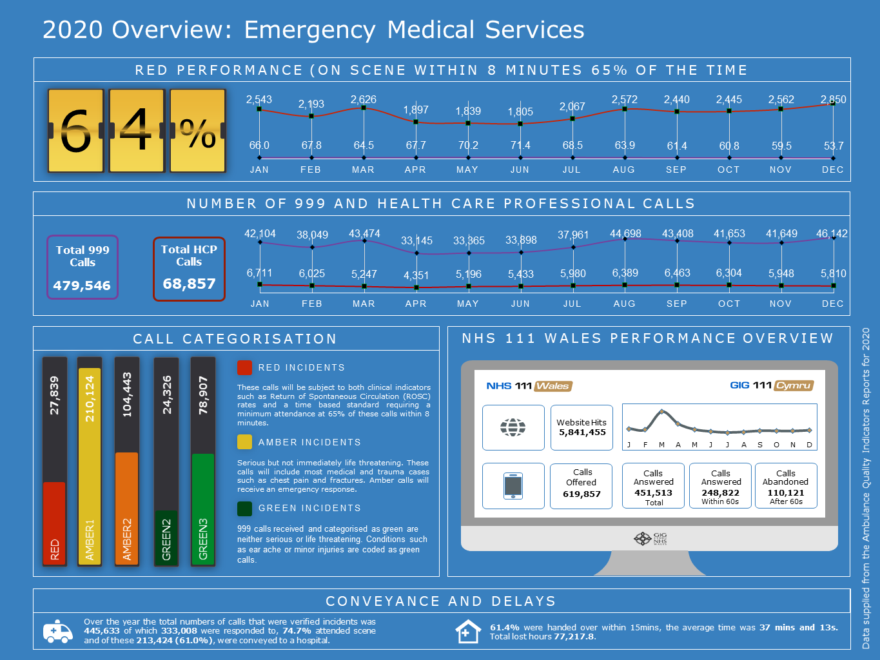

Appendix 2-NEPTS Overview 2020-21
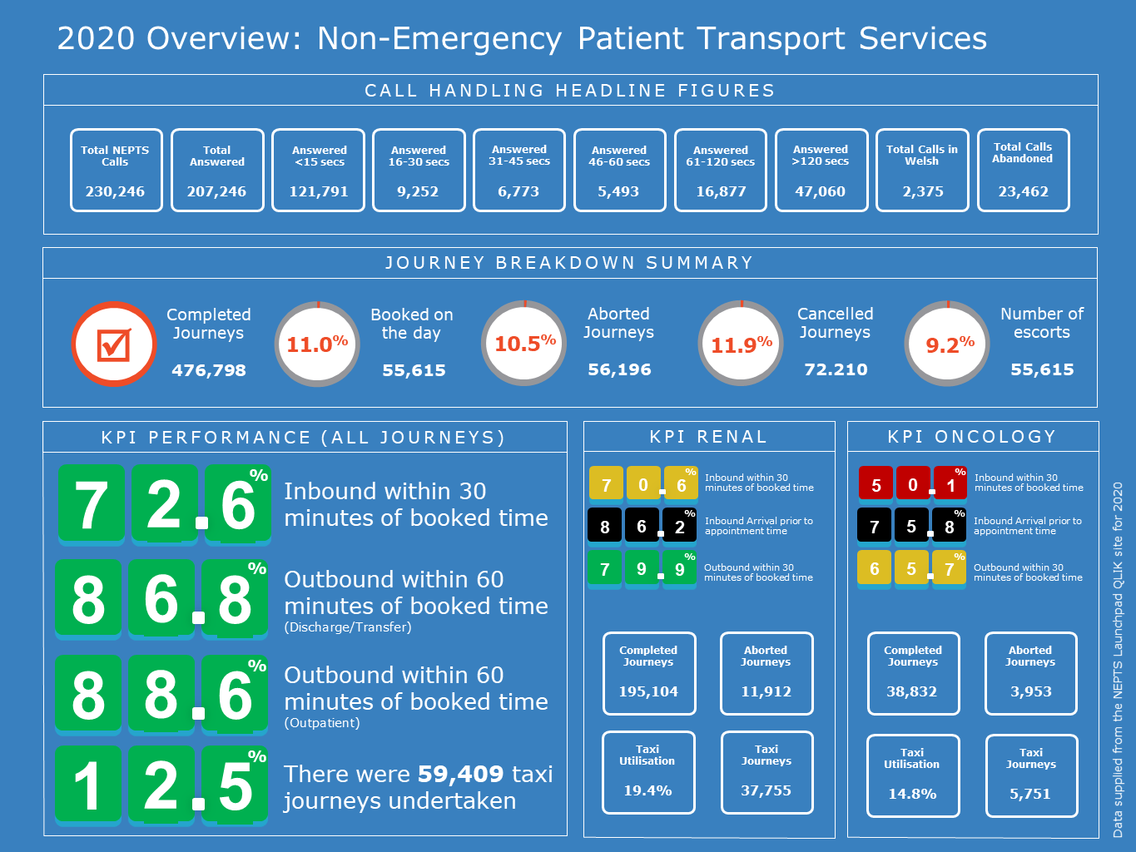

Appendix 3-EMRTS Overview 2020-21
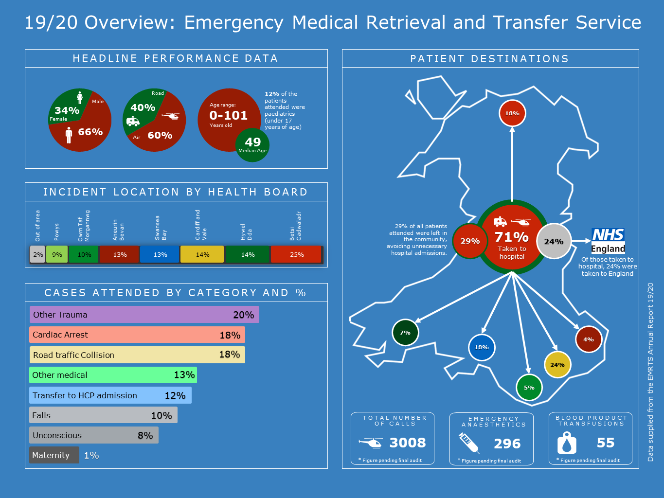

Appendix 4-EMS Commissioning Intentions 2021-22
Emergency Ambulance Services Committee – Emergency Ambulance Services Commissioning Intentions 2021-22

This document sets out the revised approach and guiding principles to the Emergency Ambulance Services commissioning intentions for 2021-22 and beyond.

These intentions aim to reflect the direction from Committee members to limit the additional asks on commissioned organisation this year, including but not limited to minimising meetings, reporting and developments in order to allow for commissioned organisations to focus on the pandemic response, stabilisation and recovery of services.

They also reflect the guidance and spirit of the NHS Wales Annual Planning Framework 2021-22 and aim to support the transition of performance management arrangements to focus on outcomes, quality and safety of service delivery.

The ongoing development of the commissioning framework is considered as a core principle of the collaborative commissioning process and as such do not require specific commissioning intentions.

These commissioning intentions are not intended to set out all activity that will be undertaken this year by commissioners or the provider, but to provide a clear indication of the priorities of the Committee for the provider of Emergency Ambulance Services in Wales for 2021-22.

Guiding Principles for 2021-22
- Intentions will be at the strategic level and will be extant for a minimum of 3 years
- Collaborative priorities ie WAST, HB’s and CASC Team will be agreed annually for each intention
- They will focus on delivery and outcomes
- Each intention will have annually agreed of an aims, product or indicator or a combination of these.
- They will recognise the challenges of resetting in post-covid environment and the opportunities to fast track service transformation
- They will not replace or override extant requirements within the commissioning framework or statutory targets or requirements.

Delivery
Progress against delivery will be monitored via the monthly Chief Ambulance Services Commissioner Quality and Delivery meetings. Assurance on delivery to the committee will take place via quarterly reports and discussions taking place at EASC management group.
Commissioning Intention – CI1 Clinical Response Model
The Emergency Ambulance Service and its Commissioners will seize the opportunities afforded by the Welsh Clinical Response Model and the 5 Step EMS Ambulance Pathway.

Commissioning Statement
The 5 step EMS Ambulance Pathway provides a simplified framework for health systems to collaborate to optimise the care patients receive at each step. A high performing health system will enable services and practitioners at each step to resolve a patient episode of care without the need to progress further along the pathway. Maximising the potential of this opportunity will require system wide collaboration that transcends traditional organisational and professional boundaries.

Aims
CI1-A1 | Increase the proportion of activity resolved at Step 2 – Using the activity within the demand and capacity review as a baseline, this aim requires the proportion of activity resolved at step 2 to increase. No specific proportion of activity will be set for achievement of this aim for 2021/22 but stretch goals will be agreed collaboratively throughout the year.
CI1-A2 | Right response first time – Optimising multiple responses at Step 3 – Using activity within the demand and capacity review as a baseline, this aim requires an improvement in the multiple response rate (excluding Red) and the resolution of that episode of care by a single resource.
Products
CI1-P1 | Remote Clinical Support Strategy – Development and approval of an overarching remote clinical support strategy that outlines the organisational ambition for remote clinical support at the forefront of ambulance service care.
CI1-P2 | Optimising Conveyance Improvement Plan – Development and implementation of an improvement plan or programme that support the optimisation of conveyance. This will include non-conveyance as well as improving conveyance destination decisions.
Indicators
CI1-I1 | Clinical Support Desk Outcomes – Process for recording episodes of care within the CSD will be developed to enable routine identification of patients NHS Number to enable tracking of a patient’s outcome. By close of 2021/22 Quarterly reports will be available that describe the high level outcomes for clinical support desk care episodes.
CI1-I2 | Outcome by Response Type – Development of monitoring and oversight process that record outcomes by response type. By close of 2021/22 Quarterly reports will be available that describe the high level outcomes for different response types.
Commissioning Intention – CI2 Availability
The Emergency Ambulance Service and its Commissioners will optimise the availability and flexibility of front line resources to meet demand.

Commissioning Statement
The Emergency Ambulance Services Committee holds statutory responsibility for the planning and securing of sufficient ambulances services for the population of Wales. Discharging this responsibility requires close collaboration between commissioners and the provider to ensure that all available resources are used effectively.

Aims
CI2-A1 | Closing of the relief capacity gap - The existence of a relief capacity gap has been understood for over a decade. The most recent demand and capacity review has identified the current gap and whilst the closure of this gap is dependent on a range of factors (Ministerial Taskforce, funding, efficiencies etc.), this gap will be resolved by the close of 2021/22.
CI2-A2 | Rosters aligned to demand - The current demand profile is not matched by available resource. This has a significant impact on quality of service for patients and wellbeing of staff. By close of 2021/22 rosters aligned to demand will be available for each area and an implementation programme will be in place.
Products
CI2-P1 | Demand and Capacity Strategy – A collaboratively developed demand and capacity strategy will set out the ongoing arrangements for proactively undertaking this work for the next decade, this will include the use of forecasting, modelling and health economic evaluations.
Indicators
C2-I1 | Additionality measure – A collaboratively agreed additionality requirement for the end of 2021/22 will be in place by the end of Quarter 1. This will account for vacancy factors, turnover and other confounders.

Commissioning Intention – CI3 – Productivity
The Emergency Ambulance Service and it Commissioners will maximise productivity from resources and demonstrate continuous improvement.

Commissioning Statement
Ensuring appropriate levels of productivity from the resources available is a key component of delivering an effective ambulance service. There are a number of external and internal drivers leading to suboptimal productivity. Addressing these areas has the potential to deliver significant gains for emergency ambulance provision and the wider emergency and urgent care system.

Aims
CI3-A1 | Reducing Post-Production Lost Hours – Post-production lost hours have been a significant contributor to reduced productivity. Using an agreed baseline measurement period, Post-production lost hours will be reduced in line with a quarterly agreed improvement trajectory.
CI3-A2 | Reducing Notification to Handover Time – NHS Wales is a significant outlier in the UK and Internationally for lost productivity due to extended notification to handover times. By the end of 2021/22 NHS Wales will have reduced 1 hour waits to less than 5% of total arrivals and ensured that total lost hours at Welsh Hospitals do not exceed 150 hours per day on 95% of the year.
Products
CI3-P1 | Modernising Workplace Practices Implementation Plan – There will be an implementation plan and supporting structures in place to ensure workforce practices and policies are reviewed, modernised and improved. The wellbeing of the workforce and safety of patients will be paramount within this.
Indicators
CI3-I1 | Unit Hour Utilisation Metric – By the end of Quarter 2 A metric and appropriate dashboard will be developed that demonstrates the utilisation rate (and activity type) of various resources types, this will be available at Wales, HB, Locality, Station and individual resource level.

Commissioning Intention – CI4 - Value
The Emergence Ambulance Service and its Commissioners will develop a value-based approach to service commissioning and delivery which enables an equitable, sustainable and transparent use of resources to achieve better outcomes for patients.
Commissioning Statement
Value is created when we achieve the best possible healthcare outcomes for the Welsh population with the most efficient and effective use of available resources. We also recognise that value can be depleted and therefore the development of a value-based strategy will need to identify ways to effectively manage and mitigate the risks of value depletion in addition to identifying opportunities for value creation.
Aims
CI4-A1 | Value-Based Healthcare for the Welsh Ambulance Service  Develop and embed a value-based approach for the Welsh Ambulance Service which enables better collective decision making across the whole urgent and emergency care system and accounts for WAST’s use of, and impact on, economic, social and environmental resources over the short, medium and long term. This will include:  - Development of WAST’s strategy and approach to Value-Based healthcare which links outcomes, patient experience and use of resources  - Implementation of a costing model for “5 step” pathway  - Improvement in ability to identify areas of unwarranted variation in service delivery across Wales
Products
CI4-P1 | Value-Based Strategy -The Trust will develop a strategy to implement a value-based approach across the organisation and outline its role in delivering value across the wider UEC system. The value-based strategy will be integrated with and align to existing organisational strategies (e.g. clinical, quality, long term, digital, environmental etc) and the commissioning intentions outlined in this document in order to ensure goal congruence.
CI4-P2 | Value-Based Tools and Methods - In order to monitor and measure value-based performance, the Trust will need to design, develop and implement a range of tools including, but not limited to, the following:  - Patient Level Costing Model  - Benchmarking Dashboard(s)
CI4-P3 | Value-Based Reporting -WAST will enable a clear line of sight from commissioner allocation through to utilisation and the outcomes delivered by the services. WAST will holistically demonstrate through its reporting all separate revenue streams and associated costs of broader service provision (e.g. 111, NEPTS, etc).  WAST receives a capital allocation directly from Welsh Government. The utilisation of the capital budget and the use of the ring-fenced depreciation allocation will need to be clearly identified in any report. As a result, WAST will be able to demonstrate how its capital allocation is being invested to deliver on the commissioning intentions.
Indicators
CI4-I1 | Value-Based Core Requirement to be agreed with Commissioner by the end of quarter 2:  - WAST Value Based Strategy  - Plan for Value Based Tools and Methods design, development and implementation  - Value Based Reports developed for revenue and capital  - Value-Based indicators developed in line with broader indicators outlined in CI1 to CI5  - Connections to system-wide urgent and emergency care performance measures as identified in CI6 – Wider Health System

Commissioning Intention – CI5 – Harm & Outcomes
The Emergency Ambulance Service and its Commissioners will collaborate to reduce and prevent harm, and improve quality of service and outcomes for patients.

Commissioning Statement
Emergency ambulance services operate in complex and challenging environments. The delivery of a quality ambulance service requires effective, safe and people-centred care. To realize the benefits of quality health care, ambulance services must be timely, equitable, integrated and efficient. A mature health system proactively seeks opportunity’s to reduce and prevent harm. Continuous improvement based on learning from errors and adverse events must be a cornerstone of emergency ambulance provision.

Aims
CI5-A1 | Proactively Identifying Harm – The proportion of harm/near missies proactively identified prior to a complaint or report will increase. This will include process for reviewing patient clinical records and engagement with the wider health system (i.e. sharing information around patients impacted by DMP levels)
Products
CI5-P1 | Clinical Indicator Plan and Audit Cycle – A clinical indicator plan and audit cycle will be in place, this will provide a forward view of the type, content and regularity of clinical indicator and audit reporting. Specific seasonal and responsive (to emerging trends) reports and audits will be included within the plan.
Indicators
CI5-I1 | Call to door times – Time is an essential aspect of quality service delivery for emergency ambulance services. For some condition such as STEMI and Stroke time is a major component of improving outcomes. By the end of quarter 2, call to door times for STEMI and Stroke will be being produced on a monthly basis.

Commissioning Intention – CI6 – Wider Health System
The Emergency Ambulance Service and its Commissioners will collaboratively develop and deliver services that allow the ambulance service to contribute to the wider health system.

Commissioning Statement
The Emergency Ambulance Services has a unique role as the only all Wales operational service. Today ambulance services provide mobile urgent treatment services with staff educated and trained to deal with a wide range of emergency and urgent conditions. Maximising both of these opportunities will benefit the whole of NHS Wales

Aims
CI6-A1 | System Flow – Optimise the flow of ambulances into hospital sites in Wales, reducing batching and increasing the timeliness of patient accessing secondary care
CI6-A2 | Transfer and Discharge Service – To reduce the number of transfers and discharges being undertaken by the EMS feet.
Products
CI6-P1 | System wide escalation and demand management plan – A single aligned escalation and demand management plan will be in place, this will include the actions health boards must take to support patients when the EMS service has reached DMP 4. Health Boards will develop an equivalent of the DMP for Emergency Departments.
CI6-P2 | National Transfer and Discharge Commissioning Framework – A collaborative commissioning framework for a national transfer and discharge service will be agreed by close of 2021/22.
Indicators
CI6-I1 | System Pressures Dashboard – WAST and Health Boards will collaborate to develop a live system pressures dashboard that enables users to understand current and emerging pressures.

Appendix 5-NEPTS Commissioning Intentions 2021-22
Emergency Ambulance Services Committee – Non-Emergency Patient Transport Services Commissioning Intentions 2021-22

This document sets out the approach and guiding principles to the commissioning intentions for Non-Emergency Patient Transport Services (NEPTS) for the period 2021-22 and beyond.

These intentions aim to reflect the direction from Committee Members to limit the additional asks on commissioned organisations this year, including but not limited to minimising meetings, reporting and developments in order to allow for commissioned organisations to focus on the pandemic response, stabilisation and recovery of services.

Intentions reflect the guidance provided within the NHS Wales Annual Planning Framework 2021-22 and aim to support the transition of performance management arrangements to focus on outcomes, quality and safety of service delivery.

These commissioning intentions are not intended to set out all activity that will be undertaken this year by commissioners or the provider, but to provide a clear indication of the priorities of the Committee for the Non-Emergency Patient Transport Services for 2021-22.

2021-22 is considered as a transitionary year for NEPTS as such intentions will be focused on delivery for this year. A set of strategic commissioning intentions will be developed for NEPTS during 2021-22.

Guiding Principles for 2021-22
- Ongoing engagement and review between NEPTS and Commissioners will allow the detail of each intention to be refined during the period, if required
- Intentions will not replace or override extant requirements within the Quality and Delivery Framework or statutory targets or requirements.

Development and monitoring
- NEPTS Delivery Assurance Group will hold responsibility for the development and monitoring of progress against commissioning intentions to ensure the strategic intent is achieved
- The EASC commissioning team will develop a three year commissioning cycle from 21-22 to allow earlier review and collaborative development of commissioning intentions.

NEPTS Commissioning Intention 1- Plurality Model

CI1a - Transfer of Work - Complete the transfer of work from health boards to WAST and develop a plan to novate any outstanding areas.
CI1b – Resource Efficiency - Demonstrate that resources are being utilised effectively following transfer of work.
CI1b - Plurality Providers - Continue to expand and improve the availability of plurality providers.

NEPTS Commissioning Intention 2 – Demand

CI2a – Planning - Implement improved and dynamic planning process that maximise the utilisation of resources.
CI2b – Reducing Demand – Identify opportunities to reduce and redirect demand to more appropriate transport options (for 2021/22 this should focus on T1 Walker and Renal Patients)

NEPTS Commissioning Intention 3 – Capacity

CI3a – Transforming Capacity – Implement processes to increase NEPTS capacity within current resources.
CI3b – Reducing lost capacity – Implement improvement plans and oversight arrangements to deliver reduction in lost capacity due to system inefficacies

NETPS Commissioning Intention 4 – System Transformation

CI4a - Demand and Capacity Strategy – A collaboratively developed demand and capacity strategy will set out the ongoing arrangements for proactively undertaking this work for the next decade, this will include the use of forecasting, modelling and health economic evaluations.

Appendix 6-EMRTS Commissioning Intentions 2021-22
Emergency Ambulance Services Committee – Emergency Medical Retrieval and Transfer Service Commissioning Intentions 2021/22

This document sets out the approach and guiding principles to the commissioning intentions for the Emergency Medical Retrieval and Transfer Service (EMRTS) for the period 2021-22 and beyond.

These intentions aim to reflect the direction from Committee members to limit the additional asks on commissioned organisations this year, including but not limited to minimising meetings, reporting and developments in order to allow for commissioned organisations to focus on the pandemic response, stabilisation and recovery of services.

Intentions reflect the guidance provided within the NHS Wales Annual Planning Framework 2021-22 and aim to support the transition of performance management arrangements to focus on outcomes, quality and safety of service delivery.

These commissioning intentions are not intended to set out all activity that will be undertaken this year by commissioners or the provider, but to provide a clear indication of the priorities of the Committee for the Emergency Medical Retrieval and Transfer Service for 2021-22.

2021-22 is considered as a transitionary year for EMRTS, as such, intentions will be focused on delivery for this year. A set of strategic commissioning intentions will be developed for EMRTS during 2021/22.

Guiding Principles for 2021-22
- Ongoing engagement and review between EMRTS and Commissioners will allow the detail of each intention to be refined during the period, if required
- Intentions will not replace or override extant requirements within the Quality and Delivery Framework or statutory targets or requirements

Development and monitoring
- EMRTS Delivery Assurance Group will hold responsibility for the development and monitoring of progress against commissioning intentions to ensure the strategic intent is achieved
- The EASC commissioning team will develop a three year commissioning cycle from 21-22 to allow earlier review and collaborative development of commissioning intentions

EMRTS Commissioning Intention 1- Service Expansion

CI1a – Evaluation and Review – Undertake evaluation and review relating to the implementation of Phase 1, reporting on lessons learned, service activity and providing the required assurance regarding the realisation of anticipated outcomes and benefits.
CI1b – Planning – Build on the implementation and consolidation of Phase 1, working collaboratively to plan the implementation of the remaining phases of the EMRTS Service Expansion programme.

EMRTS Commissioning Intention 2 – Adult Critical Care Transfer Service Implementation

CI2a – Project Set-Up and Implementation – Complete the set-up and implementation phases including workforce, governance and operational elements.
CI2B – Service Delivery - Evolve to a phase of ongoing service delivery and a shift in focus of the reporting regime.

EMRTS Commissioning Intention 3 – Service Evaluation

CI3a – Review – Consider and review the EMRTS Service Evaluation Report in order to understand its implications for the service.
CI3b – Improvement Plan – Develop and implement an improvement plan in response to the Report.

EMRTS Commissioning Intention 4 – System Transformation

CI4a - Demand and Capacity Strategy – A collaboratively developed demand and capacity strategy will set out the ongoing arrangements for proactively undertaking this work for the next decade, this will include the use of forecasting, modelling and health economic evaluations.

