Emergency Ambulance Services Committee
Register of recommendations from Internal Audit Reports
EASC Recruitment review May 2021  Overall rating reasonable assurance  Two medium recommendations | 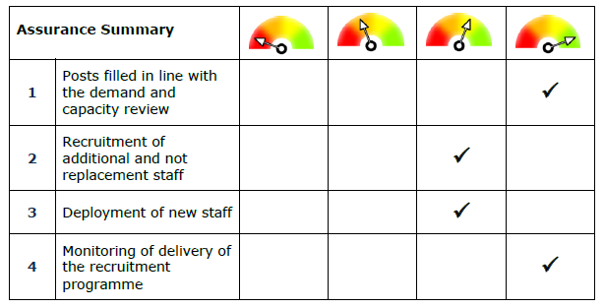

No | Findings | Recommendation and risk | Priority | Timescale | Lead | Progress | Completed
1 | Each month WAST provides EASC with a Recruitment and Training Plan highlight  report. The report provides a detailed overview of the additional recruitment to date against each of the three staffing groups identified in the demand and capacity report and highlights the key issues and risks for the recruitment  programme.  However, we have been informed that fully understanding all aspects of WAST’s recruitment programme including how the data within the highlight reports has been generated and its interaction with the wider workforce headcount and other recruitment streams has at times been challenging for EASC. While WAST have  provided detailed explanations to queries raised by EASC following review of the  recruitment monitoring information, if additional information was included in the reports, this may negate the need to raise queries.  For example, at points in the year there have been variations month on month in the planned recruitment numbers. April 2020 report showed a figure of 571.5 FTE needed (this allows for the additional staff, plus turnover and promotion of existing staff). By July the number has fallen to 488.5 and rose again to 525.5 by October.  The report does not clearly explain why there have been these movements.  Furthermore, the data in the highlight report is based around headcount numbers.  No financial data is included making it difficult for EASC to reconcile financial information to the recruitment information.  We note that when EASC agreed to provide WAST with the funding to support the additional posts, no SLA or funding agreement was put in place, setting out That the recruitment drive, funded  with non-recurrent funding from EASC fails to deliver the  requirements WAST set out in its demand and capacity plan review. | 1. EASC should continue to work with WAST to ensure that satisfactory evidence and explanations are provided for all its queries regarding the additionality and wider workforce headcount and financial information. Where possible, EASC should encourage WAST to include such information on the monthly highlight report in order to better contextualise the data within the report.  2. If the existing arrangements between EASC and WAST do not clearly set out expectations, consideration should be given to having a formal agreement in  place to provide greater clarity around the expectations of both parties in relation to areas such as access to information and data from WAST regarding the programme.  Risk  That the recruitment drive, funded with non-recurrent funding from EASC fails to deliver the requirements WAST set out in its demand and capacity plan review. | Med | Oct 2021 | CM | EASC has set a Commissioning Intention on Value, which is currently being developed into a collaborative programme of work between EASC and WAST. As part of this, it is intended that EASC’s holistic Value-Based Commissioning model  is developed and applied to the D&C programme to establish a clear evidence base for identifying, monitoring and measuring value which will also help to address the issue of contextual information.  Update  The Value Based Commissioning Model is currently being integrated into a refreshed EASC Commissioning Framework.  The refreshed Framework will act as the foundation for the development of improved reporting, assurance and decision making processes for D&C but also EMS services more broadly. This will address the risks and recommendations identified in the internal audit review. The EASC Commissioning Framework will be presented at EASC Management Group on 21 October for review and approval.  Update  The approach to develop the Commissioning framework was approved by EASC Management Group in October 2021.  The EAS Joint Committee will receive an alternate approach to the intended commissioning framework to adapt to the changed position where core and transformational work is more easily defined.  The actions can therefore be closed | March 2022
2 | A report produced in February 2020 by external consultants on behalf of WAST, identified a number of scenarios to answer the question ‘What are the sensible locations for adding 136 FTE over the WAST area?’  We understand that during the recruitment process WAST attempted to locate staff in line with the report findings. However, we acknowledge that this was made more difficult by the pandemic, forcing staff to be located close to home as opposed to where demand was, although ambulance resources can be moved around Wales each day in order to respond to demand.  We understand that work is ongoing by WAST to review any imbalance caused, and that the 2021/22 recruitment, plus other reviews such as the response roster review and estates review, will help in addressing any issues. | Deployment of new staff should continue to be monitored to ensure recruitment happens in line with the recommendations arising from February 2020 consultant report.  Further consideration should be given to identifying if the flexible approach to staff deployment could impact on patient safety.  Risk  That the recruitment drive, funded with non-recurrent funding from EASC fails to deliver the requirements WAST set out in its demand and capacity plan review. | Med | March 2022 | RW | We will continue to monitor the deployment of new recruits as part of our ongoing assurance mechanism via the sub-structures of EASC.  In addition to this where deviations to deployment are requested / required we will require WAST to produce robust modelling that allows commissioners to understand the impact on the ambulance response to their population.  We have already requested a number of areas of modelling / planning around rural responsiveness and red performance variation.  In recognition of the changes that have occurred as a result of the pandemic, an update to the Demand and Capacity review is currently being undertaken, this finding of this update will support the development of the rosters and subsequent deployment of staff. The results of the update should be available by November 2021  Update March 2022  136WTE originally intended have been recruited and have been in post since before 31 March 2021.  The additional recruitment of up to 127wte by March 2022 will fill the remaining vacancies at stations across Wales.  Completed. | March 2022
EASC Governance Arrangements
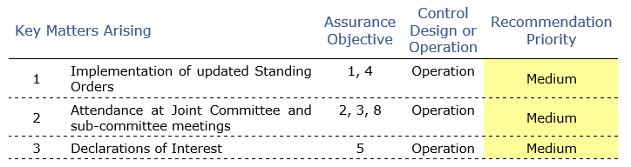

1 | Implementation of updated model standing orders | 1.1 Further work should be prioritised to implement the remaining actions required to ensure EASC is compliant with the adopted model Standing Orders. | Med | July 2022 | GR | The work on the adopted Model Standing Orders will be completed, presented and approved by EASC.
1 | Implementation of updated model standing orders | 1.2 Updates on progress to implement the outstanding actions should be reporting to the relevant committee for monitoring. | Low | July 2022 | GR | Outstanding actions will be initially reported at the EAS Joint Committee and following at the next Audit and Risk Committee meeting
2 | Attendance at Joint Committee and sub_committee meetings | The importance of attendance at Joint Committee and sub-committee meetings should be re-emphasised collectively and should be followed up with those who regularly miss meetings. | Med | July 2022 | GR | The Chair of the Committee and sub-committees will write to members in relation to meeting attendance by health board or NHS Trust representation. Attendance information will be included in the Committee and sub-committee annual reports. Attendance information will be included in the Committee and sub-committee annual reports.
3 | Declarations of interest | 3.1 The list of people required to make a declaration of interest should be reviewed for completeness and then completed declarations should be obtained from all. | Med | July 2022 | GR | The Committee Secretary will review the table of declarations of interest for completeness and will obtain responses from all and present to the EASC.
3 | Declarations of interest | 3.2 The EMRTS sub-committee should require members to make or confirm any declarations of interest at the start of each meeting. | Low | Completed | ME | Completed, added to the Agenda for the EMRTS DAG in December and ongoing | Dec2021

