Present
Stephen Harrhy (Chair) EASCT | Hugh Bennett WAST
Ross Whitehead EASCT | Chris Moreton EASCT
Ricky Thomas EASCT | Meinir Williams BCUHB
Lee Brooks WAST | Marie Davies CVUHB
Richard Baxter EASCT | Sian Harrop Griffiths SBUHB
Navin Kalia WAST | Shaun Ayres HDdaUHB
Gill Harris BCUHB | Robert Mahoney CVUHB
Kathryn Smith ABUHB | Adam Wright CVUHB
Claire Nelson CTMUHB | Andy Swinburn WAST
Rachel Marsh WAST | Craige Wilson SBUHB
Chris Turner Chair EASC | Geraint Farr BCUHB
Alex Crawford WAST | Mark Winter EMRTS
Jason Collins WAST | Matthew Edwards EASCT
Tim Woodhead BCUHB | Neil Miles ABUHB
Gareth Robinson CTMUHB | Pete Hopgood PTHB
Philip Meredith ABUHB | Susan Evans EASCT
Wendy Herbert WAST | Gwenan Roberts EASCT

Item
Welcome, Introductions & Apologies

Stephen Harrhy welcomed all present and thanked everyone for making the time to attend the meeting and gave an overview of why the meeting was taking place. Those present noted that EASC had previously discussed what a modern ambulance service would look like and that only those patients who needed should actually go to hospital.

The importance of the role of the ambulance service aligning to all health boards IMTPs for improved patient care was emphasised. Those present were fully aware that the whole system was under tremendous pressure and a lot of the ambulance resource was currently waiting outside emergency departments across Wales.

A huge number of hours had been lost outside emergency departments; the working premise by EASC had set a limit of 6,500 lost hours (as per December 2018); in January 2022, 22,500 were lost in the month in an increasing trend. WASTs Clinical Safety Plan had been in operation and they had been unable to send a resource to patients. In January 2022, there were occasions that amber 2 category patients were not receiving a response due to the volume of calls to the ambulance service.

HBs had supported WAST to recruit more staff 136WTE and 127WTE (last year and this) and it was noted that WAST would be supported by the military until the end of March 2022.

In terms of pressure, very serious position and patients coming to harm. In terms of developing a modern ambulance service need to reduce those attending Eds when not required. Six Goals for Urgent and Emergency Care handbook now launched and the importance of the work to improve services for patients in Wales.

EASC have asked WAST to describe what they could do within this current environment and what real additionality without robbing staff from other areas of NHS Wales. EASC discussed the general situation and asked for more scrutiny on the plan and viability, suitability

Doing nothing means that the situation will increase and more patients will come to harm.

Stephen Harrhy asked the WAST team to take those attending the meeting through their proposed plan. No decisions will be made today but will be discussed at the EASC Management Group

Members asked:
- Why increasing numbers of handover delays? – CASC has written to HBs asking for plans to improve local improvements
- Where decisions will be made?
- Still funding available in the national urgent and emergency care programme could this be considered? – yes through the programme arrangements

Key items for discussion
Welsh Ambulance Services NHS Trust’s Emergency Medical Services Transition Plan

Rachel Marsh presented the report and gave and overview of how the work had been undertaken in WAST in relation to internal discussions in relation to what WAST could offer to reduce harm. Aim to improve outcomes and reduce harm; improve the working lives of frontline staff; use resources to maximum value to meet patient needs and a more transformed ambulance service.

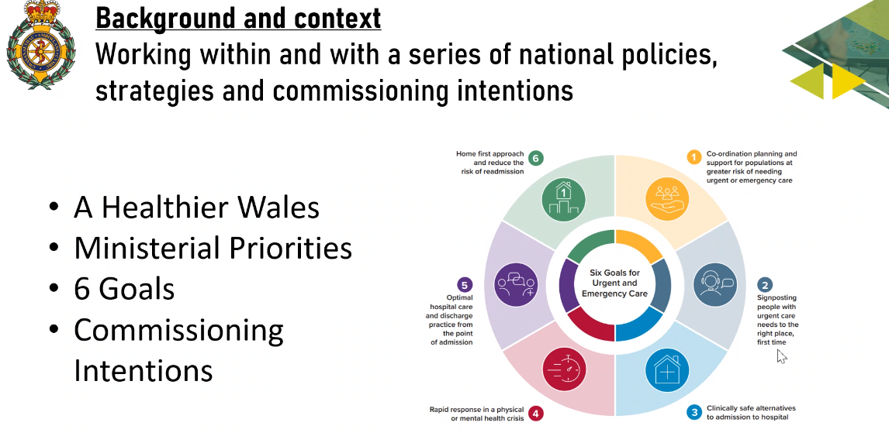

The following areas were highlighted:
- Addressing commissioning intentions
- Continued progress of the EMS Demand and Capacity Plan; overview included additional 500wte staff over 5 years, improved efficiency, rosters, sickness level and reduce hospital lost hours; and demand management
- Overview of current position

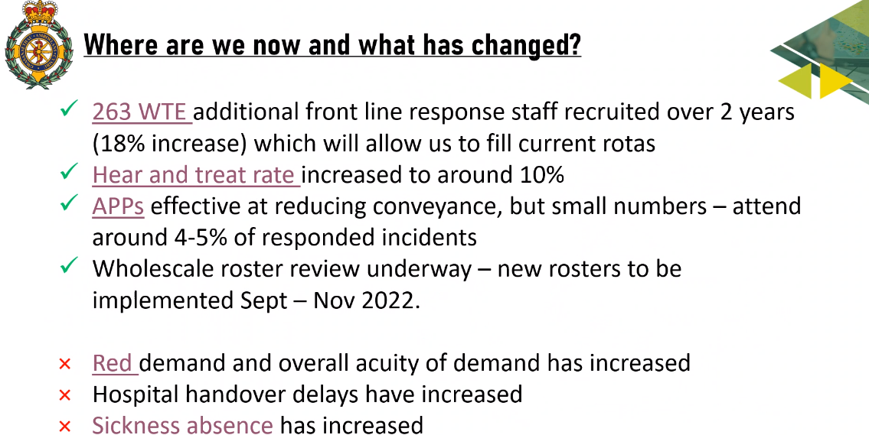

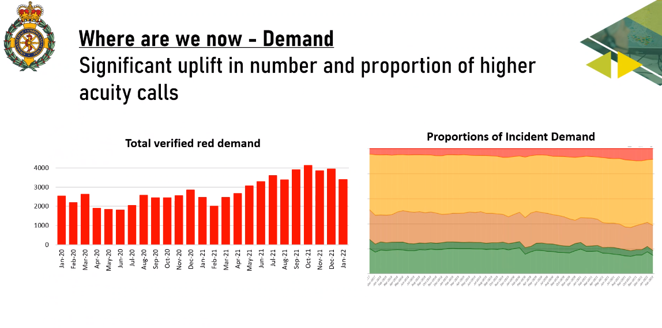
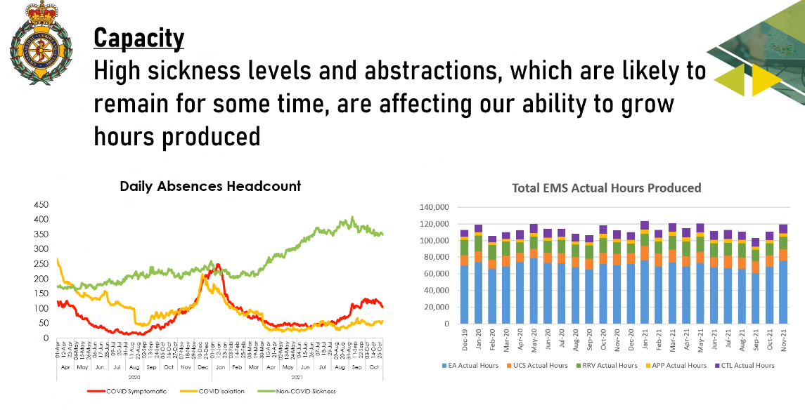
- Despite more staff in post

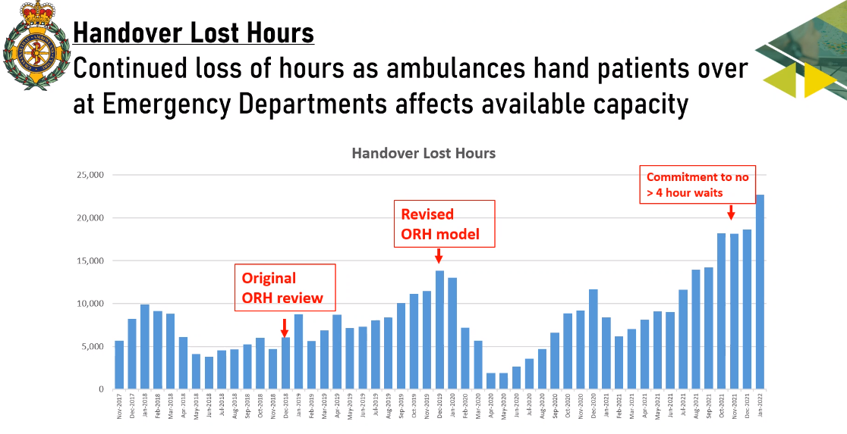

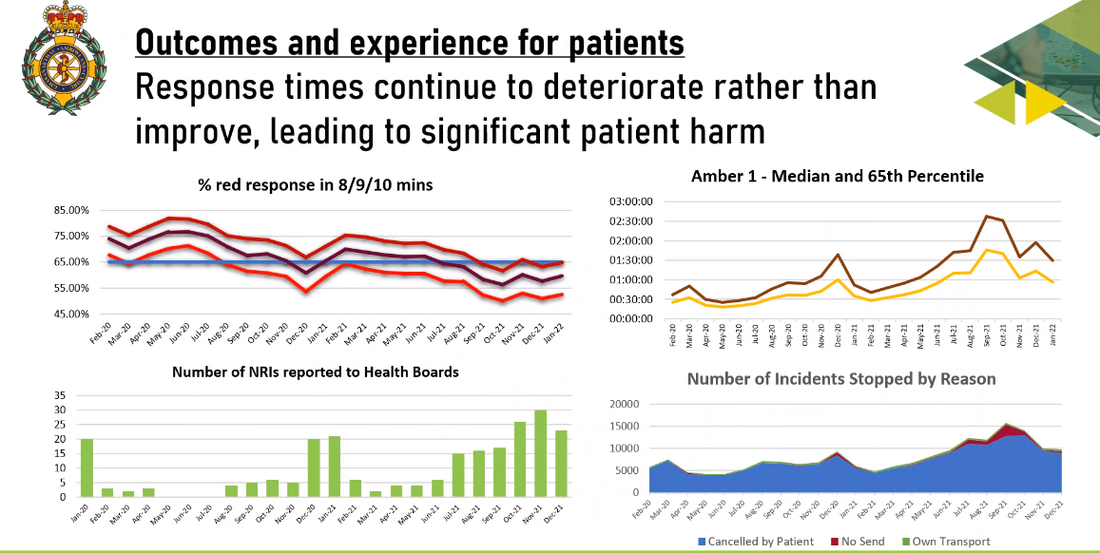
- In recent month not hitting target times and average of an hour for amber 1 call
- Serious adverse incidents (NRIs) increasing
- Clinical Safety Plan numbers and reducing due to the support from the military
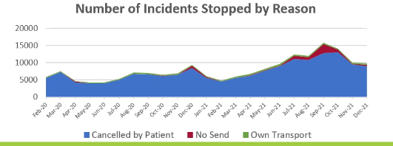

- In developing a modern ambulance service
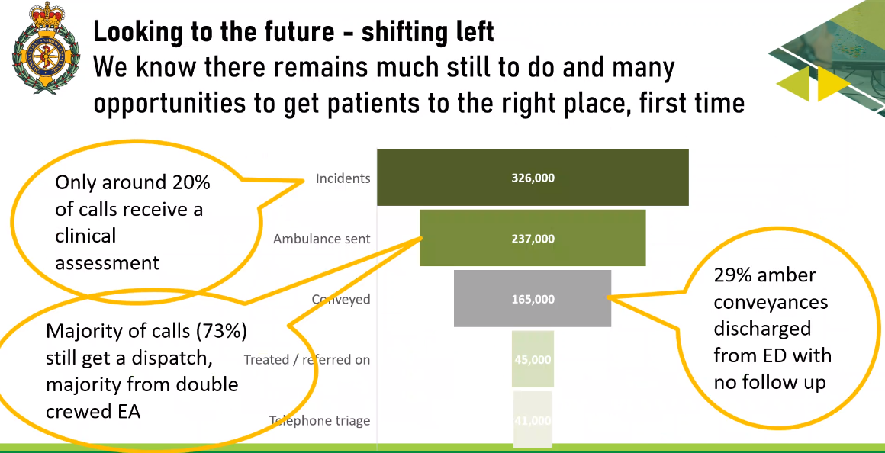

Model for the future:

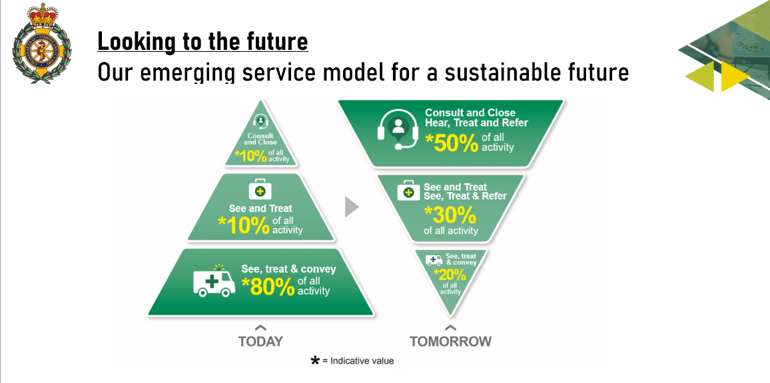
Next steps – military will finish on 31 March 2022
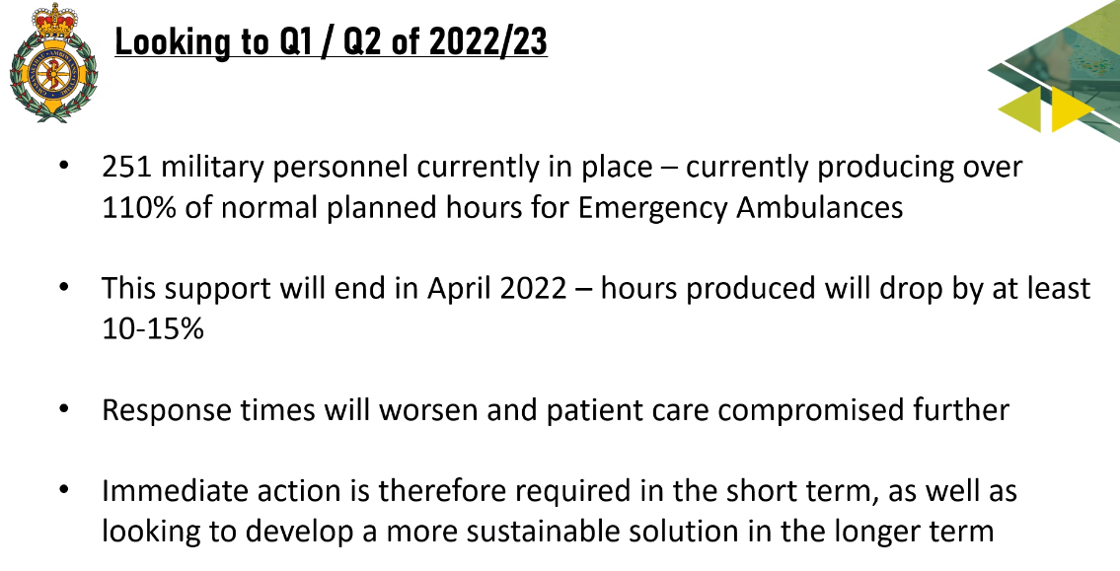
ORH asked to undertake modelling based on actual
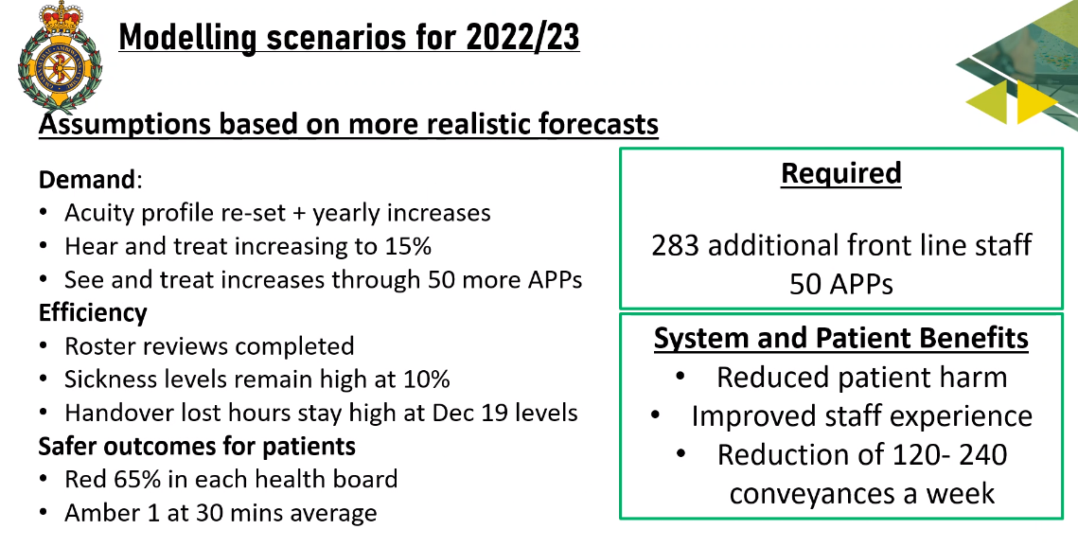
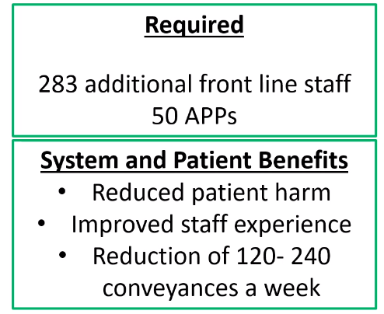
Explanation of the broad modelling scenarios
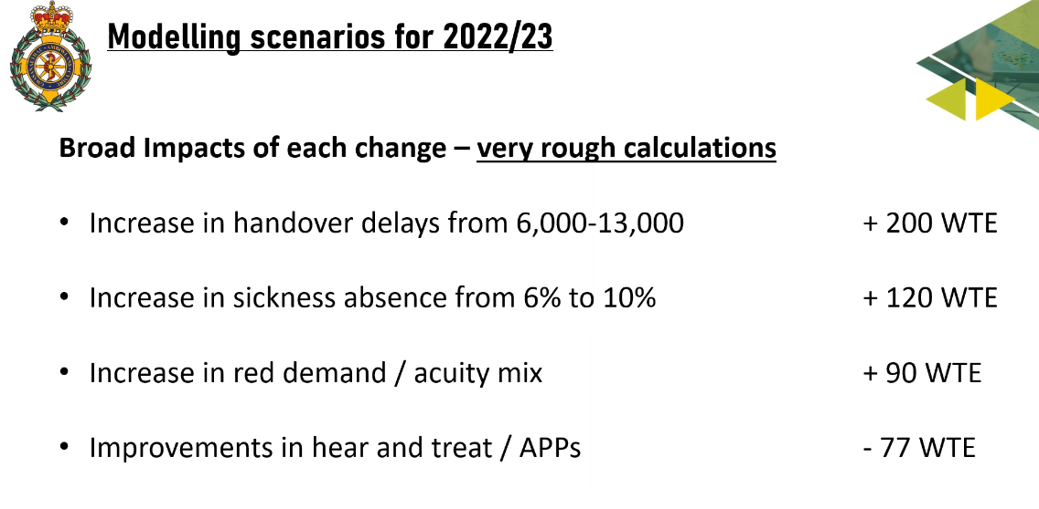
Assessment of what could be achieved (without taking from other areas of NHS Wales) model of care – CHARU (cars with paramedics for red calls; improved ROSC rates)
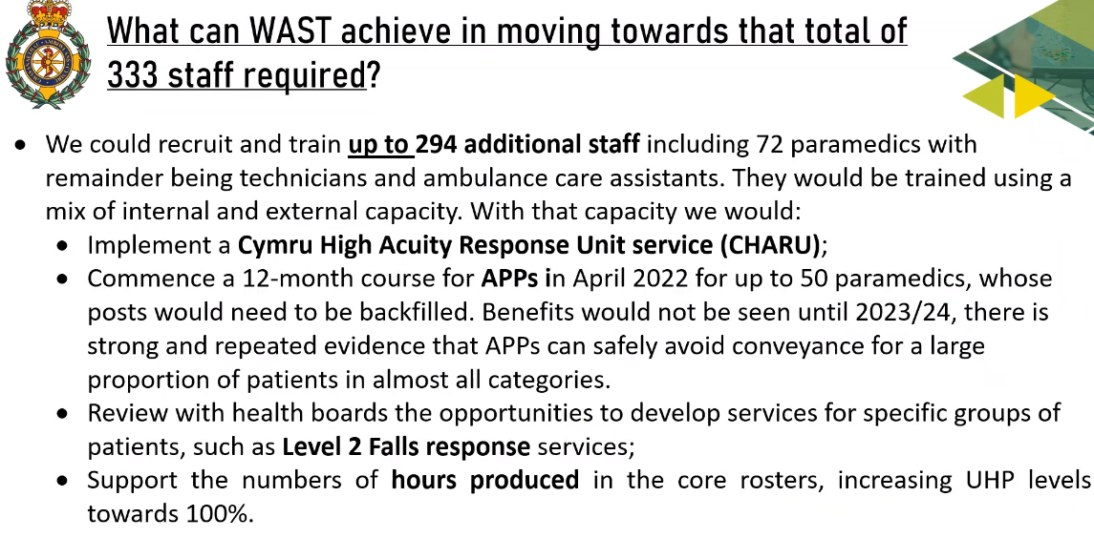

WAST efficiency improvements – sickness eventually to 6%; roster reviews 72WTE (performance benefit not cost saving); 11% hours staff not available for patients eg cleaning vehicles; return to station for meal breaks (6-7,000hours a month) a difficult issue working with staff side orgs and trades unions. Hear and treat and turning the investment into hear and treat rates.
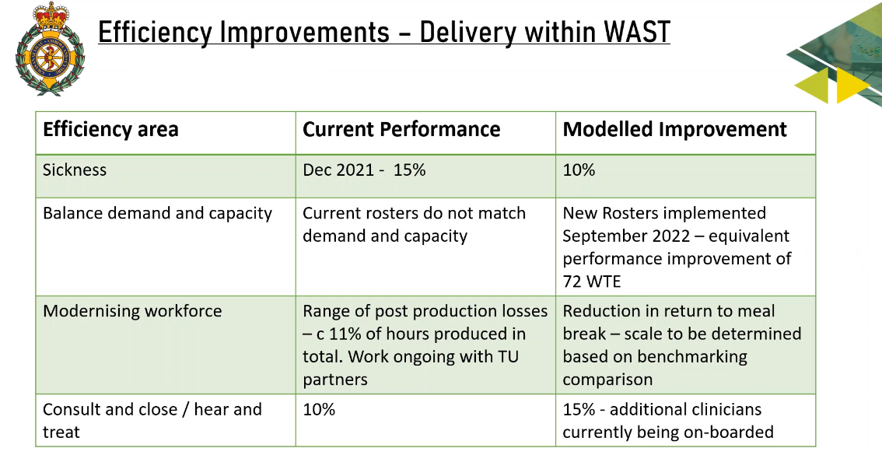

Health board representatives raised:
- Actual level of sickness - December 15%; Lee Brooks agreed to provide information
- Worry using response times to associating with harm – wider issue (felt one dimensional) e.g. in last 6 weeks that conveyance rate from 54% to 62% - conversion rate and the average waiting times on stack have reduced and not solving the problem with more capacity – more harm to patients, minimal intervention and off loading and difficulties to discharge and getting patients back home. Could have unintended consequences of putting more staff. Agreement that harm across the pathway but most serious within WAST are patients who die when resources not available in the right time frame (Amber 1 patients in particular); evidence information shared with CEOs on a weekly basis – energy needs to be on pre hospital pathway rather than conveying to hospital. Length of wait after a fall leads to more likelihood of being conveyed to ED. Important re the relative importance how to use the funding – a different pathway. Judged on its own merits supported but potential to use the finite resource in other parts of the system.
- Business case evidence behind the improvements – make sense but what is the evidence base?
- Anticipated scheme need understanding of what will be received from it
- What are the capital constraints? £16m would it be the best use of the resource?
- Impact and evidence needs to be increased
- Harm and risk in the system now – whole system approach but transition space and a gap to
- Immediate harm issue
- Part of the urgent and emergency care system – costs and benefits
- Sickness issue? Achieve 10% sickness rate – is this acceptable? Probably not but in a pandemic, it has been a difficult time but will reduce. Some are due to policies in organisations and need to be ambitious and back to business as usual pre pandemic sickness assumptions (but a trajectory towards) equity important. WAST response -agree to get to pre pandemic levels (accepting a commissioned organisation) but what is realistic in terms of timescales, impact will be a reduced service. Need for a transitional planning to go from actual to optimal. Importance of job satisfaction for all front-line staff – WAST and HBs
- What will be in place when the military leave?
- How are the staff being supported to work differently?

Summary from Stephen Harrhy
- Need to see the trajectory in relation to improving sickness levels (clarity)
- Might be helpful to have scenario modelling, high base and work back and its impact, what would altered variables bring?
- How certain are WAST that roster changes will be completed by November 2022? (fairly confident) (clarity)
- Post-production hours lost needs to have more clear trajectory and ambition to include a time scale – as part of the case needs to be clarified as with rosters – working with ORH for best in class and take stock, where is the partnership working and what commitments can be made and by when (clarity).
- Changes to flow and impact – improvement trajectory and the supporting evidence (to the triangles)
- re RED incidents 2.3% growth by ORH and agreed collaboratively which WAST have continued to use but closely monitoring the levels
- Moving towards 100% UHP – understood that this would be managed this if the relief gap is covered? Influenced by the sickness rate
- HBs need to work on handover hours lost by HB, same as hours lost and all efficiency gains are known and can be used to predict demand – letter sent to CEOs for organisational plans, important part of the case
- Are we delivering what we are intending? need an independent evaluation mechanism to be developed by the commissioners to help all to understand that all expectations delivered and appropriate and what learning could be captured moving forward
- Important to have transformation, not the specific number of additional staff

Back to the presentation
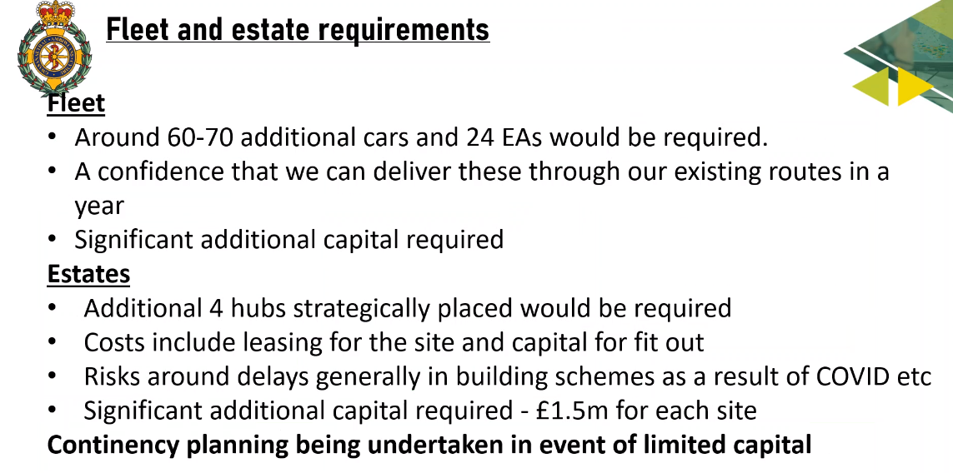
- Case has already been sent to Ian Gunney at WG
- Risk identified
- What is the phasing and timescale even if the modelling all accepted and need to agree and evaluate the delivery – but must do all we can to reduce patient harm
- Important to recognise that the level of detail is not yet available as need understanding whether to go ahead to progress the work

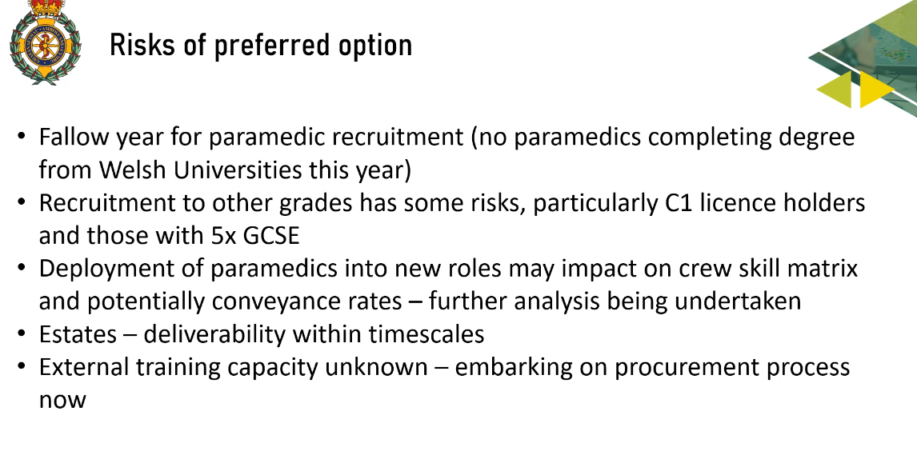
- Paramedic course extended
- Teams working hard to recruit paramedics and to support other grades; driving licence issue too; may consider what type of staff are within EMS vehicles learning from the lessons with the military
- Need to consider carefully the level of conveyancing and alignment between the offer by WAST and HB own plans to deliver 6 Goals – another risk – variation will inevitably occur in the model e.g. Powys
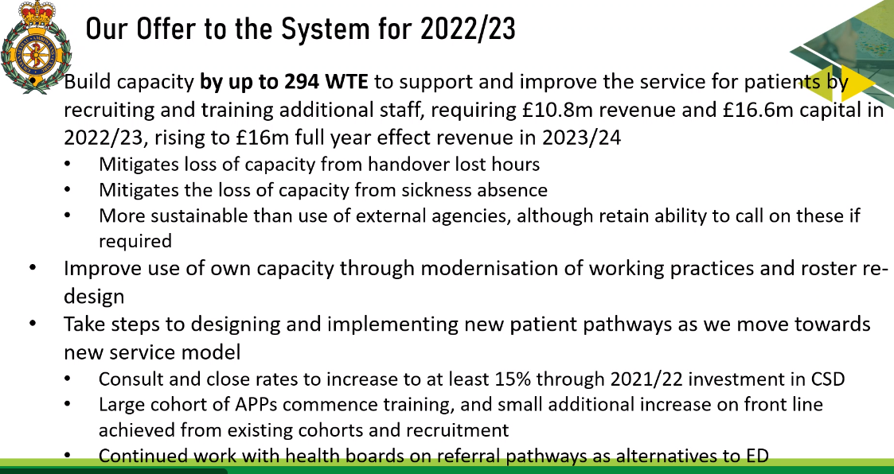

- Revenue and capital impact
- Mitigated lost capacity and trajectory for sickness absence
- Way towards the new service model

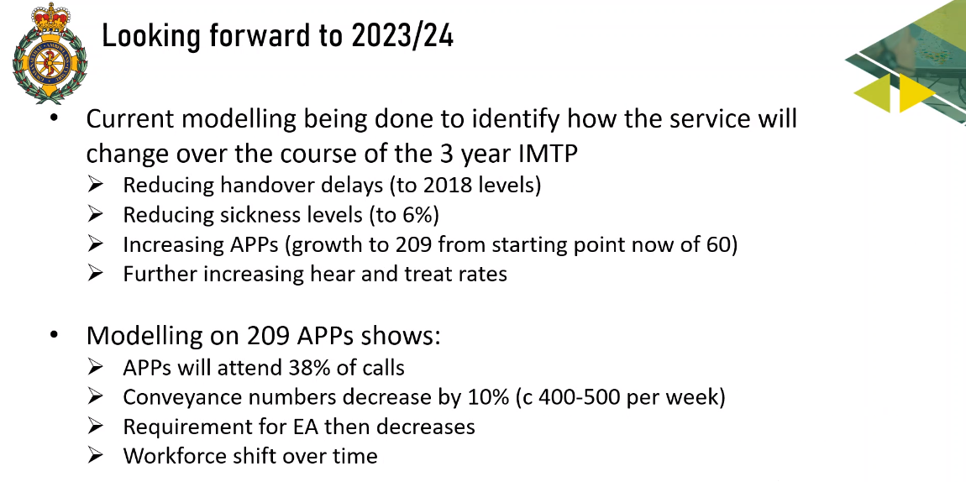
Have asked ORH to model in 3 years; resolved handover delays, sickness developing a picture as within year 3 of the IMTP anticipated to be ready
Transitionary year and moving towards a different model

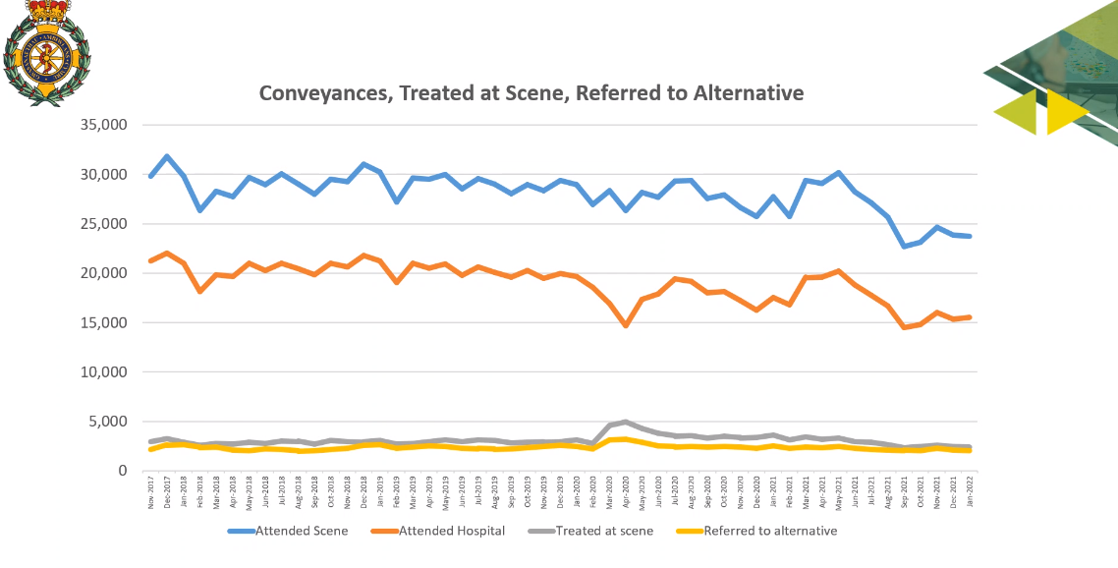
Pathway work to ED; attend at scene; conveyed; treated at scene and referred to GPs, comm services and it’s a small number at the moment, further work to do and model of service and how quickly this will change in any significant way.

Members raised:
Two areas
- Immediate crisis
- Transition to stable and longer term
Where are we transitioning to and how can we get to where we want to be; IT?; training? Infrastructure? Light on where are we transitioning to and looking for more information

What does the Trust look like before and after the investment; what does the £13m give, what would £16m – 20% additional investment so percentage ask is colossal; scenario how this plays in the transition need more about the context and what it will look like. System issues and social services / front door – interesting financial analysis on what might assist health boards

Summary CASC
Need to align with plans at HBs to start to make the change; steps to take; need to start somewhere and what is the right point to start to turn the triangle and move forward to the next phase. Core function of EASC. Need a balance - one not more important than the other. WAST developing a more programme plan to provide more clarity on what is expected.

Overall
- Note of the discussion will be provided
- Inform discussions at health boards, at EASC management group and EASC
- Workforce issue – slight different between this case and others but this gives an option of additionality and quite quickly and not a net loss of staff in the system
- But additionality may not be enough of a reason for itself and how it could be used – but able to mitigate risks in the system so patients do receive a resource (serious consideration)
- Understand and link with WASTs ambition and HBs – phased approach as right thing to do and unable to do big bang (no capital available)
- Evaluate to be able to move forward to next phase
- We can’t do nothing with Rome burning
- Need to ensure we get value for money and will lead to variation and discussion at health boards and how this will be achieved
- Options on urgent and emergency care funding
- Need to come back with the art of the possible and what WAST can offer what the system needs and what is possible to reduce harm

Members RESOLVED to:
- NOTE the presentation and the opportunities for Members to work together

